School characteristics
Data source: the DfE’s January school census for 2025, 2024 and 2023, and children in need census for 2024, 2023 and 2022
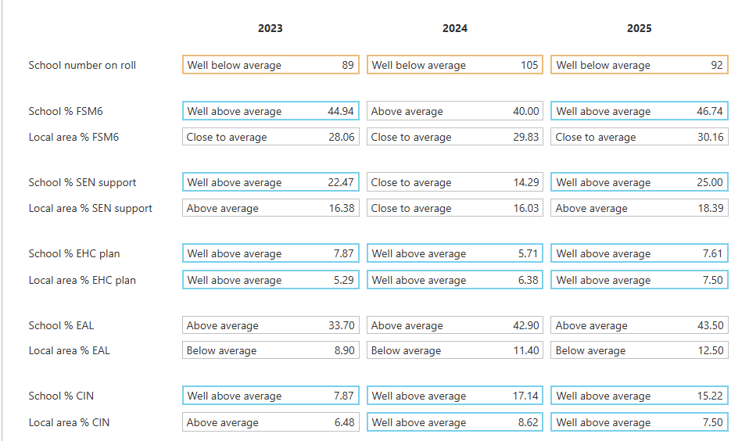
School local area (MSOA) = Cheshire East 021
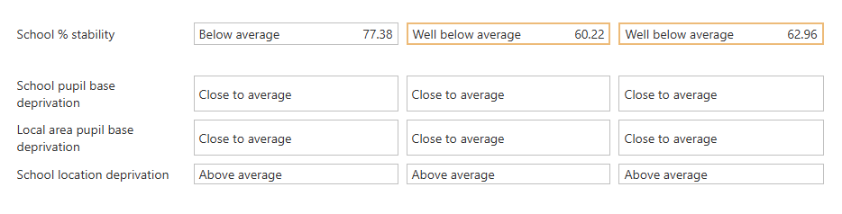

Staffing
Data source: the DfE’s November 2024, 2023, 2022 and 2021 school workforce census data
- There is no data for teachers with at least one period of sickness absence.
- There is no data for days lost to teacher absence in 2023/24 for this school.
- There is no November 2024 school workforce census data for this school.
- Staff turnover was in the highest 20% in: 2022.

Attendance and behaviour
Daily attendance and absence
Data source: the DfE’s 2025/26 daily attendance collection up to and including spring part 1
Unlike the census, this is operational data and should serve as a starting point for conversations with school leaders about recent pupil attendance. A school’s live management information may differ for this time period, so school leaders can share their own data with the inspection team if they wish.
- Attendance
- Year group absence
Attendance
There is no data in this section for this school or it was incomplete.

Attendance and persistent absence
Data source: the DfE’s 2024/25 (3 term), 2023/24 (3 term), 2022/23 (3 term) and 2018/19 (3 term) academic year data from the ‘Pupil absence in schools in England’ statistical release series
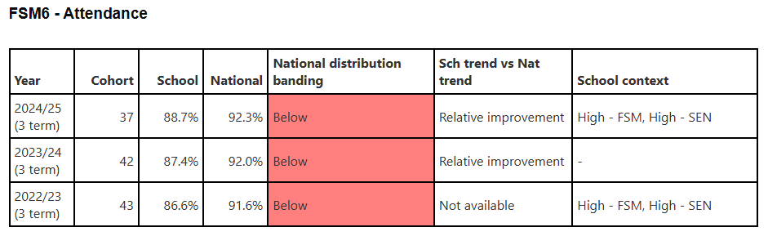
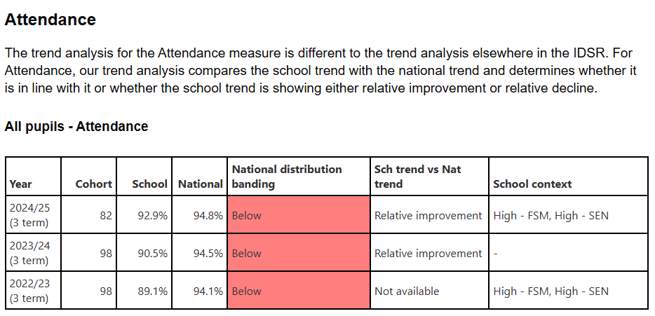

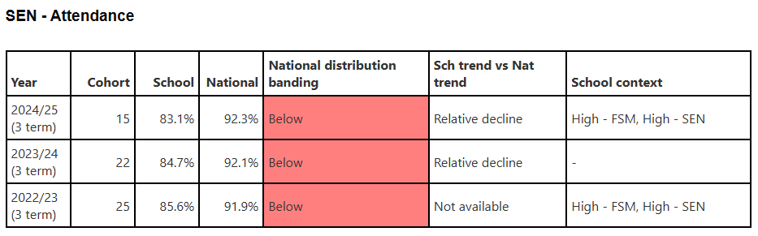
Suspensions and permanent exclusions - whole school
Data source: the DfE’s 2024/25 (spring term), 2024/25 (autumn term), 2023/24 (3 term) and 2022/23 (3 term) academic year data
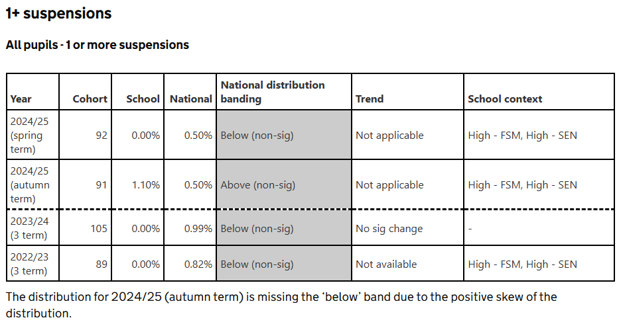
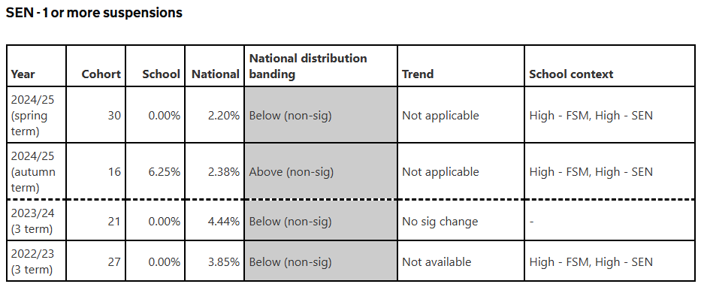
Links to alternative provision and other providers
Data source: the DfE’s autumn term 2025 alternative provision placements data

There is no data in this section for this school or it was incomplete.

Achievement in phonics and at key stage 2
Summary of attainment measures
Key stage 2 data source: the DfE’s final 2025, final 2024, final 2023 and final 2022 data
Phonics and MTC data source: the DfE’s final 2025, final 2024 and final 2023 data
The 2022 outcomes may reflect residual impacts of the COVID-19 pandemic, including disrupted learning and attendance, which could affect pupil performance and school-level results, so comparisons with later years should take this into account.
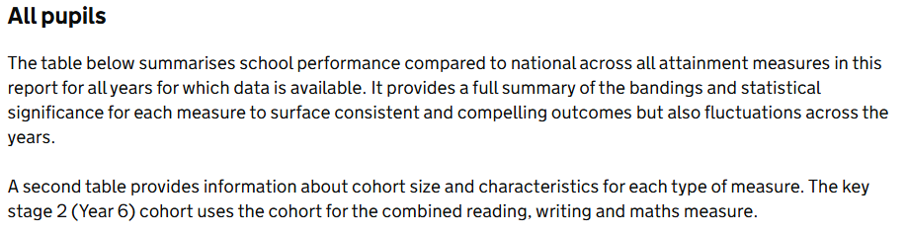
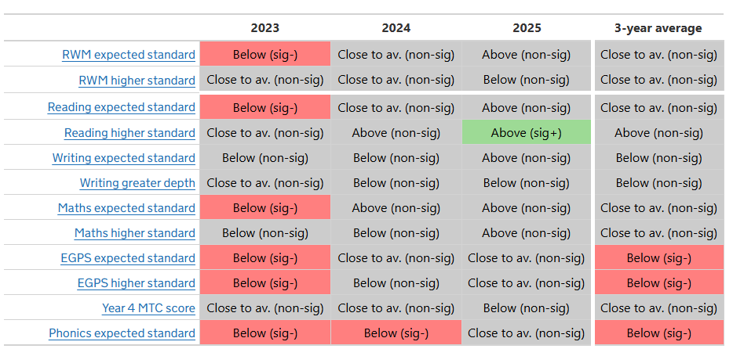
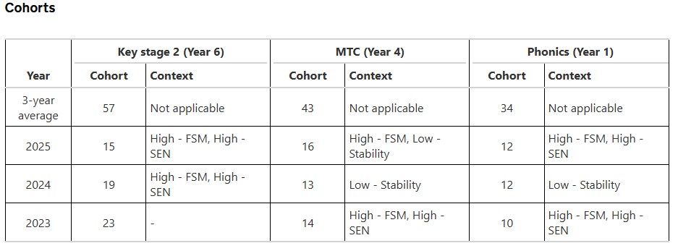

Summary of progress measures
Data source: the DfE’s final 2023 and final 2022 data
The 2022 outcomes may reflect residual impacts of the COVID-19 pandemic, including disrupted learning and attendance, which could affect pupil performance and school-level results, so comparisons with later years should take this into account.
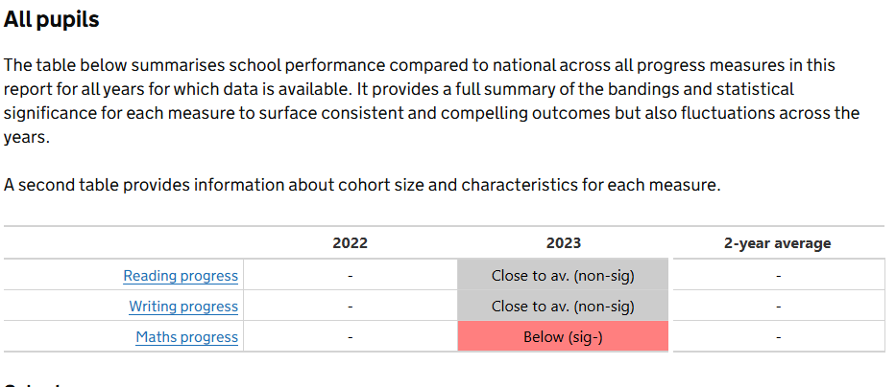
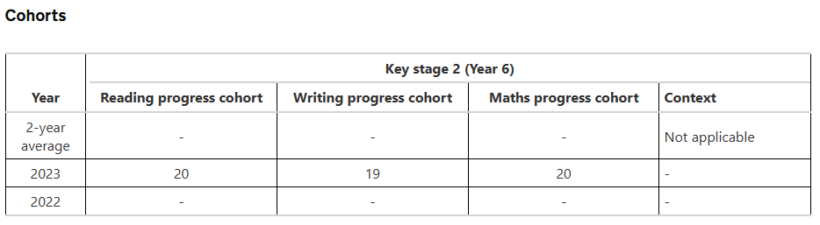
- Reading, writing and maths
- Reading
- Writing
- Maths
- EGPS
- Other

Reading, writing and maths
Data source: the DfE’s final 2025, final 2024, final 2023 and final 2022 data
The 2022 outcomes may reflect residual impacts of the COVID-19 pandemic, including disrupted learning and attendance, which could affect pupil performance and school-level results, so comparisons with later years should take this into account.
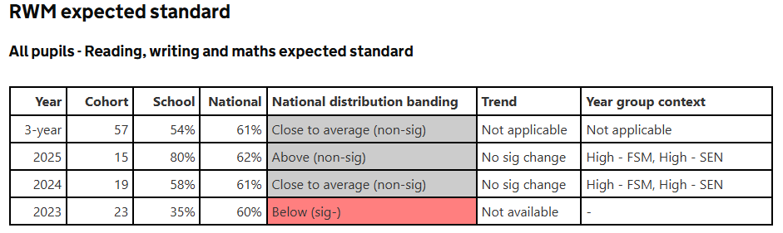
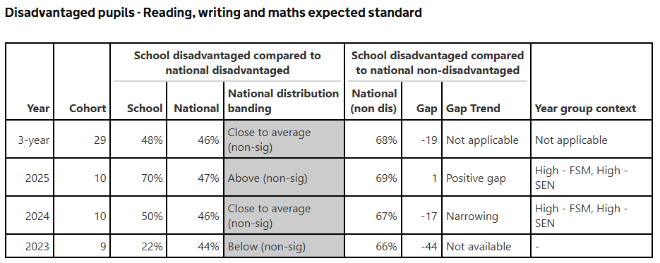
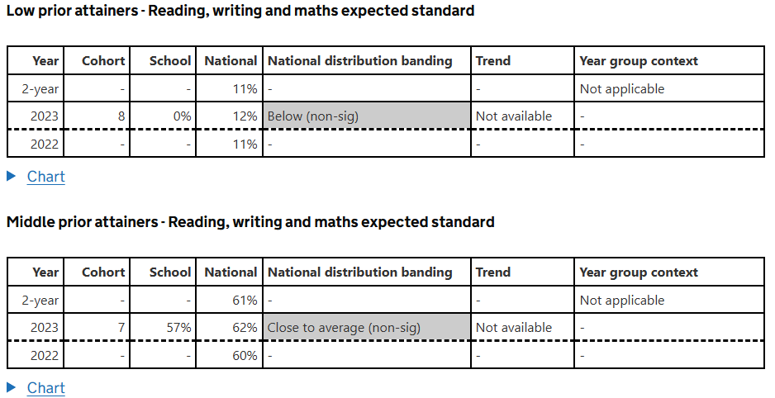
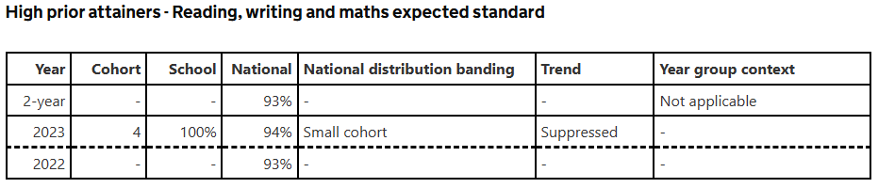

Reading
Data source: the DfE’s final 2025, final 2024, final 2023 and final 2022 data
The 2022 outcomes may reflect residual impacts of the COVID-19 pandemic, including disrupted learning and attendance, which could affect pupil performance and school-level results, so comparisons with later years should take this into account.
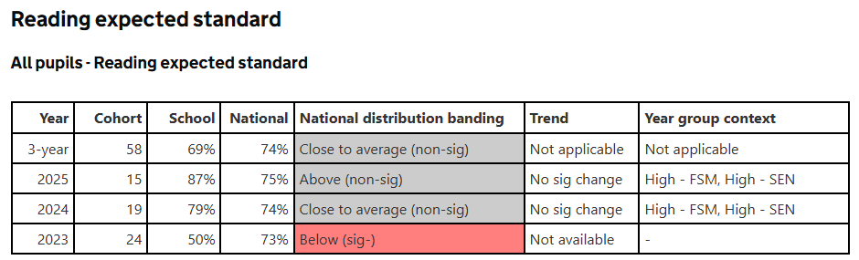
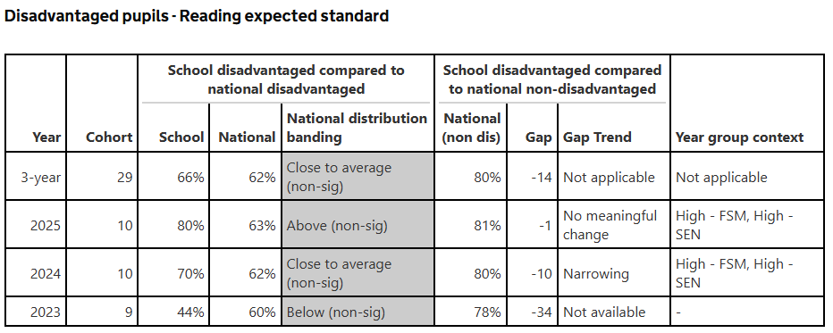
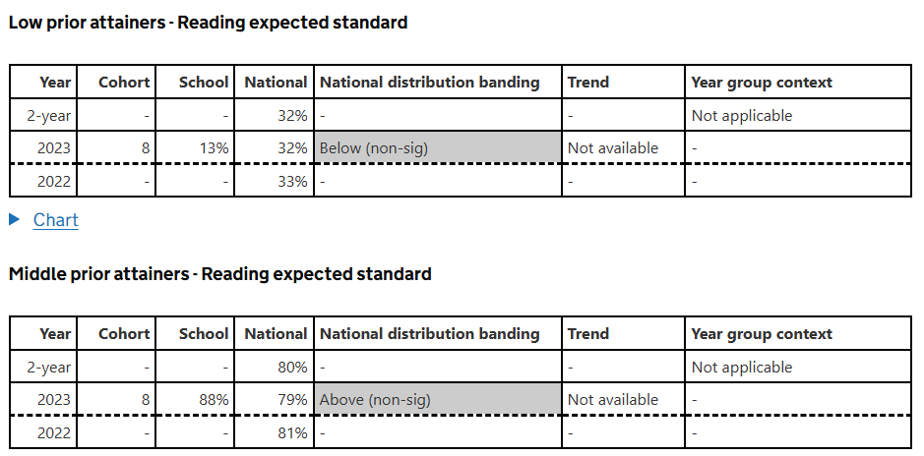
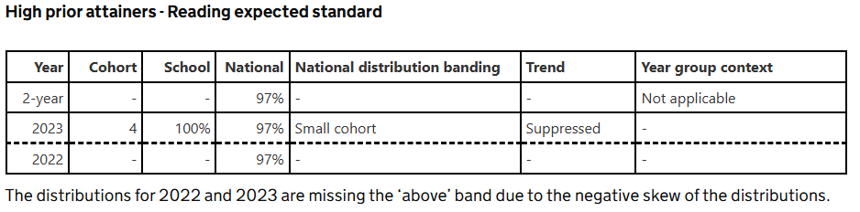
Writing
Data source: the DfE’s final 2025, final 2024, final 2023 and final 2022 data
The 2022 outcomes may reflect residual impacts of the COVID-19 pandemic, including disrupted learning and attendance, which could affect pupil performance and school-level results, so comparisons with later years should take this into account.
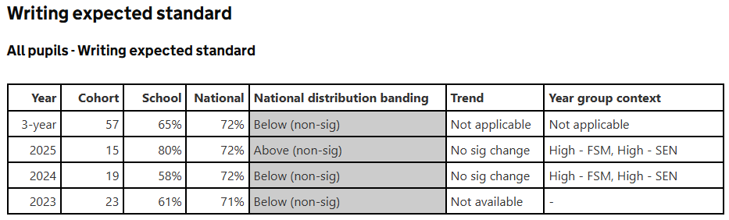
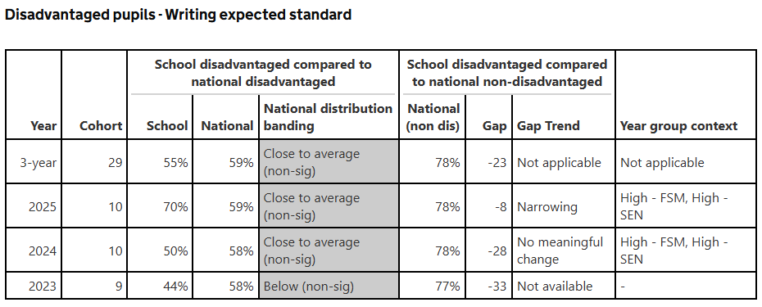
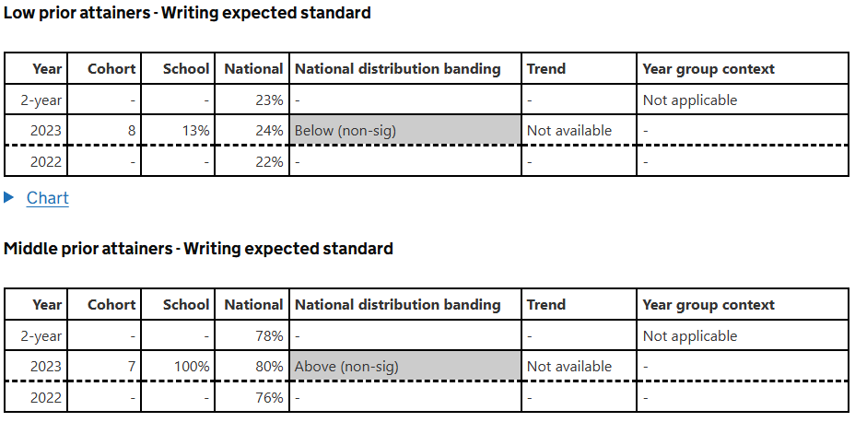
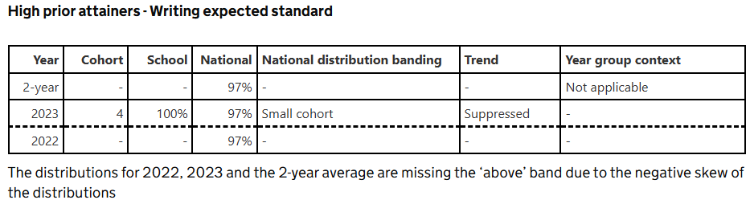
Maths
Data source: the DfE’s final 2025, final 2024, final 2023 and final 2022 data
The 2022 outcomes may reflect residual impacts of the COVID-19 pandemic, including disrupted learning and attendance, which could affect pupil performance and school-level results, so comparisons with later years should take this into account.
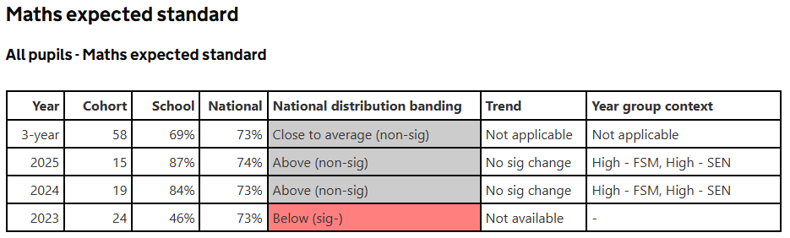
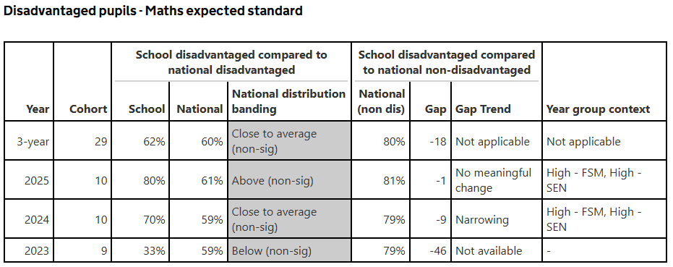
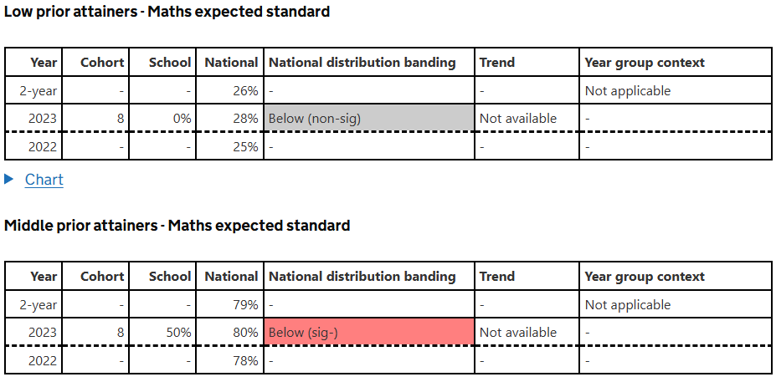
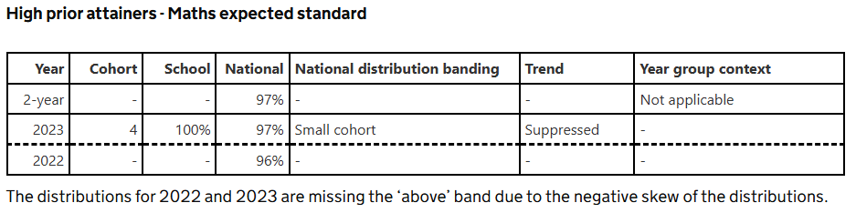
EGPS
Data source: the DfE’s final 2025, final 2024, final 2023 and final 2022 data
The 2022 outcomes may reflect residual impacts of the COVID-19 pandemic, including disrupted learning and attendance, which could affect pupil performance and school-level results, so comparisons with later years should take this into account.
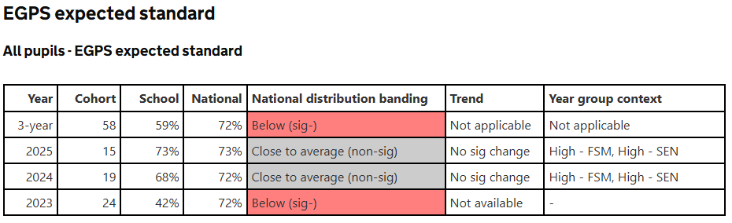
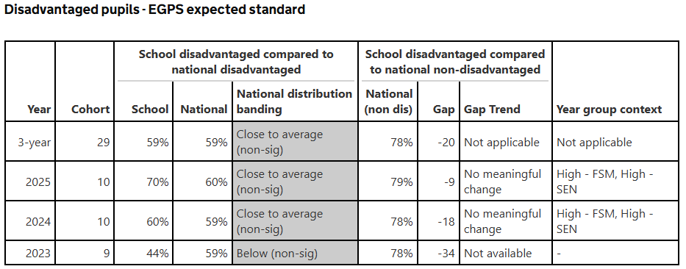
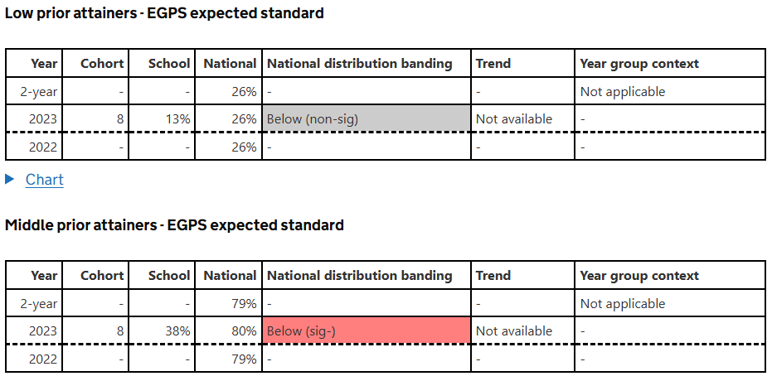
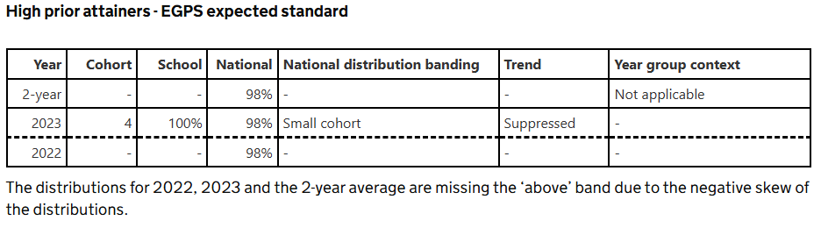
Year 4 MTC score
Data source: the DfE’s final 2025, final 2024 and final 2023 data
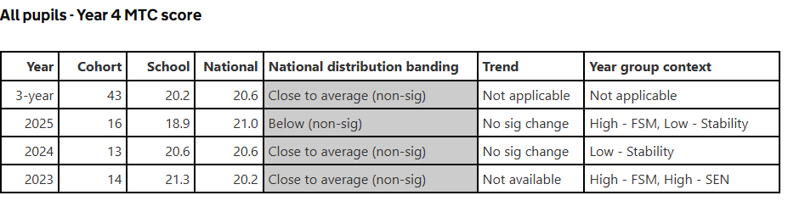

Report card


