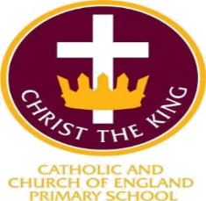
CHRIST THE KING CATHOLIC & CofE PRIMARYSCHOOL TERM DATES

SEPTEMBER 2026 – JULY 2027

HOLIDAY PERIOD | DATE OF CLOSING | DAY OF RE-OPENING
Autumn |  | Wednesday 2 September 2026
Autumn half term | Friday 23 October 2026 | Monday 2 November 2026
Christmas | Friday 18 December 2026 | Monday 4 January 2027
Spring half term | Friday 12 February 2027 | Monday 22 February 2027
Easter | Thursday 25 March 2027 | Monday 12 April 2027
Summer half term | Friday 28 May 2027 | Monday 7 June 2027
INSET Day | Thursday 24 June 2027 | Monday 28 June 2027
Summer | Friday 16 July 2027
INSET (closed to pupils): | Tuesday 1 September 2026
 | Friday 25 June 2027
 | Monday 19 July 2027
 | Tuesday 20 July 2027
 | Wednesday 21 July 2027

July 2025

