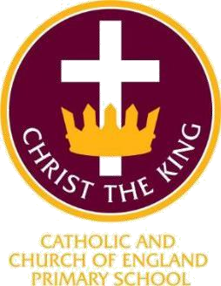

Admissions 2026/27

I have come that they may have life and have it to the full (John10:10)



Admission Arrangements

Christ the King Catholic & Church of England Primary School was founded in 2011. This school is voluntary aided, jointly operated by the Catholic Diocese of Shrewsbury and the Anglican Diocese of Chester. The school welcomes applications from families of either faith, we encourage all parents to give their full and positive support for the aims and ethos of the school. The governing body is the admissions authority and has responsibility for admissions to this school.

The local authority undertakes the co-ordination of admission arrangements during the normal admission round. The closing date for applications is 15th January and families will be informed of the final decision by 15th April 2027.
For the school's year commencing September 2026, the Governing Body has set its admissions number at 30. Of these places 30 places, 18 will be set aside for Catholic children and 12 for Church of England children.

In the event that the school receives more applications than the number of places available, applications will be prioritised on the basis of the oversubscription criteria listed in.

Oversubscription Criteria:

- Looked After Children
A ‘looked after child’ has the same meaning as in section 22(1) of the Children Act 1989, and means any child who is (a) in the care of a local authority or (b) being provided with accommodation by them in the exercise of their social services functions (e.g. children with foster parents) at the time of making application to the school.

A 'previously' looked after child' is a child who was looked after, but ceased to be so because he or she was adopted, or became subject to a child arrangements order or special guardianship order. Included in this definition are those children who appear (to the governing body) to have been in state care outside of England and who ceased to be in state care as a result of being adopted.

Places designated for Roman Catholic Children
The governors have designated 18 places, to be offered to baptised Catholic children. If there are more than 18 qualified applicants, places will be allocated according to the following criteria. These are stated in order of priority:

  - Baptised Catholic children who have a sibling in the school at the time of admission.
  - Baptised Catholic children from the parish of St Edward the Confessor.
  - Baptised Catholic children from other parishes.

Places designated for Church of England Children
The governors have designated 12 places, to be offered to children who are members of the Church of England. If there are more than 12 qualified applicants, places will be allocated according to the following criteria. These are stated in order of priority:

  - Children whose parents are faithful and regular worshippers in the Church of England who have a sibling in the school at the time of admission.
  - Children whose parents are faithful and regular worshippers at St Barnabas. (please see attached map)
  - Children whose parents are faithful and regular worshippers in the Church of England

Where places designated for Catholic children remain unfilled, priority will be given to those children who fulfil the criteria set out for children from the Church of England. Similarly where places for children from the Church of England remain unfilled priority will be given to those who fulfil the criteria set out for Catholic children

Other children who have a sibling in the school at the time of admission

- Other children who parents want them to have an education in a Joint Catholic and Church of England Primary School.
If in any category there are more applications than places available, priority will be given on the basis of distance from home to school, those living nearer to the school having priority. This will be measured by the Local Authority in a straight line using the National Property Gazetteer .

All Catholic applicants will be required to produce baptismal certificates.

A parent for the Church of England criteria is ‘any person who has parental responsibility or care of the child. Where admission arrangements refer to ’parents attendance at church’ it is sufficient for just one parent to attend. For parents of Church of England applicants “faithful and regular” means attendance at a minimum of two services per month for at least six months prior to the closing date for applications. A letter from an incumbent or minister or other church officer will be required as proof of attendance. This should be sent to the school by 15th January 2027

In the event that, during the period specified for attendance at worship, the church has been closed for public worship and has not provided alternative premises for that worship, the requirements of these admissions arrangements in relation to attendance will only apply to the period when the church, or alternative premises have been available for public worship”.

Siblings are defined as brother or sister, half brother or sister, adopted brother or sister, step brother or sister, or the child of the parents/carer’s partner, and in every case, the child should be living in the same family unit at the same address already attending the school and expected to continue at the school at the time of admission.

Please indicate which of the above criteria are being used to support your application.

Application Procedures and Timetable

To apply for a place at this school in the normal admission round, you must complete a Common Application Form available from the local authority in which you live. You are also requested to complete the Supplementary Information Form attached to this policy Appendix 1. The Supplementary Information Form should be returned to the Head teacher at admin@christtheking.cheshire.sch.uk. By 15th January 2027. You will be advised of the outcome of your application on 16th April or the next working day, by the local authority on our behalf. If you are unsuccessful (unless your child gained a place at a school you ranked higher) you will be informed of the reasons, related to the oversubscription criteria listed above, and you have the right of appeal to an independent appeal panel.

Children with EHCPs

Section 324 of the Education Act 1996 requires the governing bodies of all maintained schools to admit a child with an Educational Health Care Plan (EHCP) that names their school.

Late applications for admission

Where there are extenuating circumstances for an application being received after the last date for applications, and it is before the governors have established their list of pupils to be admitted, then it will be considered alongside all the others. Otherwise, applications which are received after the last date will be considered after all the others, and placed on the waiting list in order according to the criteria.

Waiting list

Where we have more applications than places, the admissions criteria will be used. Children who are not admitted will have their name placed on a waiting list. The names on this waiting list will be in the order resulting from the application of the admissions criteria. Since the date of application cannot be a criterion for the order of names on the waiting list, late applicants for the school will be slotted into the order according to the extent to which they meet the criteria. Thus it is possible that a child who moves into the area later to have a higher priority than one who has been on the waiting list for some time. If a place becomes available within the admission number, the child whose name is at the top of the list will be offered a place. This waiting list will operate until the end of the Autumn term.

Address of pupil

The address used on the school’s admission form must be the current one at the time of application. If the address changes subsequently, the parents should notify the school. Where the parents live at different addresses, the current-at- the-application, normal address of the child will be the one used. This will normally be the one where the child wakes up for the majority of Monday to Friday mornings. Parents may be asked to show evidence of the claim that is being made for the address. Where there is dispute about the correct address to use, the governors reserve the right to make enquiries of any relevant third parties, e.g. the child’s GP. For children of UK Service personnel and other Crown Servants returning to the area proof of the posting is all that is required.

Appeals

Where the governors are unable to offer a place because the school is over- subscribed, parents have the right to appeal to an independent admission appeal panel, set up under the Schools Standards and Framework Act, 1998, as amended by the Education Act, 2002. Parents should notify the school within 20 days of receiving the letter refusing a place. Parents will have the opportunity to submit their case to the panel in writing and also to attend in order to present

their case. You will normally receive 14 days’ notice of the place and time of the hearing.
If your child was refused a place in Reception or Key Stage 1 because of the Government limits on Infant class sizes, the grounds on which your appeal could be successful are limited. You would have to show that the decision was one which in the circumstances no reasonable governing body would have made, or that your child would have been offered a place if the governors’ admissions arrangements had been properly implemented.
Please note that this right of appeal against the governors’ decision does not prevent you from making an appeal in respect of any other school.

Fraudulent applications

Where the governing body discovers that a child has been awarded a place as the result of an intentionally misleading application from a parent (for example a false claim to residence in the catchment area or if involvement in a place of worship) which effectively denies a place to a child with a stronger claim, then the governing body is required to withdraw the offer of the place. The application will be considered afresh and a right of appeal offered if a place is refused.

Deferred admission

If your child is due to start school during the next academic year, it is important that you apply for a place for September. If your child’s fifth birthday is between the months of September and December, then, if you wish it, admission may be deferred until January; if it is between January and April, then admission may be deferred until the start of the summer term though it is likely to be in your child’s interest to start no later than in January.

Twins

Where there are twins or multiple births wanting admission and there is only a single space left within the admission number, then the governing body will exercise as much flexibility as possible within the requirements of infant class sizes. If only one place can be offered then a random allocation will be undertaken by an independent body. Parents will be advised of their right of appeal for the other child/ren.

Tie Break

Priority will be given to children living closest to the school determined by the shortest distance. Distances are calculated [on the basis of a straight-line measurement between the front door of the child’s home address (including the community entrance to flats) and the main entrance of the school] using the local authority’s computerised measuring system. In the event of distances being the

same for two or more children where this would determine the last place to be allocated, random allocation will be carried out and supervised by a person independent of the school. All the names will be entered into a hat and the required number of names will be drawn out.

In-Year Applications

An application can be made for a place for a child at any time outside the admission round and the child will be admitted where there are available places. Application should be made to the school by contacting Cheshire East Admissions. Where there are places available but more applications than places, the published oversubscription criteria, as set out in this policy, will be applied.
You will be advised of the outcome of your application as soon as possible and in writing, and you have the right of appeal to an independent appeal panel.

If there are no places available, the child will be added to the waiting list. Please see the admission arrangements for more details.
You will be advised of the outcome of your application in writing as soon as possible. Applicants must be informed of the outcome of their application within 15 school days of receipt, but the aim is to notify applicants of the outcome of their application within 10 school days of receipt.
You have the right to appeal to an independent appeal panel if your application is unsuccessful.
If you have any questions in relation to in-year admissions please contact the headteacher via admin@christtheking.cheshire.sch.uk. You may also wish to discuss in-year applications with the local authority:
email admissions@cheshireeast.gov.uk or you can call 0300 123 5012

https://www.cheshireeast.gov.uk/schools/admissions/in-year-applications.aspx

Cheshire East has a Fair Access Protocol agreed in partnership with the head teachers of both primary and secondary schools. These can be found on the Cheshire East Website.

https://www.cheshireeast.gov.uk/schools/admissions/fair-access-protocol.aspx

Appendix 1


SUPPLEMENTARY INFORMATION FORM 2026/7
If you are expressing a preference for a place for your child at CHRIST THE KING CATHOLIC AND C of E ACADEMY in Cheshire East and wish to apply under a faith criterion, you should complete this Supplementary Information Form.
- The completed Supplementary Information Form, together with all supporting documentation (see Notes below), should be returned to admin@christtheking.sch.uk by the closing date 15th January 2027

- If you are applying to more than one Catholic school or academy you will need to complete a separate Supplementary Information Form for each school/academy.

If you do not provide the information required in this form and return it to the school/academy, with all supporting documentation, by the closing date, your child may not be placed in the appropriate faith category and this may affect your child’s chance of being offered a place.
- Remember – you must also complete the Common Application Form.

Name of child: Address of child:

Parent/Carer Name:1 Parent/Carer Email:
Please read the relevant school/academy Admissions Policy, noting in particular any faith criteria, and your Local Authority booklet, before completing this form.

NOTE: When completing the Common Application Form, it is important that you provide details of any siblings (brothers or sisters) who will be attending the Catholic school/academy at the proposed time of admission. If this information is not provided the admission authority of the Catholic school/academy may not be able to place the application within the correct criteria.

Religious Status of child (please indicate by placing a tick in the appropriate box – please note that a tick should be indicated in only a single box)2
Criteria | Tick Box | Evidence: insert details in accordance with the Notes below
1. Catholic | □
Church of England | □
Catholic [Parish] [Deanery] in which your child lives:

Priest or Vicar’s name:

In compliance with the UK General Data Protection Regulation (UK GDPR) and the Data Protection Act 2018, we wish to ensure that you are aware of the purpose for which we collect and process the data we have asked you to provide on this form.

  - We are part of Our Lady Help of Christians Catholic Multi Academy trust. The trust is the Data Controller and Christ the King is part of the academy trust company
  - Being a Catholic education provider, we work closely with the School’s Diocesan Authority, the School’s Trustees, the Local Authority, the Catholic Education Service and the Department for Education, and may share the information you provide on this application form if we consider it is necessary in order to fulfil our functions.
  - The person responsible for data protection within our organisation is the headteacher and you can contact them with questions relating to our handling of the data. You can contact them by emailing admin@christtheking.cheshire.sch.uk
  - We require the information we have requested for reasons relating to our functions as the admission authority of the school/academy.
  - It is necessary for us to process personal data for the performance of a task carried out in the public interest or in the exercise of official authority vested in the controller (Article 6(1)(e) of the UK GDPR).

  - To the extent that you have shared any special categories of data this will not be shared with any third parties except as detailed in paragraph 2 above, unless a legal obligation should arise.
  - It is necessary for us to process special category data for the performance of a task carried out in the public interest or in the exercise of official authority vested in the controller (Article 6(1)(e) of the UK GDPR). Additionally, processing is necessary for reasons of substantial public interest on the basis of domestic law which is proportionate to the aim pursued and which contains appropriate safeguards (Article 9(2)(g) of the UK GDPR).
  - If the application is successful, the information you have provided on this form will be migrated to the school’s/academy’s enrolment system, and the data will be retained and processed on the basis of the school’s/academy’s fair processing notice and data protection policies which apply to that data.
  - If the application is unsuccessful, the application form and any documents submitted in support of the application will be destroyed after a period of 12 months. The school/academy may keep a simple record of all applications and their outcome as part of their permanent archives in accordance with the school’s/academy’s data retention policy.
  - To read about your individual rights you can refer to the school’s/academy’s fair processing notice and data protection policies.
  - If you wish to complain about how we have collected and processed the information you have provided on this form, you can make a complaint to our organisation by following the complaints policy which can be found here: https://www.christtheking.cheshire.sch.uk/page/?title=Policies&pid=26 If you are unhappy with how your complaint has been handled, you can contact the Information Commissioner’s Office via their website at: ico.org.uk.

I confirm that I have read the Admissions Policy of the school/academy and that the information I have provided is correct. I understand that I must notify the school/academy immediately if there is any change to these details and that, should any information I have given prove to be inaccurate, the Admission Authority may withdraw any offer of a place even if the child has already started school.

Signed……………………….. Date………………………………

Notes
- Evidence of Catholic Baptism
If an application is being made for a place at the school/academy for a Catholic child evidence of Catholic baptism or reception into the Church is required. A certificate of baptism or certificate of reception into the full communion of the Catholic Church should be provided at the same time as this form is returned to the school/academy.
[The admission authority may request additional supporting evidence if the written documents that are provided do not clarify the fact that the child was baptised or received into the Catholic Church, e.g. where the name and address of the Church is not on the certificate or where the name of the Church does not state whether it is a Catholic Church or not. Those who have difficulty obtaining written evidence of baptism or reception into the Church should contact their Parish Priest.]

Evidence for Catechumens
If an application is being made for a place at the school/academy for a catechumen evidence of their being a member of the catechumenate of a Catholic Church will be required. A certificate of reception into the order of catechumens should be provided at the same time as this form is returned to the school/academy.

Evidence of Membership of an Eastern Christian Church
If an application is being made for a place at the school/academy for a member of an Eastern Christian Church, including Orthodox Churches, evidence of membership will be required. A certificate of baptism or reception from the authorities of that Church should be provided at the same time as this form is returned to the school/academy.

Evidence for Other Christian Denominations and Other Faiths
If an application is being made for a place at the school/academy as a member of another Christian denomination or another faith evidence confirming membership of that Christian denomination or faith, and signed by the appropriate minister of religion or faith leader, will be required. The evidence should be provided at the same time as this form is returned to the school/academy.

Checklist:
Have you enclosed?
  - Copy of baptism or certificate of reception into the Catholic Church (where applicable).
  - Have you completed and returned your local authority’s Common Application Form?

Appendix 2

Boundary map for St Barnabas Church of England parish

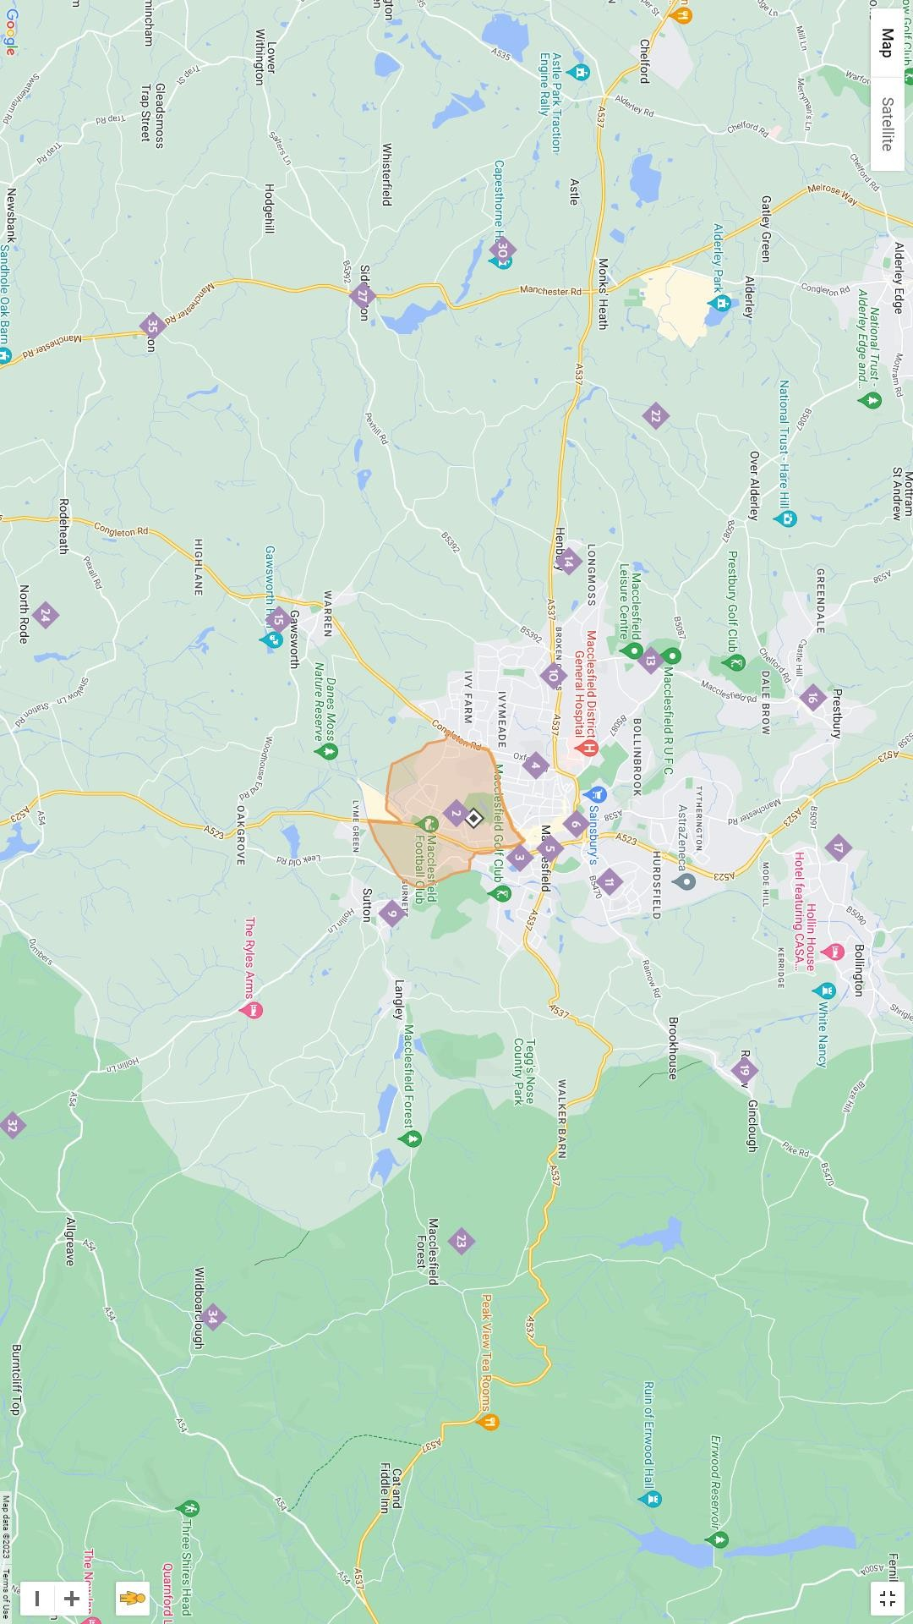

Appendix 3

Boundary Map for St Edward the confessor



