

Christ the King Catholic and C of E Primary School

Concrete / Pictorial / Abstract

Maths Calculation Policy

This policy has been largely adapted from the White Rose Maths Hub Calculation Policy with further material added. It is a working document and will be revised and amended as necessary. Many variations have been included to provide teachers with a range of tools to support pupils in their grasp of number and calculation. To ensure consistency for pupils, it is important that that the mathematical language used in maths lessons reflects the vocabulary used throughout this policy.



Recommended practice delivering a mastery approach

True mastery aims to develop all children’s mathematical understanding at the same pace. As much as possible, children should be accessing the same learning. Differentiation should primarily be through support, scaffolding and deepening, not through task.

Consistency in language is essential for pupils to understand the concepts presented in mathematics. If other, ‘child-friendly’ terminology is used, this must be alongside the current terminology recommended by maths specialists. Using this will support children with their examinations and throughout secondary s.
We are using the White Rose Hub philosophy of:
- fluency - using Learning Objectives from the National Curriculum
- reasoning
- problem-solving
In all our maths work we are using a CPA approach within our maths lessons (CPA – Concrete/ Pictorial/ Abstract)
We are using resources such as - White Rose, NCETM Mastery documents & nrich problems.
The aim is that when children leave Christ the King Catholic and C of E Primary School they:
- Have a secure knowledge of number facts and a good understanding of the four calculation operations (addition, subtraction, multiplication and division)
- Make use of jottings, diagrams and informal notes to help record steps and part answers when using mental methods that generate more information than can be kept in their heads
- Have an efficient, reliable, written method of calculation for each operation that they are able to apply with confidence when they are unable to perform a calculation mentally

Addition – EYFS
Maths for young children should be meaningful. Where possible, concepts should be taught in the context of real life.
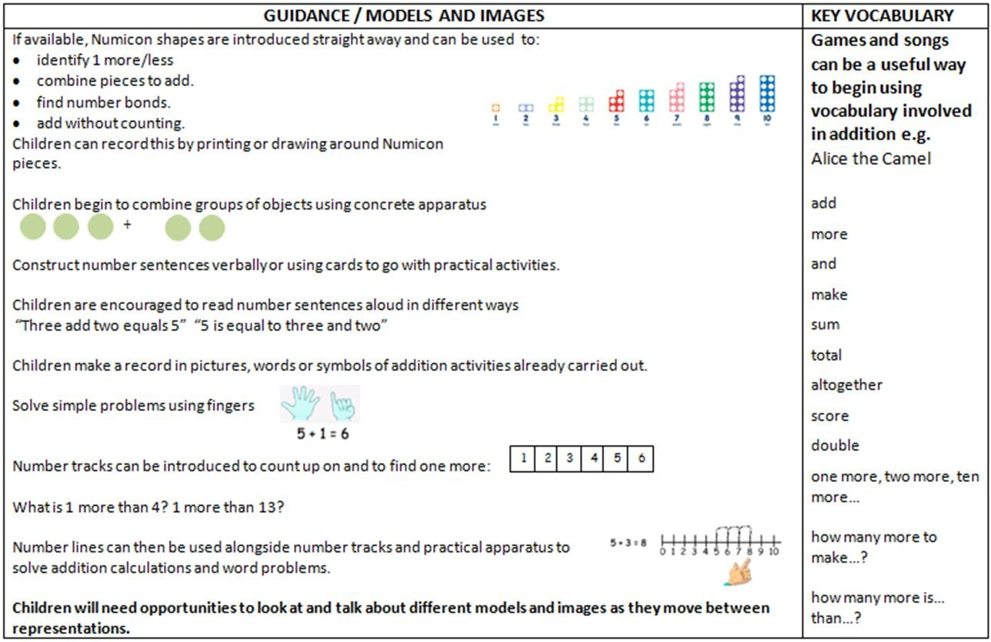

YEAR 1 Addition
Objective / Strategy | Concrete | Pictorial | Abstract
Combining two parts to make a whole: part- whole model | 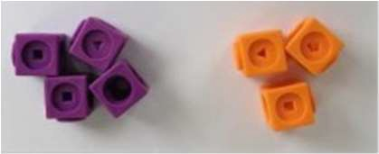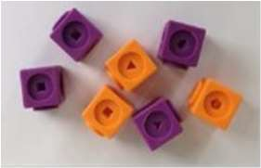  Use part, part whole model.  Use cubes to add two numbers together as a group or in a bar. | Use pictures to add two numbers together as a group or in a bar.  8 1 | 8 = 5 + 3 5  5 + 3 = 8 3  Use the part part whole diagram as shown above to move into the abstract.  Include missing number questions to support varied fluency:  8 = ? + 3  5 + ? = 8
Starting at the bigger number and counting on | 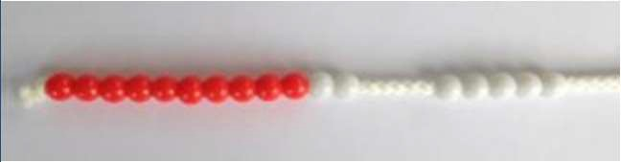 | 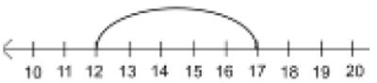  12 + 5 = 17  Start at the larger number on the number line and count on in ones or in one jump to find the answer. | 5 + 12 = 17  Place the larger number in your head and count on the smaller number to find your answer.
 | Start with the larger number on the bead string and then count on to the smaller number 1 by 1 to find the answer.
Regrouping to make | 6 + 5 = 11 | 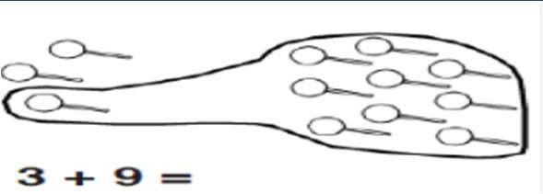  Use pictures or a number line. Regroup or partition the smaller number using the part, part whole model to make 10.  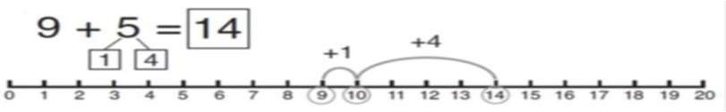 | 7 + 4= 11
10.
This is an essential skill for column addition later. |   Start with the |  | If I am at seven, how many more do I need to make 10? How many more do I add on now?
 | bigger number
 | and use the
 | smaller number to
 | make 10.
 | Use ten frames.
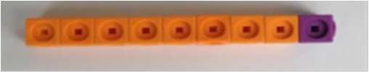
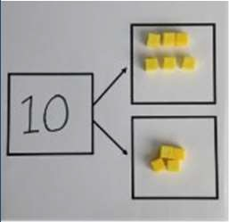
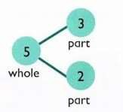

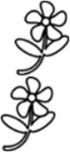
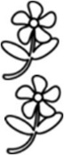
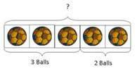
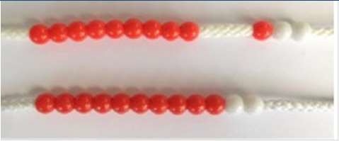
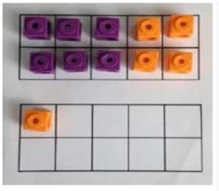



Represent & use number bonds and related subtraction facts within 20 | 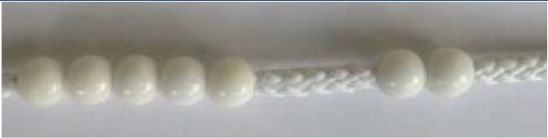  2 more than 5. | 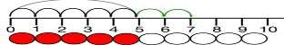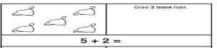 | Include missing number questions:  8 = ? + 3  5 + ? = 8  Emphasis should be on the language ‘1 more than 5 is equal to 6.’  ‘2 more than 5 is 7.’  ‘8 is 3 more than 5.’

YEAR 2 Addition
Objective /Strategy | Concrete |  | Pictorial | Abstract
Adding multiples of ten | 50= 30 = 20  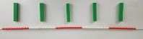  Model using dienes and bead strings |  | 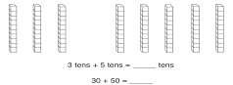 | 20 + 30 = 50  70 = 50 + 20  40 + □ = 60
 |  |  | Use representations for base ten.
Use known number facts  Part, part whole | 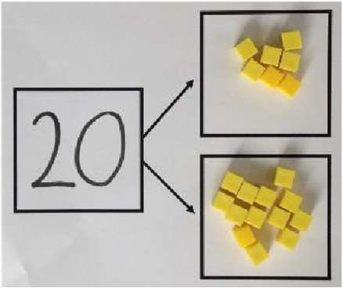  Children explore ways of making numbers within 20 |  | 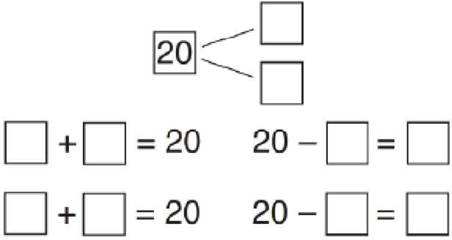 | Explore commutativity of addition by swapping the addends to build a fact family.  Explore the concept of the inverse relationship of addition and subtractions and use this to check calculations.  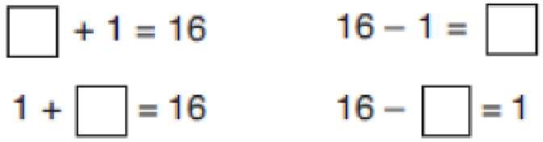
Using known facts | +  + | =    = | 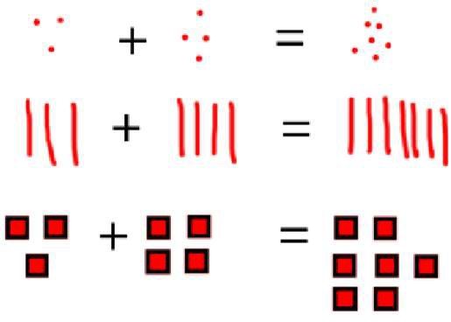 | 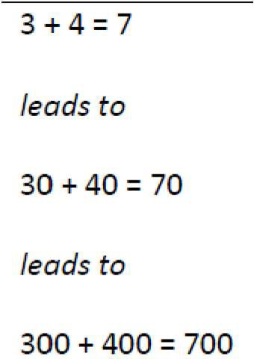
 |  |  | Children draw representations of H,T and O





Bar model | 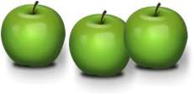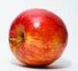  3 + 4 = 7 | 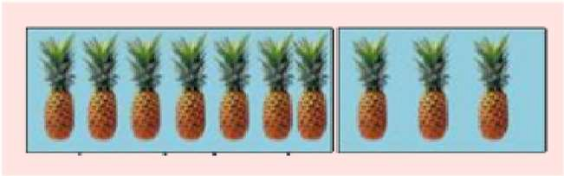  7 + 3 = 10 | 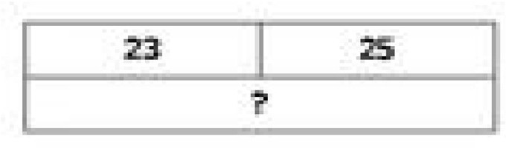  23 + 25 = 48
Add a two digit number and ones | 17 + 5 = 22  Use ten frame to make ‘magic ten  Children explore the pattern. 17 + 5 = 22  27 + 5 = 32 | 17 + 5 = 22  Use part part whole  and number  line to 3 2  model.  20 | 17 + 5 = 22  Explore related facts 17 + 5 = 22  5 + 17 = 22  22—17 = 5  22—5 = 17  Lead into recording in column format, to reinforce place value and prepare children for formal written methods with larger  values.
Add a 2 digit number and tens | 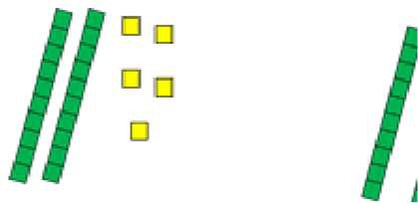  25 + 10 = 35  Explore that the ones digit does not change | 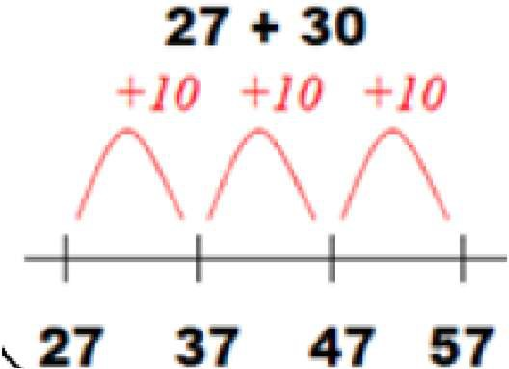 | 27 + 10 = 37  27 + 20 = 47  27 + □ = 57
Add two 2-digit numbers | Model using dienes , place value counters and numicon | Use number line and bridge ten using part whole if necessary. | 25 + 47  20 + 5 40 + 7  20 + 40 = 60  5+ 7 =12  60 + 12 = 72

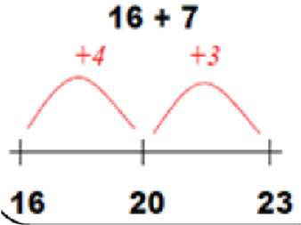





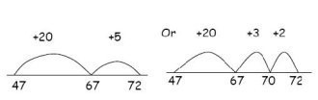
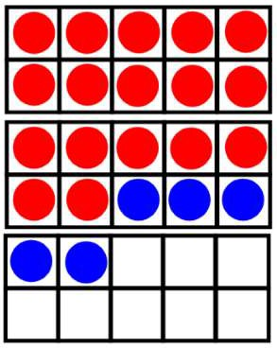
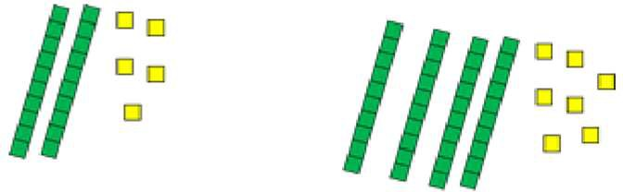
2 2
17 | 5

 |  |  | Lead into recording in column format, to reinforce place value and prepare children for formal written methods with larger values.
Add three 1-digit numbers | 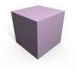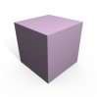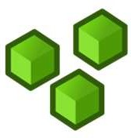  Combine to make 10 first if possible, or bridge 1o then add third digit | + + 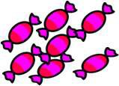  Regroup and draw representation.  + = 15 | 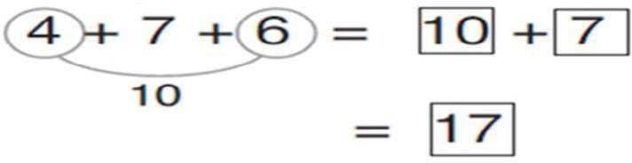  Combine the two numbers that make/ bridge ten then add on the third.

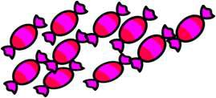
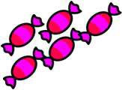

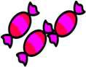

YEAR 3 Addition
Objective /Strategy | Concrete | Pictorial | Abstract
Column Addition—no regrouping (friendly numbers)  Add two or three 2 or 3digit numbers. | Dienes or numicon  Add together the ones first, then the tens.  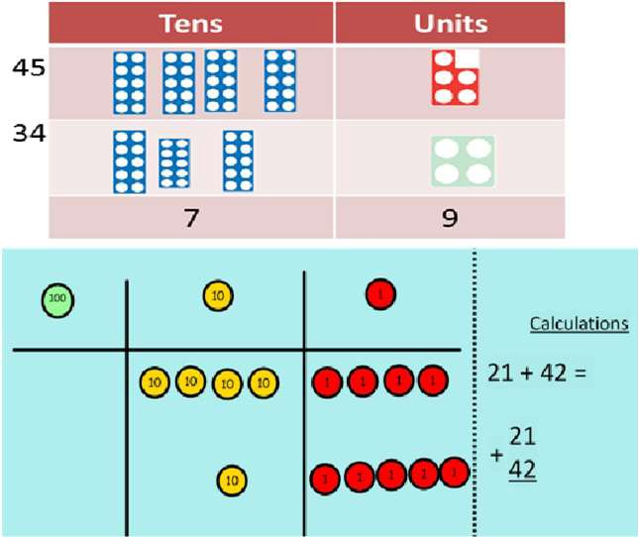  Move to using place value counters | Children move to drawing the counters using a tens and one frame.  tens ones | 2 2 3  + 1 1 4  3 3 7  Add the ones first, then the tens, then the hundreds.
Column Addition with regrouping. | 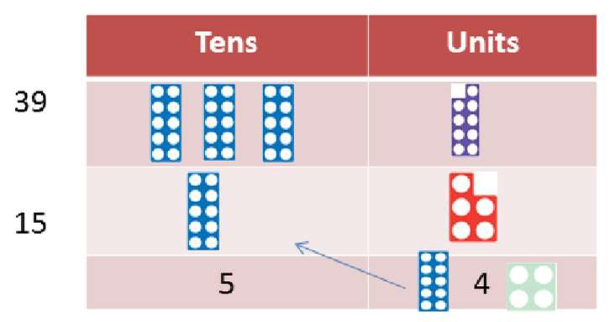  Exchange ten ones for a ten. Model using numicon and place value counters. | 3 4  +1 7  Children can draw a representation of the grid to further support their understanding, carrying the ten underneath the line | 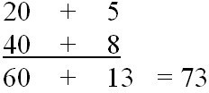  Start by partitioning the numbers before formal column to show the exchange.









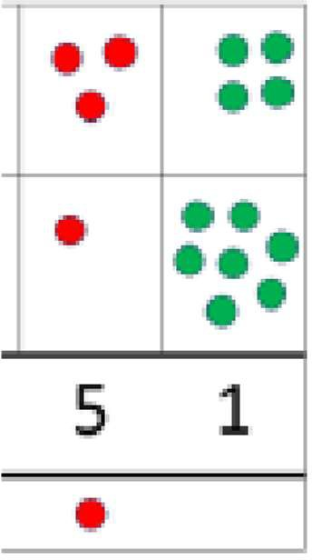
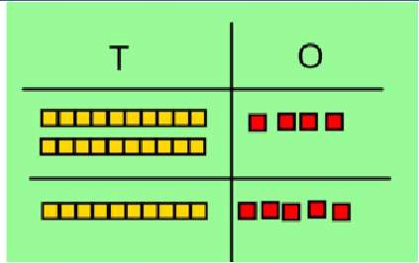
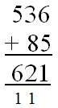

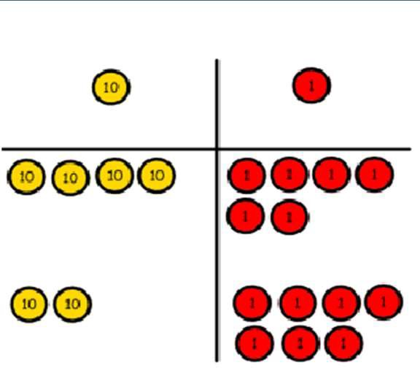

46 + 27 = 73
Estimate the answers to questions and use inverse operations to check answers | 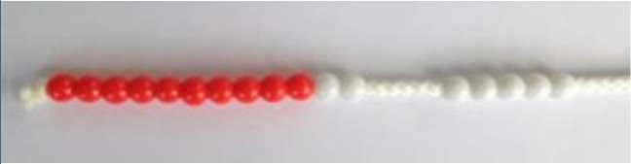  Estimating 98 + 17 = ?  100 + 20 = 120 | Use number lines to illustrate estimation.  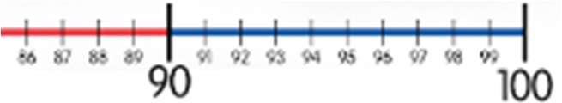 | Building up known facts and using them to illustrate the inverse and to check answers:  98 + 18 = 116 116 – 18 = 98  18 + 98 = 116 116 – 98 = 18

YEARS 4 – 6 Addition
Objective /Strategy | Concrete | Pictorial | Abstract
Years 4 – 6  Estimate and use inverse operations to check answers to a calculation | AS per Year 3
Y4—add numbers with up to 4 digits | Children continue to use dienes or place value counters to add, exchanging ten ones for a ten and ten tens for a hundred and ten hundreds for a thousand.  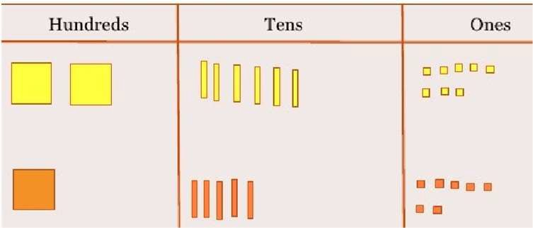 | 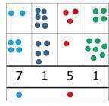  Draw representations using place value grid. | 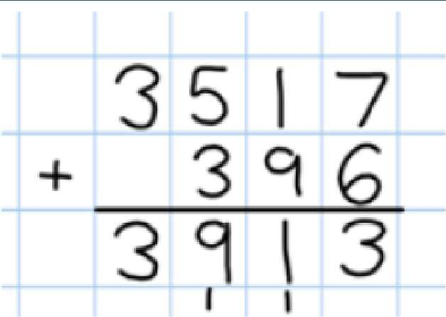  Continue from previous work to carry hundreds as well as tens.  Relate to money and measures.
Y5—add numbers with more than 4 digits.  Add decimals with 2 decimal places, including money. | As year 4  Ten ones tenths hundredths    Introduce decimal place value counters and model exchange for addition. | 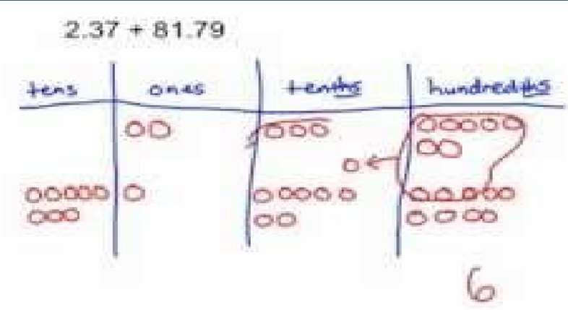 | 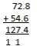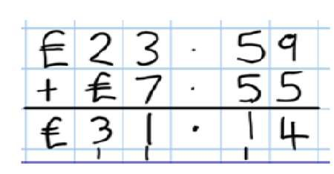
Y6—add several numbers of increasing complexity, including adding money, measure and decimals with different numbers of decimal points. | As Y5 | As Y5 | Insert zeros for place holders.  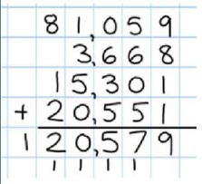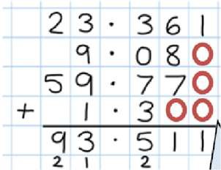




s

Subtraction - EYFS
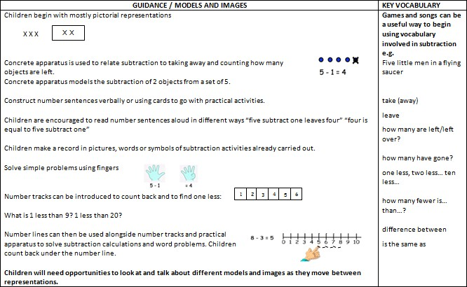
Maths for young children should be meaningful. Where possible, concepts should be taught in the context of real life.



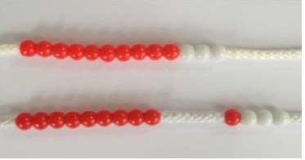
YEAR 1 SUBTRACTION
Objective /Strategy |  | Concrete |  | Pictorial |  | Abstract
Taking away ones. | Use physical objects, counters, cubes etc to show how objects can be taken away.  4—2 = 2    6—4 = 2 |  | Cross out drawn objects to show what has been taken away.  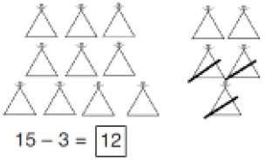 |  | 7—4 = 3  16—9 = 7
Counting back | 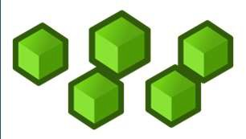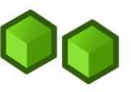  Move objects away from the group, counting backwards.  Move the beads along the bead string as you count backwards. |  | 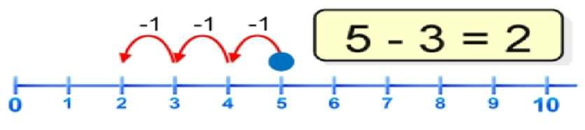  Count back in ones using a number line. |  | Put 13 in your head, count back 4. What number are you at?
Find the Difference | Compare objects and amounts  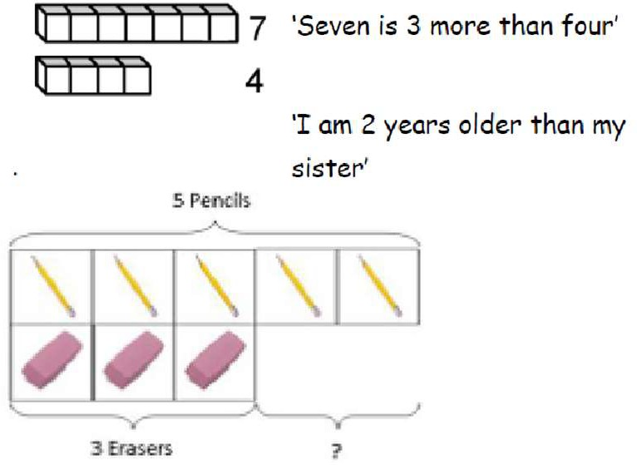  Lay objects to represent bar model. |  | Count on using a number line to find the difference.  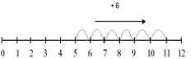 |  | Hannah has12 sweets and her sister has 5. How many more does Hannah have than her sister.?




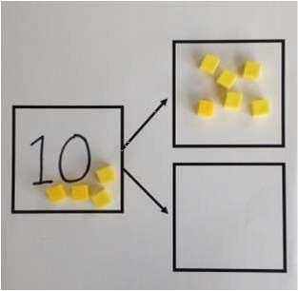
Objective/Strategy | Concrete | Pictorial | Abstract
Represent and use number bonds and related subtraction facts within 20  Include subtracting zero  Part Part Whole model | Link to addition. Use PPW model to model the inverse.  If 10 is the whole and 6 is one of the arts, what s the other part?  10—6 = 4 | 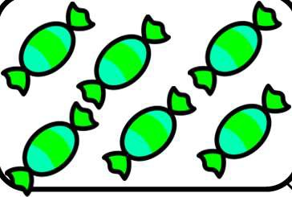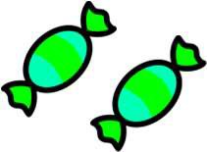  Use pictorial representations to show the part. | Move to using numbers within the part whole model.  5  12  7  Include missing number problems: 12 - ? = 5  7 = 12 - ?
Make 10 | 14—9  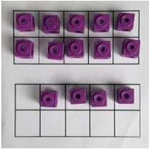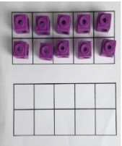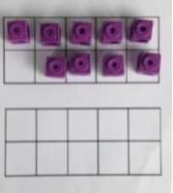  Make 14 on the ten frame. Take 4 away to make ten, then take one more away so that you have taken 5. | 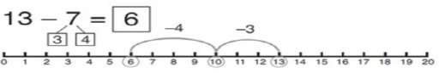  13—7  Jump back 3 first, then another 4. Use ten as the stopping point. | 16—8  How many do we take off first to get to 10? How many left to take off?

Bar model  Including the inverse operations. | 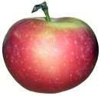  5—2 = 3 | 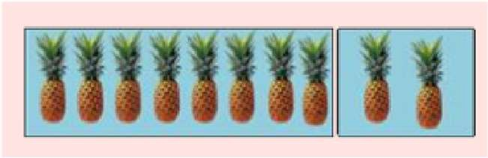 | 8 2  10 = 8 + 2  10 = 2 + 8  10—2 = 8  10—8 = 2

YEAR 2 - SUBTRACTION
Objective & Strategy | Concrete | Pictorial | Abstract
Regroup a ten into ten ones | 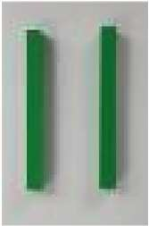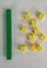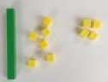  Use a PV chart to show how to change a ten into ten ones, use the term ‘take and make’ | 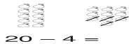 | 20—4 = 16
Partitioning to |  | Children draw representations of Dienes and cross off.  43—21 = 22
subtract without  regrouping. | 34—13 =  21 |  | 43—21 = 22
‘Friendly numbers’
 | Use Dienes to
 | show how to
 | partition the
 | number when
 | subtracting
 | without
 | regrouping.
Make ten strategy | 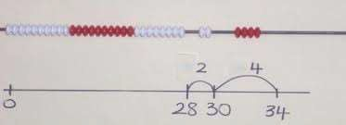  34—28  Use a bead bar or bead strings to model counting to next ten and the rest.
Progression should be crossing one ten, crossing more than one ten, crossing the hundreds. |  | 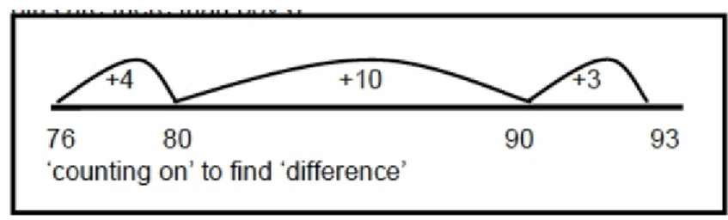 | 93—76 = 17
 |  | Use a number line to count on to next ten and then the rest.

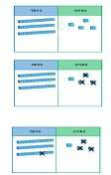

YEAR 3 - SUBTRACTION
Objective/ Strategy | Concrete | Pictorial | Abstract
Subtract numbers |  | 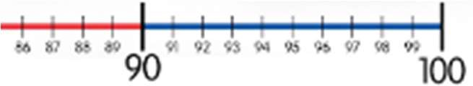 | Vary the position of the answer and question.
mentally, including:
 |  |  | Expose children to missing number questions
three digit number + |  |  | and vary the missing part of the calculation.
ones
three digit number + tens |  |  | 678 = ? - 1  688 – 10 = ?  678 = ? – 100
three digit number +
hundreds
Column subtraction without regrouping (friendly numbers) | 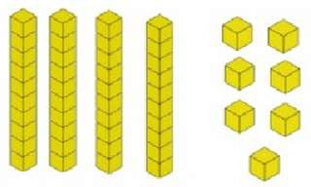  47—32 | 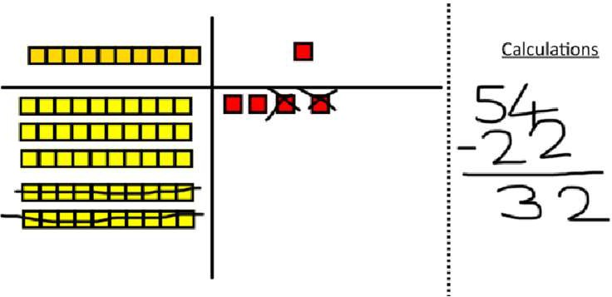  Draw representations to support understanding | 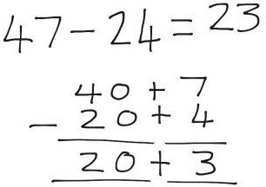  Intermediate step may be needed to lead to clear subtraction understanding.
 | Use base 10 or Numicon to model
Column subtraction with regrouping | 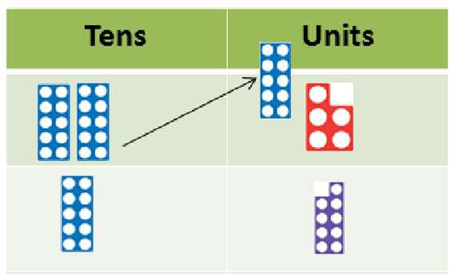  Begin with base 10 or Numicon. Move to pv counters, modelling the exchange of a ten into ten ones. Use the phrase ‘take and make’ for exchange. | 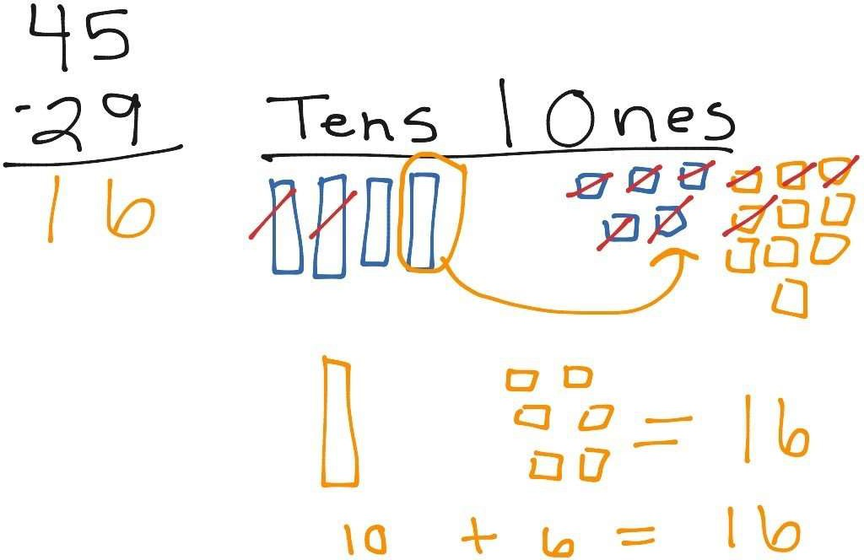  Children may draw base ten or PV counters and cross off. | Begin by partitioning into  pv columns  Then move to formal method.
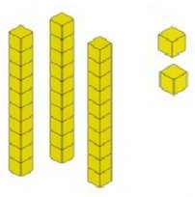
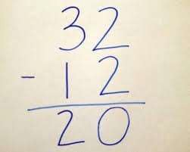
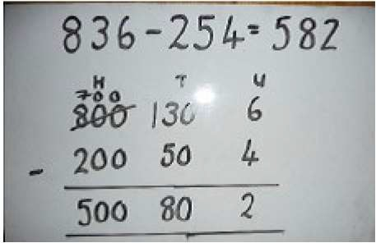
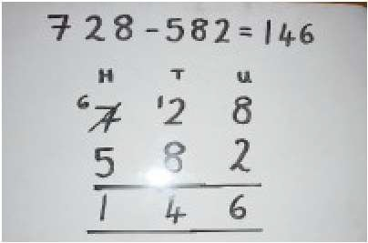

YEARS 4 – 6 SUBTRACTION
Objective /Strategy | Concrete | Pictorial | Abstract
Subtracting tens and ones | 234 - 179  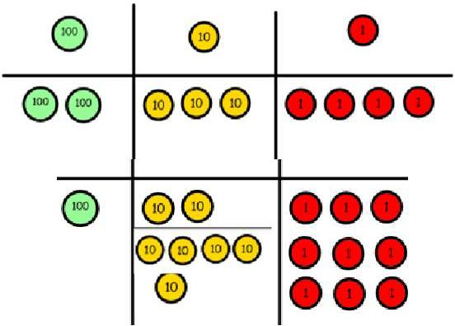  Model process of exchange using Numicon, base ten and then move to PV counters. | Children to draw pv counters and show their exchange—see Y3 | 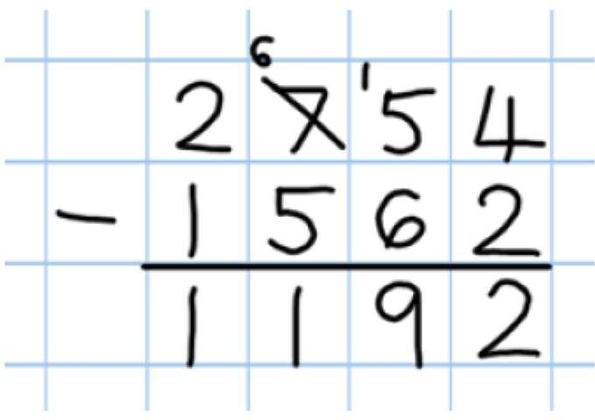  Use the phrase ‘take and make’ for exchange
Year 4 subtract with
up to 4 digits.
Introduce decimal
subtraction through
context of
money
Year 5- Subtract  with at least 4 | As Year 4 | Children to draw pv counters and show their exchange—see Y3
digits, including
money and
measures.
Subtract with decimal values, including mixtures of integers and decimals and aligning the decimal  Up to 3 decimal places |  |  | Use zeros for placeholder s.
Year 6—Subtract  with increasingly | As Year 4 | Children to draw pv counters and show their exchange—see Y3 | 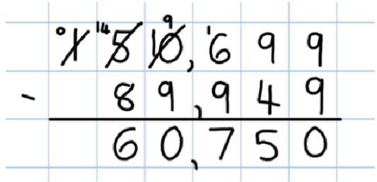  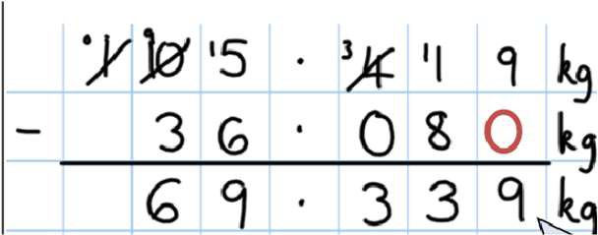
large and more
complex numbers
and decimal values
(up to 3 decimal
place).
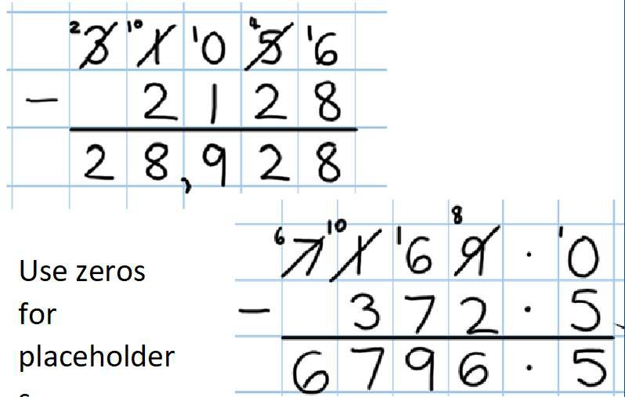

Multiplication - EYFS
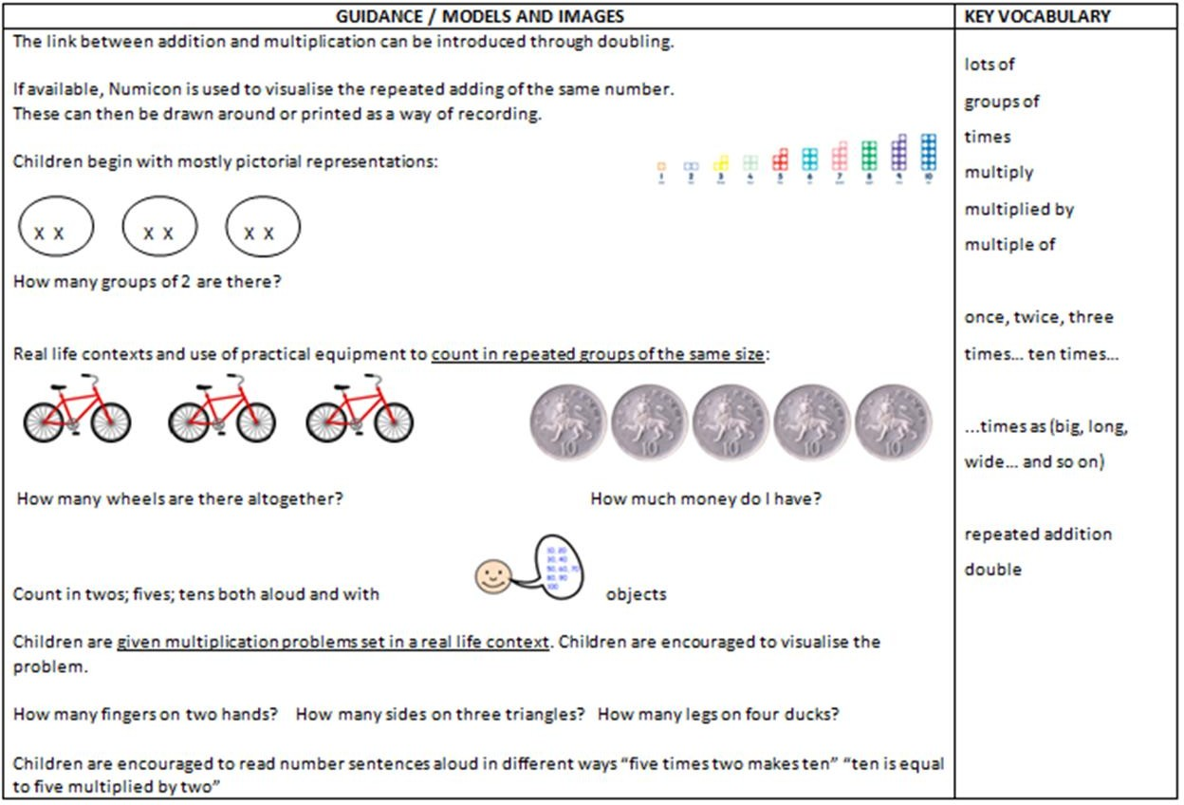
Maths for young children should be meaningful. Where possible, concepts should be taught in the context of real life.

YEAR 1 MULTIPLICATION
Programme of Study specifies the following objectives, however it does not require the explicit teaching of the mathematical symbol of multiplication

Objective / Strategy | Concrete | Pictorial | Abstract
Doubling | Use practical activities using manipultives including cubes and Numicon to demonstrate doubling  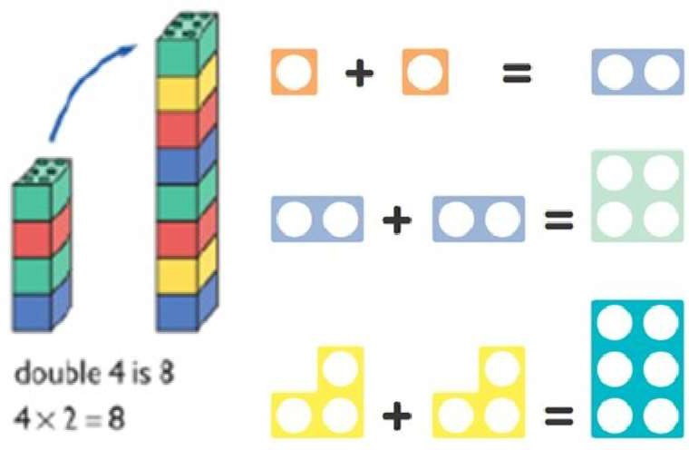 | Draw pictures to show how to double numbers  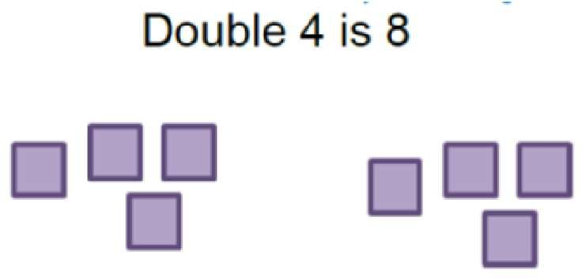 | Partition a number and then double each part before recombining it back together.  + = 32
Counting in multiples  (2s, 5s, 10s) | Count the groups as children are skip  counting, children may use their fingers as they are skip counting. |    | Count in multiples of a number aloud.  Write sequences with multiples of numbers.
 | 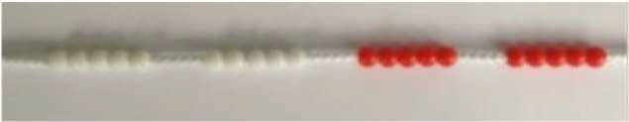 | Children make representations to show counting in multiples.
 | 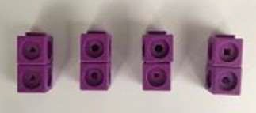 | 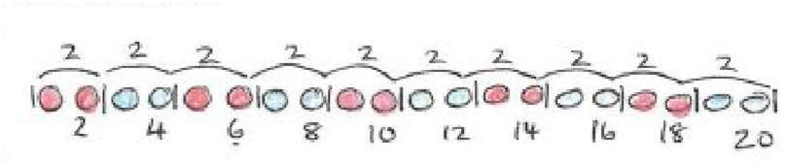 | 2, 4, 6, 8, 10  5, 10, 15, 20, 25 , 30
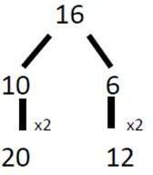

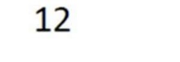


Making equal groups and counting the total | 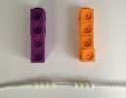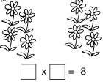  Use manipulatives to create equal groups. | 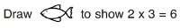  Draw and make representations | 2 x 4 = 8
Repeated addition | 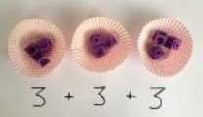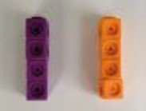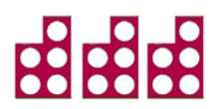  Use different objects to add equal groups | Use pictorial including number lines to solve problems | Write addition sentences to describe objects and pictures.  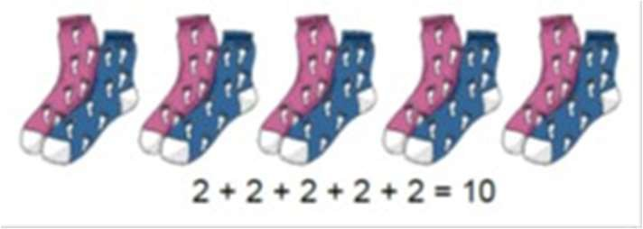
Understanding arrays | Use objects laid out in arrays to find the answers to 2 lots 5, 3 lots of 2 etc.  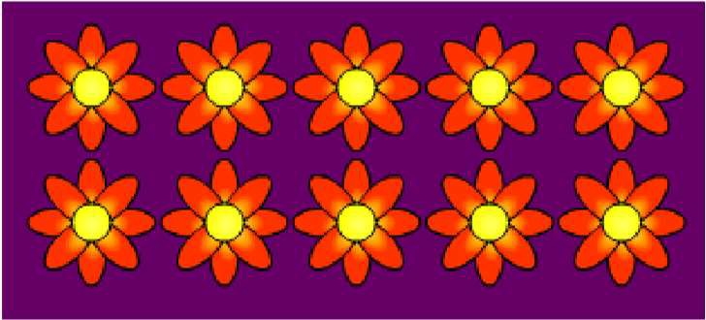 | Draw representations of arrays to show  understanding | 3 x 2 = 6  2 x 5 = 10
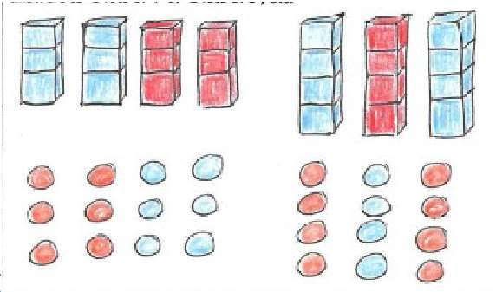

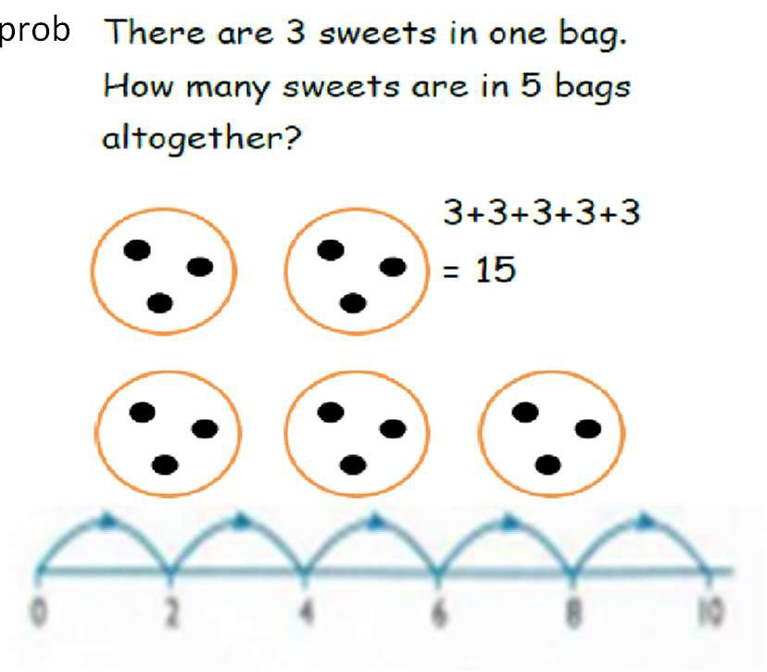

YEAR 2 MULTIPLICATION
Children should be able to recall and use multiplication and division facts for the 2, 5 and 10 times times tables.
Objective / Strategy | Concrete | Pictorial | Abstract
Doubling | Model doubling using dienes and PV counters.  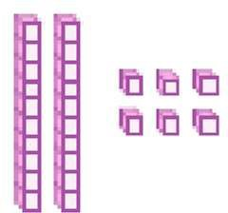  40 + 12 = 52 | Draw pictures and representations to show how to double numbers | Partition a number and then double each part before recombining it back together.  + = 32
Counting in multiples of 2, 3, 4,  5, 10 from 0 (repeated addition) | Count the groups as children are skip counting, children may use their fingers as they are skip counting. Use bar models.  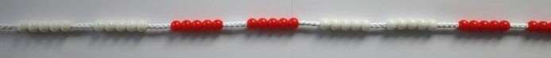  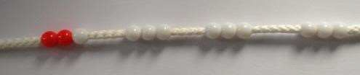  5 + 5 + 5 + 5 + 5 + 5 + 5 + 5 = 40 | Number lines, counting sticks and bar models should be used to show representation of counting in multiples.  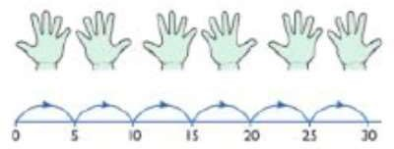  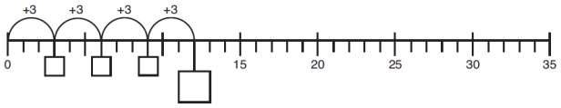 | Count in multiples of a number aloud.  Write sequences with multiples of numbers.  0, 2, 4, 6, 8, 10  0, 3, 6, 9, 12, 15  0, 5, 10, 15, 20, 25 , 30
 | 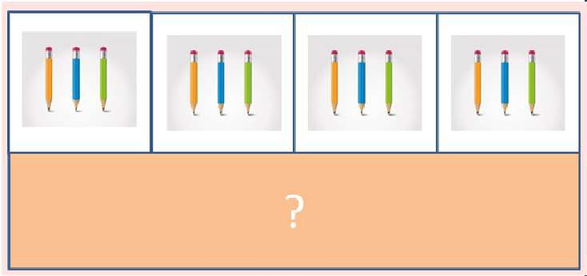 | 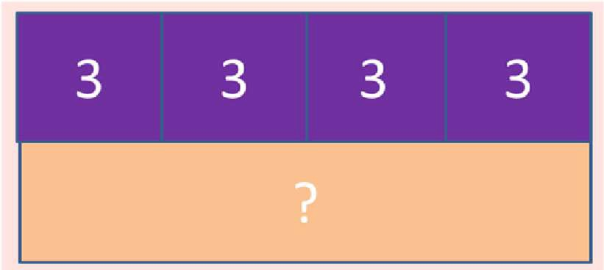 | 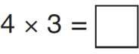
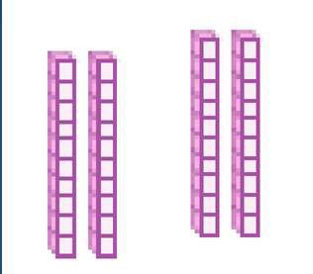
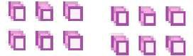

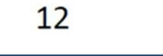


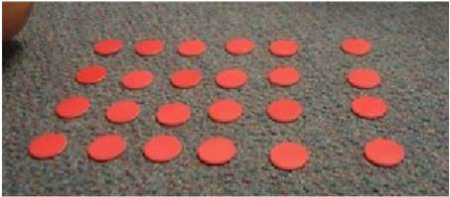
Objective / Strategy | Concrete | Pictorial | Abstract
Multiplication is commutative | Create arrays using counters and cubes and | Use representations of arrays to show different calculations and explore commutativity.  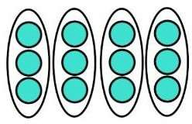  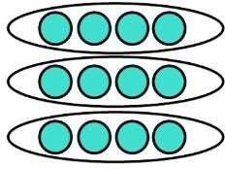 | 12 = 3 × 4 12 = 4 ×  3  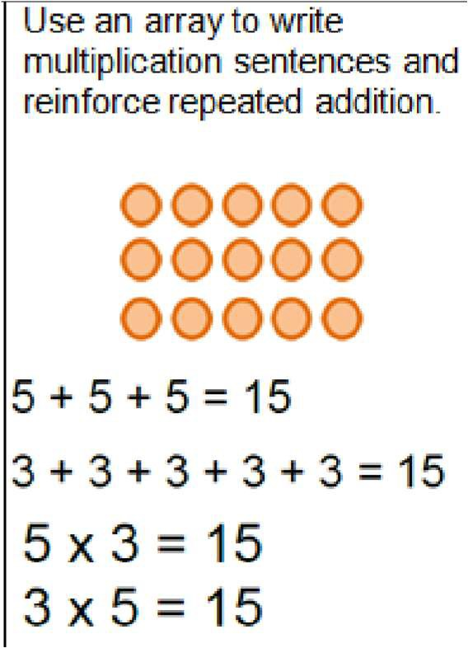
 | Numicon.
 | 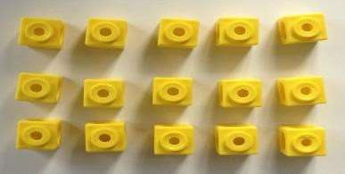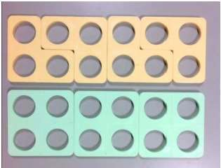
Pupils should understand that an array can
represent different equations and that, as multiplication is commutative, the order of the multiplication does not affect the answer.
 | 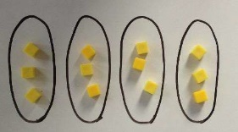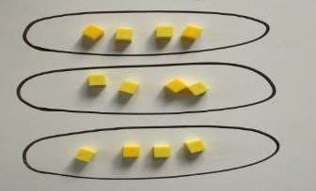
Using the Inverse | 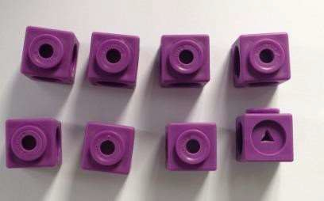 | 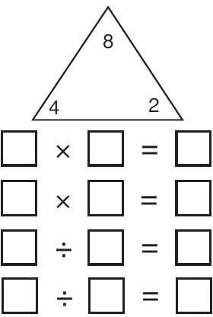 | 2 x 4 = 8
This should be |  |  | 4 x 2 = 8
taught alongside |  |  | 8 ÷ 2 = 4
division, so pupils |  |  | 8 ÷ 4 = 2
learn how they |  |  | 8 = 2 x 4
work alongside  each other. |  |  | 8 = 4 x 2
 |  |  | 2 = 8 ÷ 4
 |  |  | 4 = 8÷ 2
 |  |  | Show all 8 related fact family sentences.

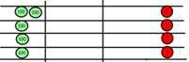
YEAR 3 MULTIPLICATION
Children should be able to recall and use multiplication facts for the 3,4, and 8 times tables
Objective /Strategy | Concrete | Pictorial | Abstract
Grid method, progressing to the formal method | Show the links with arrays to first introduce the grid method. | Children can represent their work with place value counters in a way that they understand.  They can draw the counters using colours to show different amounts or just use the circles in the different columns to show their thinking as shown below.  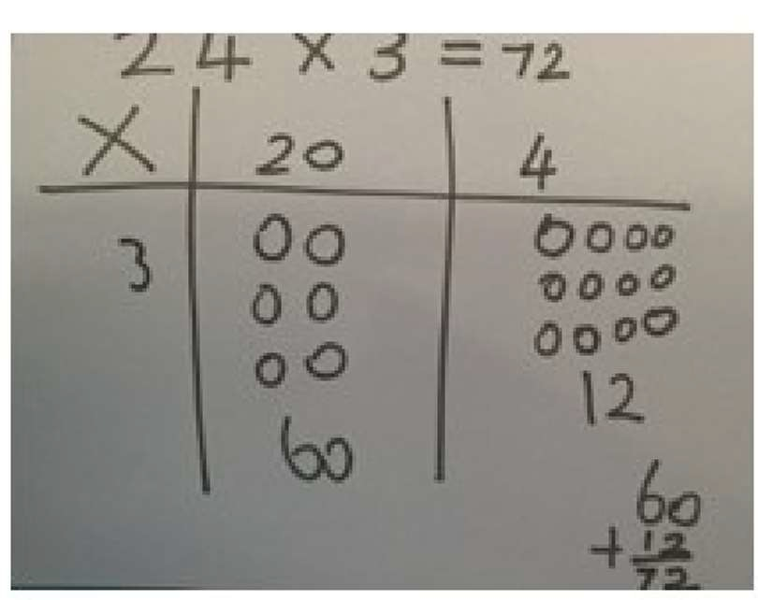  Bar model are used to explore missing numbers  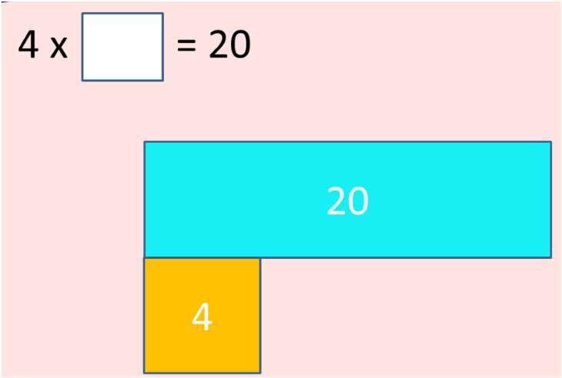 | Start with multiplying by one digit numbers and showing the clear addition alongside the grid.  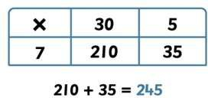  Move forward to the formal written method:  3 5  X 7  2 4 5  3
Multiply 2 digit numbers by 1 digit numbers | 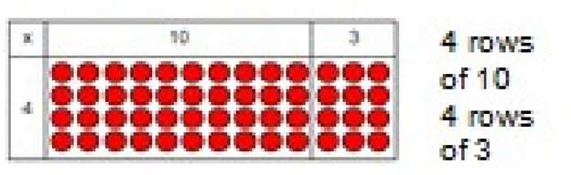  Move onto base ten to move towards a more compact method.  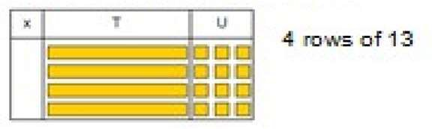
Move on to place value counters to show how
we are finding groups of a number. We are multiplying by 4 so we need 4 rows
 | 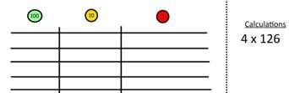
 | 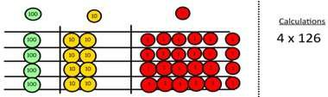
Fill each row with 126.
Add up each column, starting with the ones making any exchanges needed
Then you have your answer.
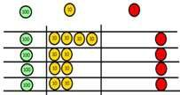

Solve problems, including missing number problems, integer scaling problems, |  |  | Three times as high, eight times as long  ? x 5 = 20  20 ÷ ? = 5  3 hats and 4 coats, how many different outfits?

YEARS 4 – 6 Multiplication
Objective /Strategy | Concrete | Pictorial | Abstract
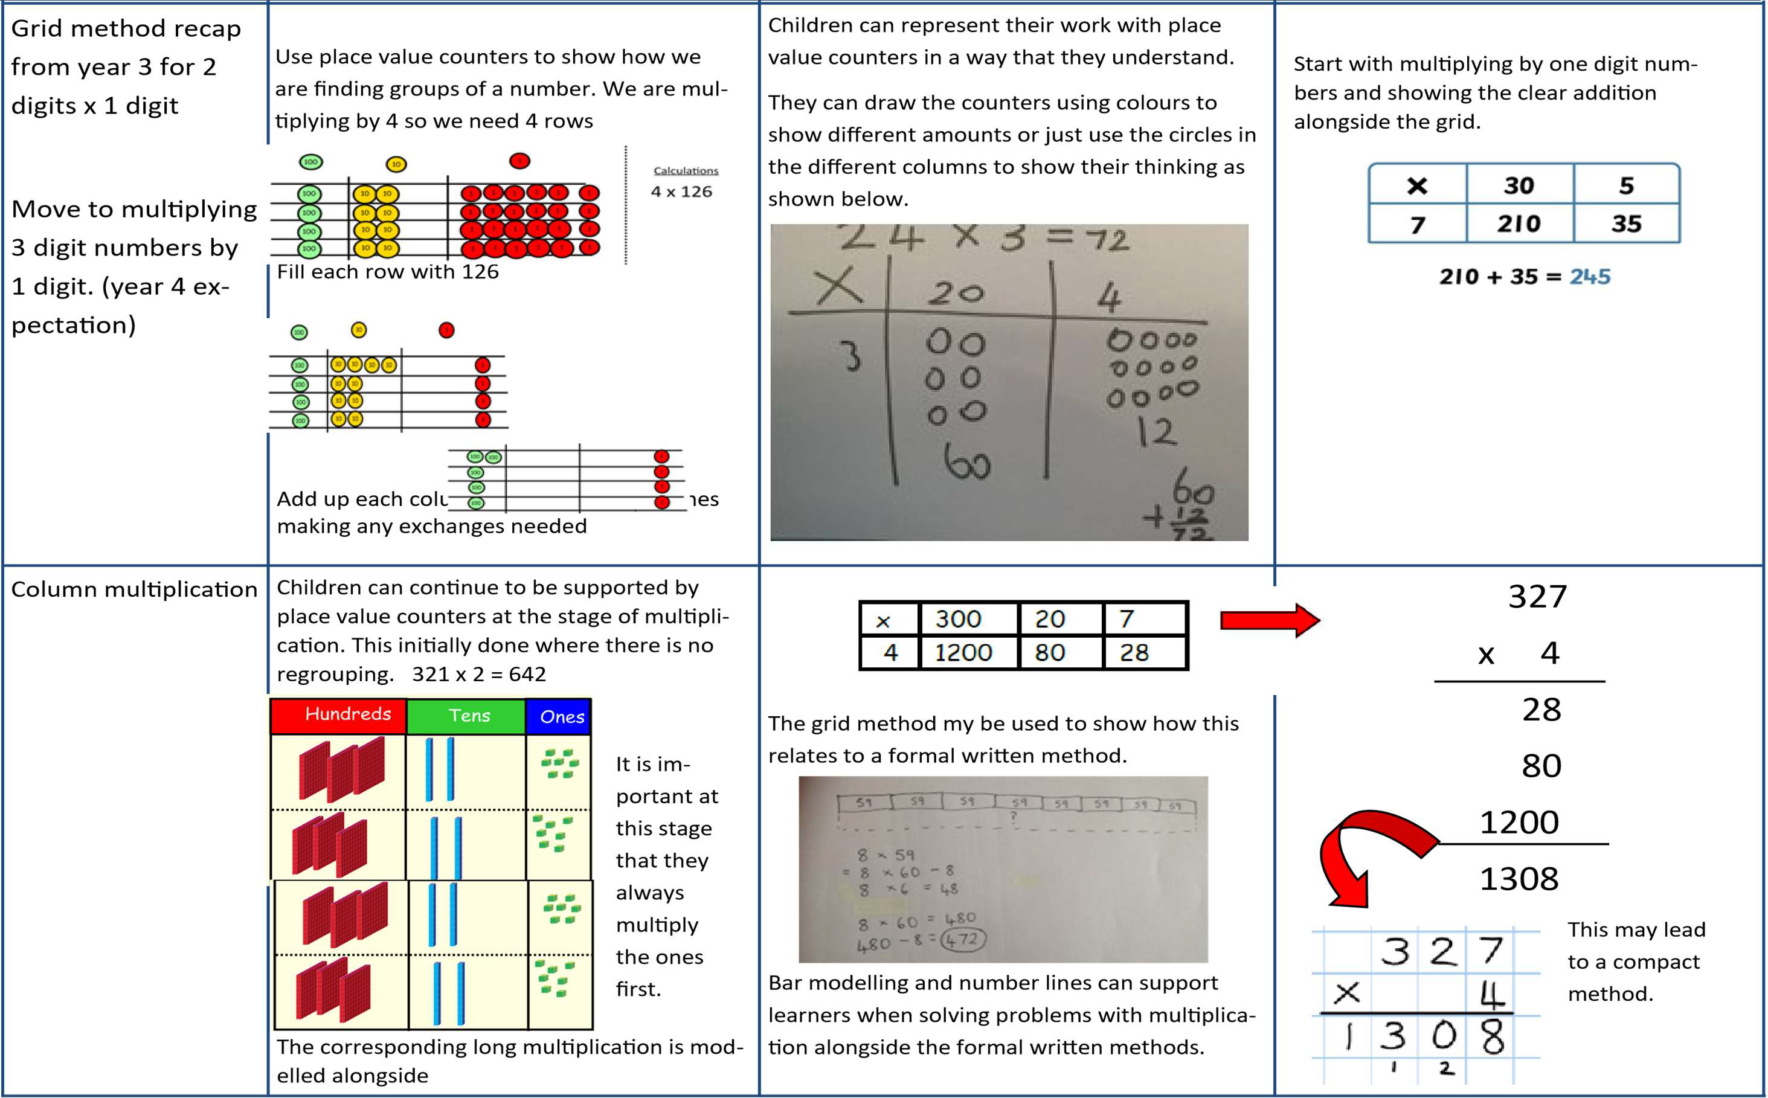

Objective /Strategy | Concrete | Pictorial | Abstract
Column Multiplication for 3 and 4 digits x 1 digit. | 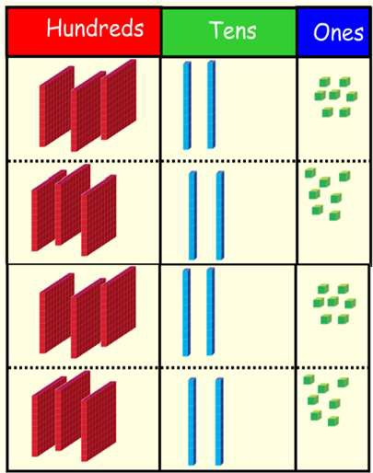 | 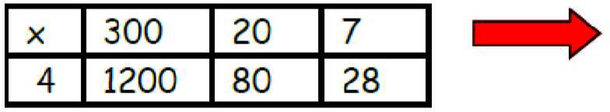 | 327  x 4  28  80  120  1308
 | It is important at this stage that they always Multiply the ones first.  Children can continue to be |  | 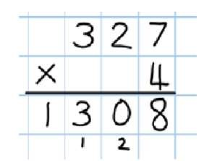
 | supported by place value
 | counters at the stage of
 | multiplication. This initially
 | done where there is no
 | regrouping. 321 x 2 = 642
Column multiplication | Manipulatives may still be used with the corresponding long multiplication modelled alongside. | Continue to use bar modelling to support problem solving | 18 x 3 on the first row  (8 x 3 =24, carrying  the 2 for 20, then 1  x 3)  18 x 10 on the 2nd row. Show  multiplyi  ng by 10 by putting zero in units first



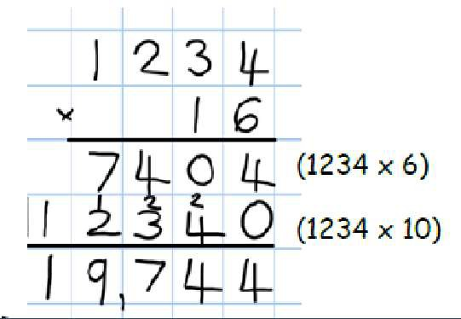
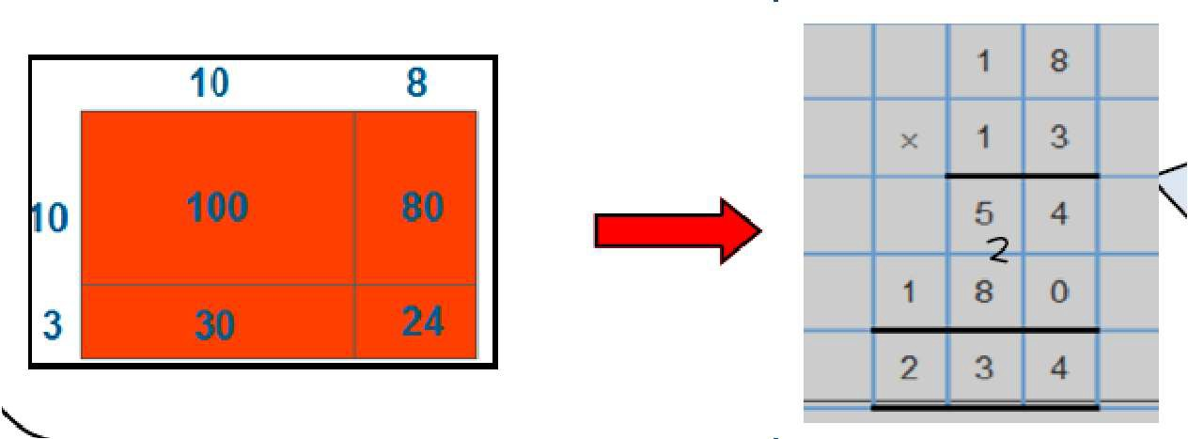
0

 |  | Pictorial
Objective/Strategy | Concrete |  | Abstract
Multiplying decimals up to 2 decimal places by a single digit. |  |  | Remind children that the single digit belongs in the units column. Line up the decimal points in the question and the answer.  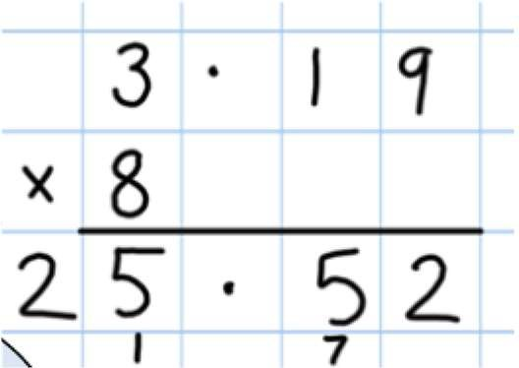

Division and fractions - EYFS
Maths for young children should be meaningful. Where possible, concepts should be taught in the context of real life.

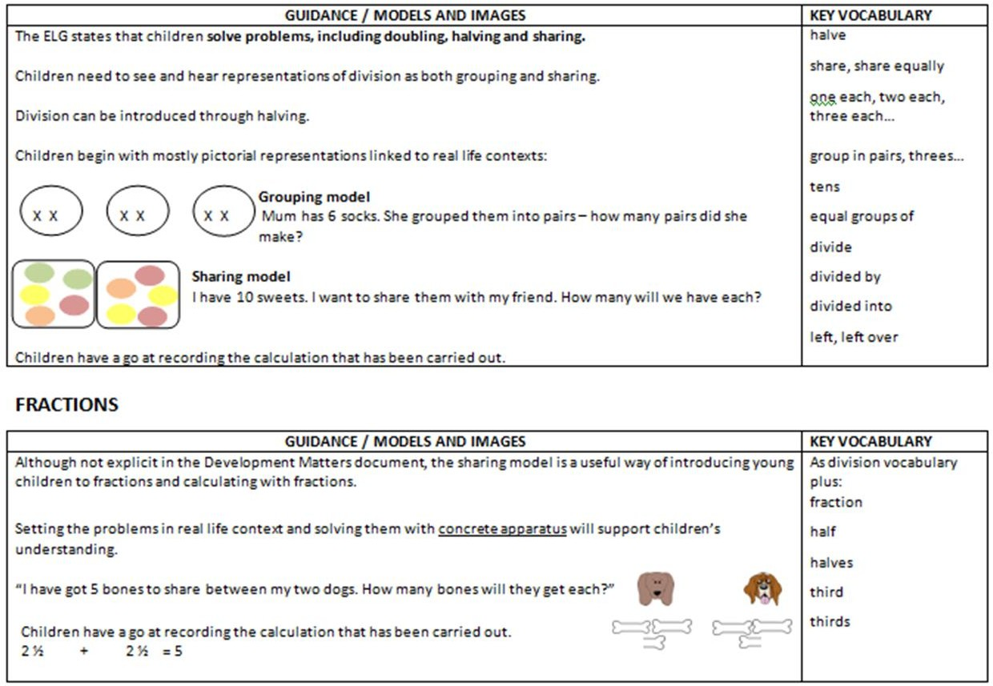

YEAR 1
Objective /Strategy | Concrete | Pictorial | Abstract












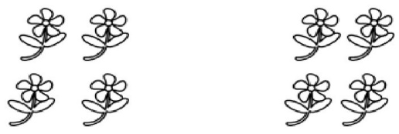


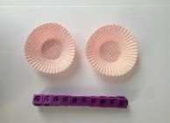
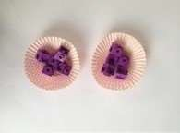
4

Objective/ Strategy | Concrete | Pictorial | Abstract
Division as sharing  Use Gordon ITPs for modelling | 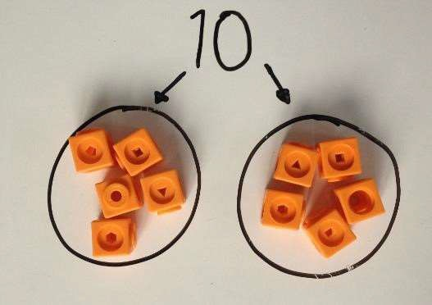  I have 10 cubes, can you share them equally in 2 groups? | Children use pictures or shapes to share quanti- ties.  8 shared between 2 is  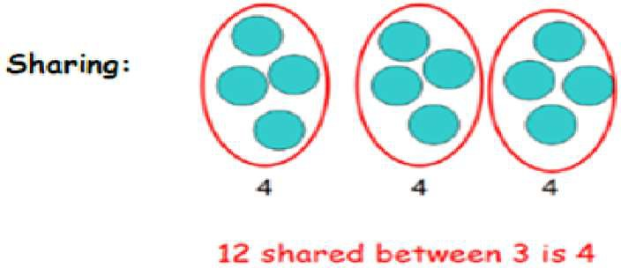 | 12 shared between 3 is  4

Objective/Strategy | Concrete | Pictorial | Abstract
Division as sharing | 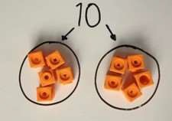  I have 10 cubes, can you share them equally in 2 groups? | Children use pictures or shapes to share quantities.  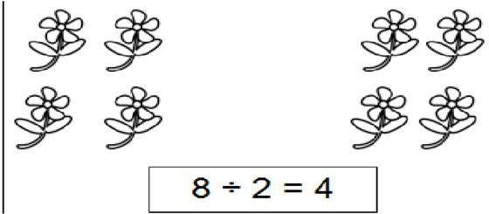  Children use bar modelling to show and support understanding.  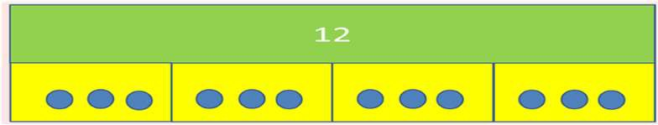  12 ÷ 4 = 3 | 12 ÷ 3 = 4
Division as grouping | Divide quantities into equal groups.  Use cubes, counters, objects or place value counters to aid understanding.  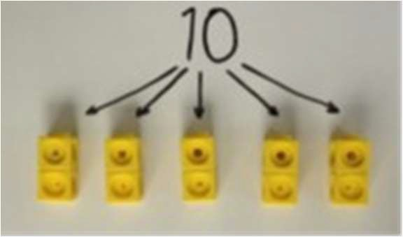  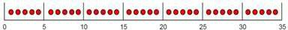 | Use number lines for grouping  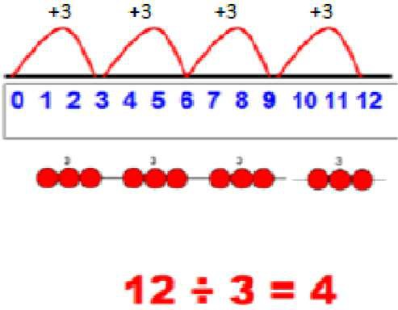  Think of the bar as a whole. Split it into the number of groups you are dividing by and work out how many would be within each group.  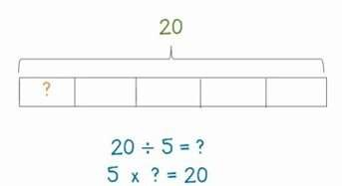 | 28 ÷ 7 = 4  Divide 28 into 7 groups. How many are in each group?

YEAR 2
Objective/Strategy | Concrete | Pictorial | Abstract
Division as grouping | Use cubes, counters, objects or place value counters to aid understanding.  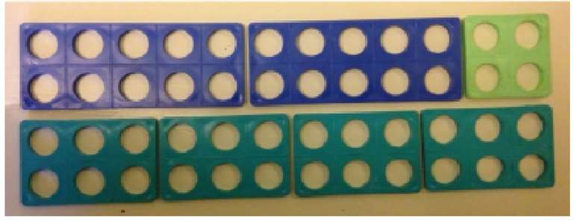  24 divided into groups of 6 = 4  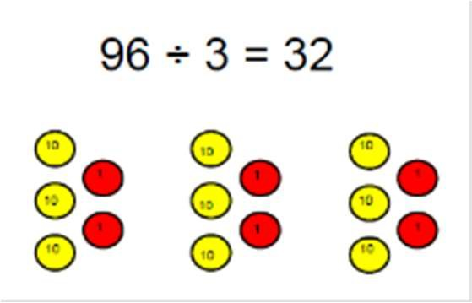 | Continue to use bar modelling to aid solving division problems. | How many groups of 6 in 24?  24 ÷ 6 = 4
Division with arrays | 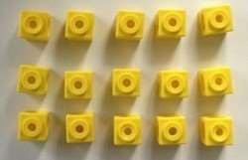  Link division to multiplication by creating an array and thinking about the number sentences that can be created.  Eg 15 ÷ 3 = 5 5 x 3 = 15  15 ÷ 5 = 3 3 x 5 = 15 | Draw an array and use lines to split the array | Find the inverse of multiplication and
 |  | into groups to make multiplication and division | division sentences by creating eight linking
 |  | sentences | number sentences. 7 x 4 = 28
 |  | 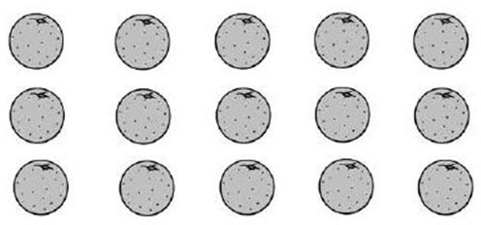 | 4 x 7 = 28  28 ÷ 7 = 4  28 ÷ 4 = 7  28 = 7 x 4  28 = 4 x 7
 |  |  | 4 = 28 ÷ 7
 |  |  | 7 = 28 ÷ 4

YEAR 3 (Greater Depth Y2)
Objective/Strategy | Concrete | Pictorial | Abstract
Division with remainders. | 14 ÷ 3 =  Divide objects between groups and see how much is left over  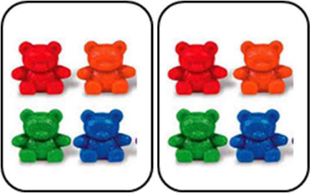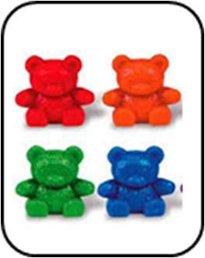  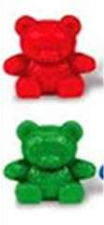 | Jump forward in equal jumps on a number line then see how many more you need to jump to find a remainder.  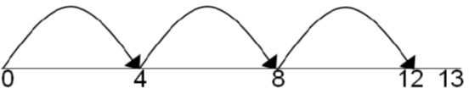  Draw dots and group them to divide an amount and clearly show a remainder.  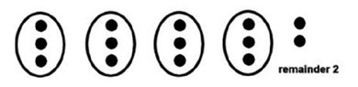  Use bar models to show division with remainders.  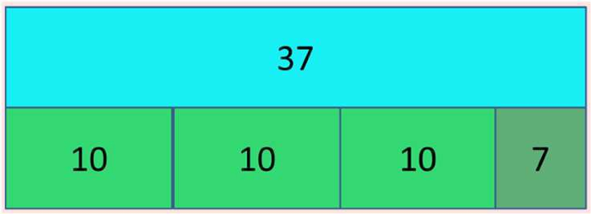  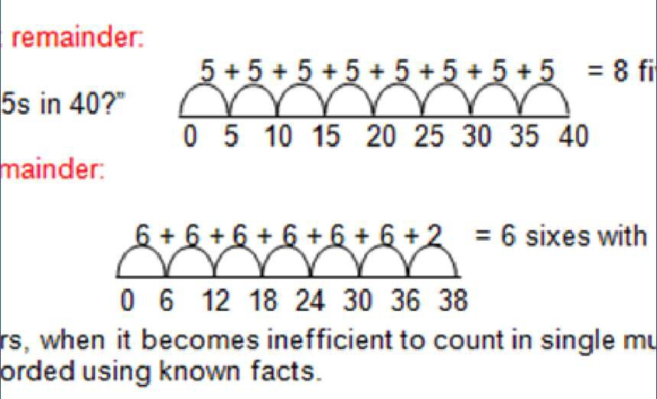 | Complete written divisions and show the remainder using r.  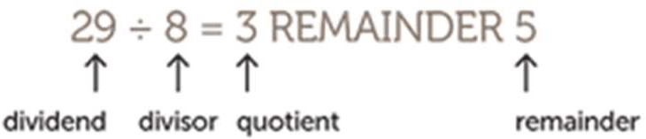

Year 4-6
Objective/Strategy | Concrete | Pictorial | Abstract
Divide at least 3 digit numbers by 1 digit.  Short Division | 96 ÷ 3  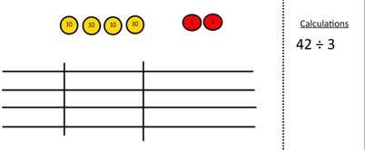  Use place value counters to divide using the bus stop method alongside  42 ÷ 3=  Start with the biggest place value, we are sharing 40 into three groups. We can put 1 ten in each group and we have 1 ten left over.  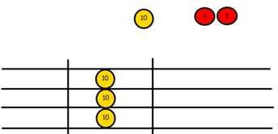  We exchange this ten for ten ones and then share the ones equally among the groups.  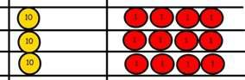  We look how much in 1 group so the answer is 14. | Students can continue to use drawn diagrams with dots or circles to help them divide numbers into equal groups.  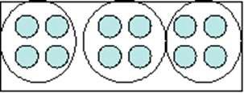  Encourage them to move towards counting in multiples to divide more efficiently. | Begin with divisions that divide equally with no remainder.  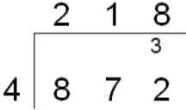  Move onto divisions with a remainder.  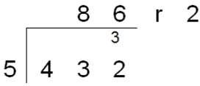  Finally move into decimal places to divide the total accurately.  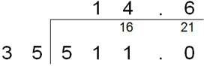  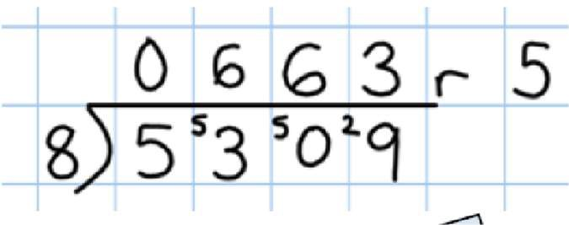
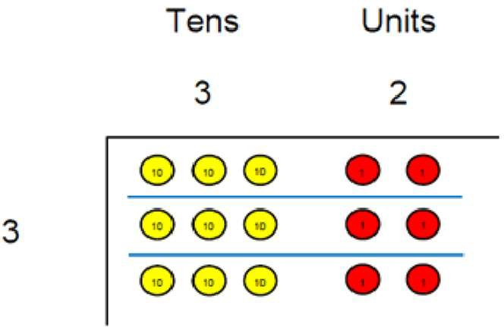


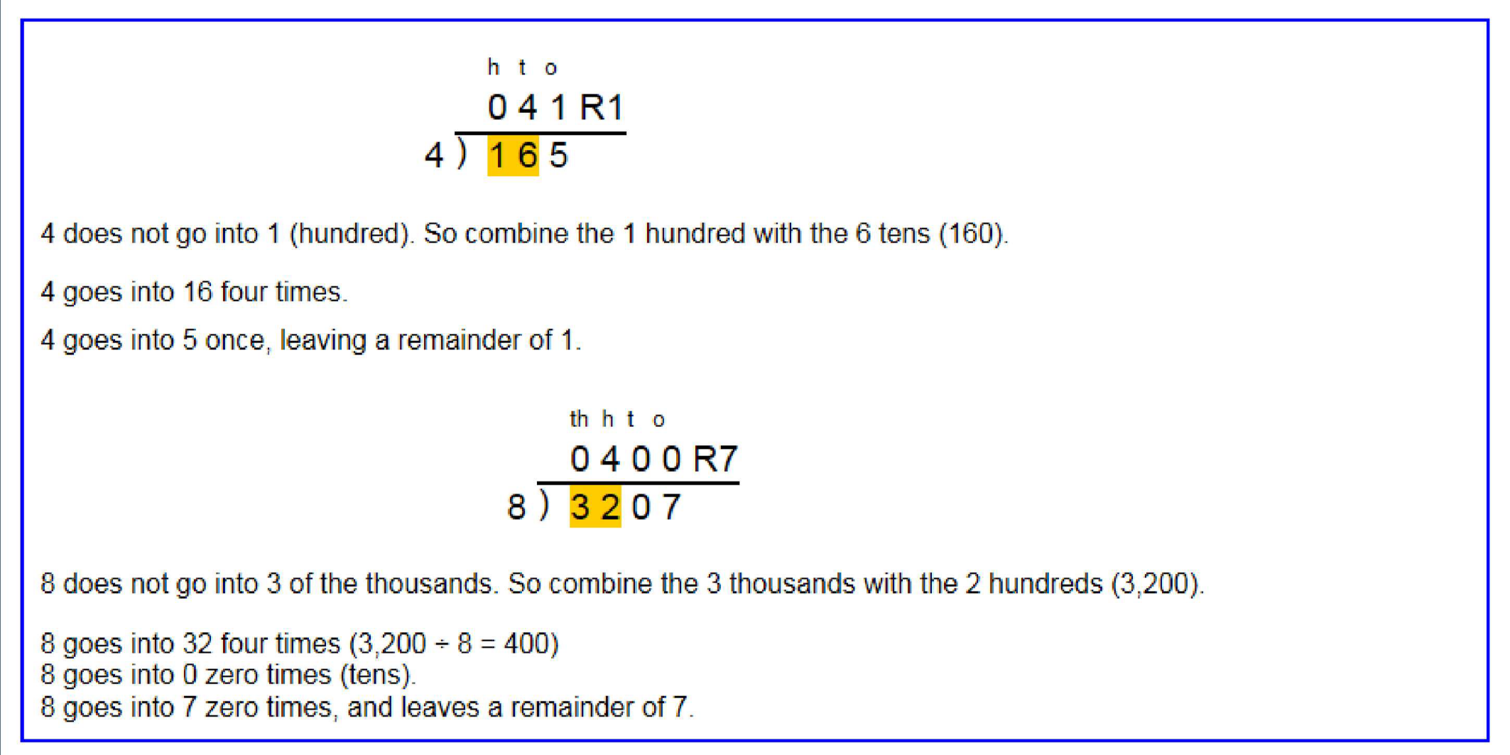

Long Division

Step 1—a remainder in the ones

Long Division
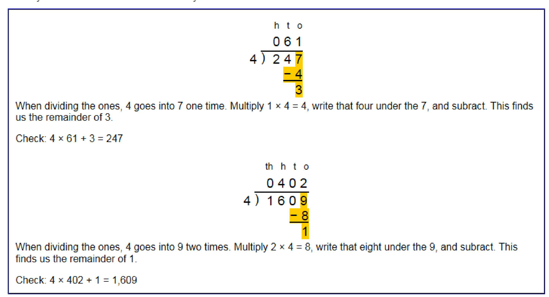
Step 1 continued...

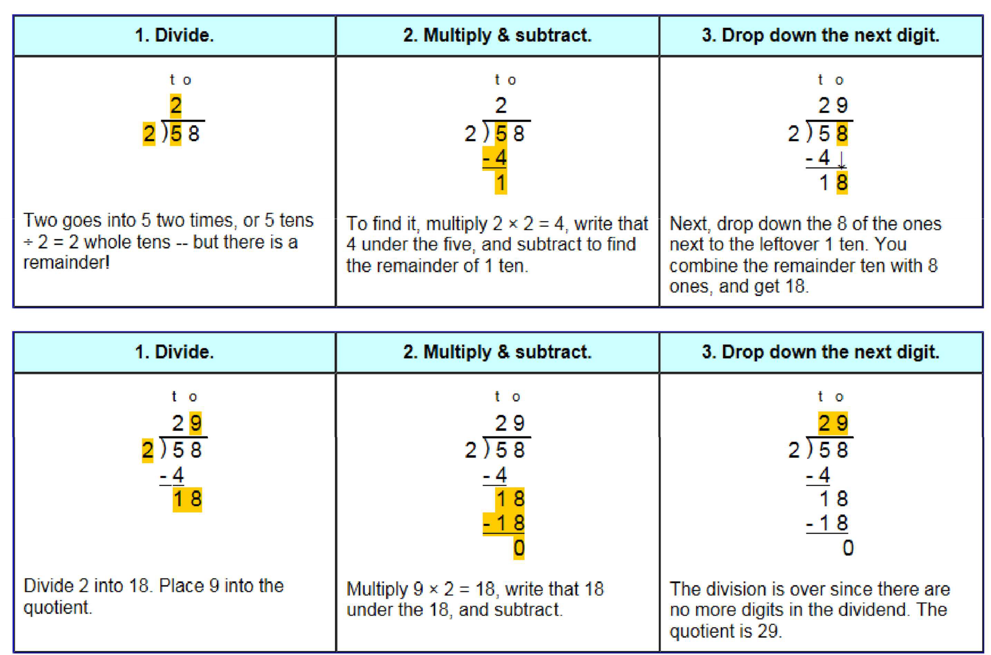

Long Division

Step 2—a remainder in the tens

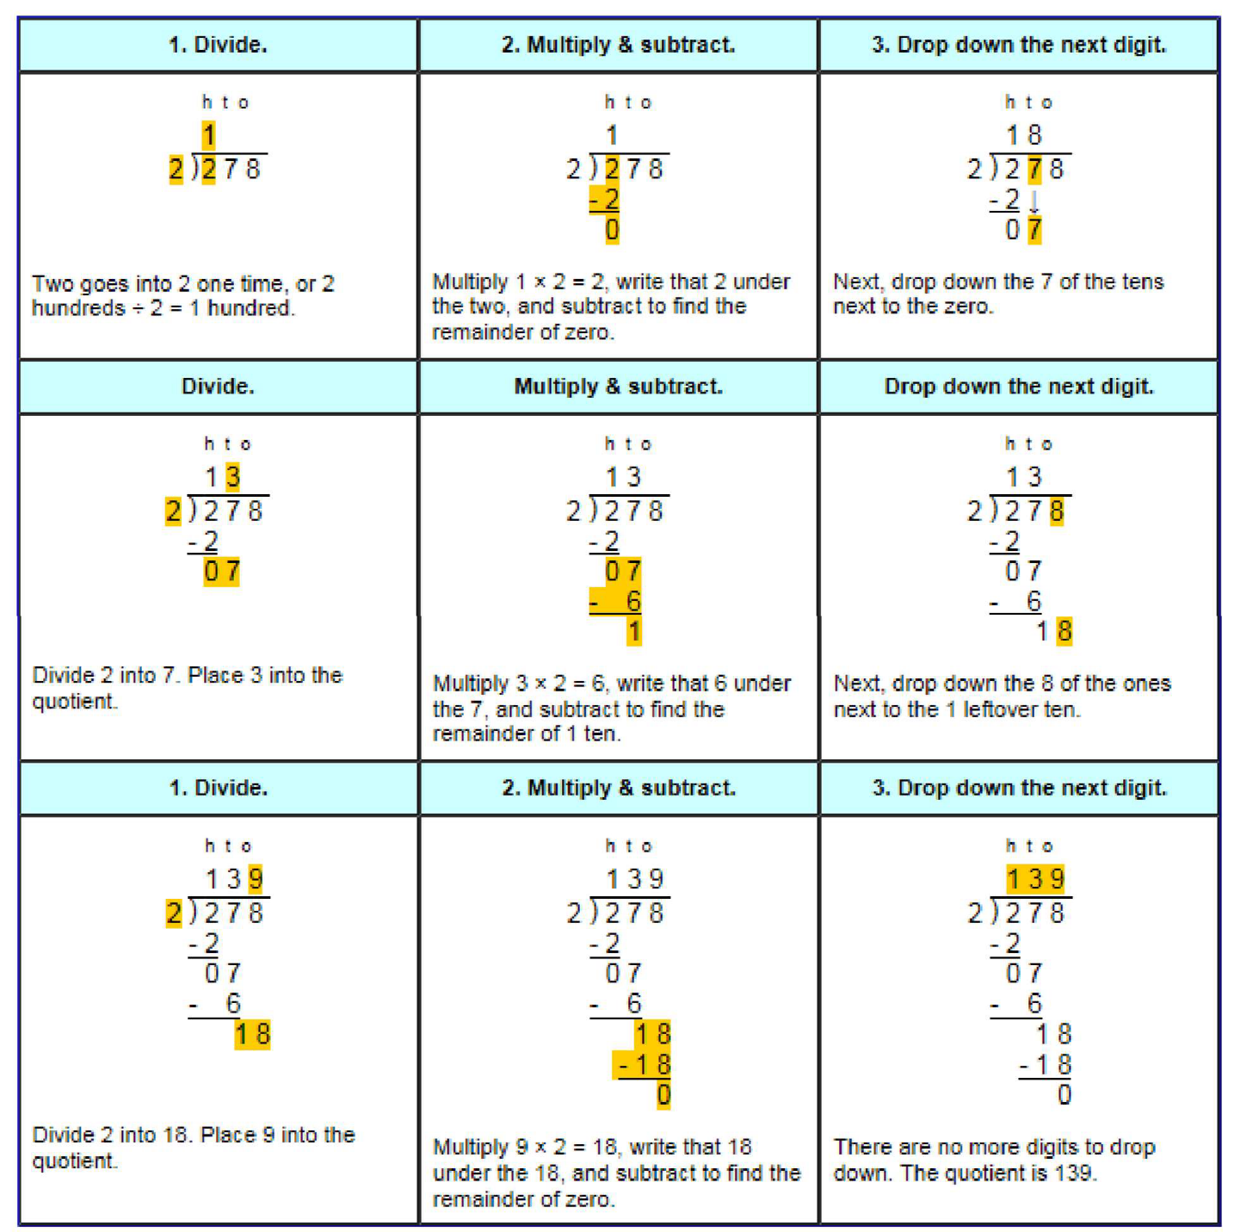

Long Division

Step 2—a remainder in any of the place values

