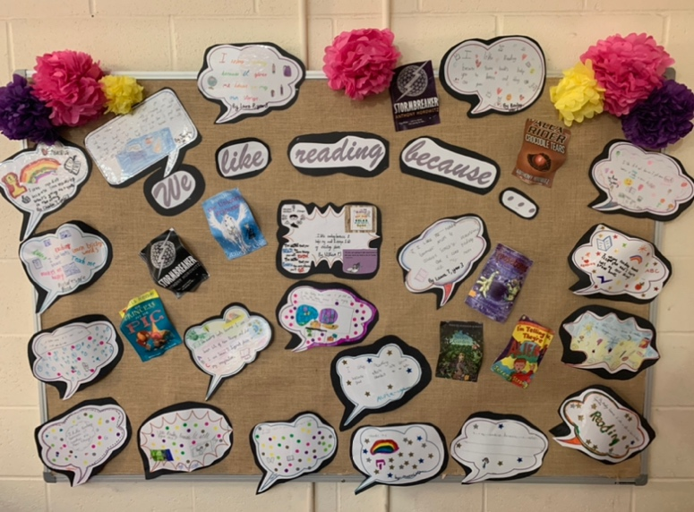
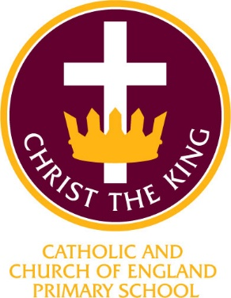

Christ the King Catholic and Church of England Curriculum Policy

Phonics

I have come that they may have life and have it to the full (John10:10)

CURRICULUM AIMS
At Christ the King, we shape our curriculum so that all pupils are provided with high quality teaching and learning, with Jesus Christ at the centre of all we do. We aim to inspire our learners to feel empowered and able to become responsible citizens in the community and the wider world, whilst motivating them to aspire and achieve the highest standard.
We aim to
- provide a Christian education based on the life and teaching of Jesus Christ, in which the Gospel values underpin all aspects of school life
- embed our core Christian values at the heart of our curriculum
- provide a nurturing environment in which the dignity of each person as a child of God is recognised and developed; and to promote the full potential of each child through a curriculum which develops spiritual, academic, creative, social and emotional growth
- provide a curriculum which is enriching and challenging, where pupils experience the opportunity to learn in a wide range of contexts.

Creativity

Hope

Respect and Reverence

Forgiveness
Wisdom
Perseverance

At Christ the King, our aims are to fulfil the requirements of the National Curriculum for phonics; providing a broad, balanced and differentiated curriculum; ensuring the progressive development of knowledge, skills and vocabulary and for our children to develop as confident readers.

CHRIST THE KING PHONICS INTENT
At Christ the King Catholic and Church of England Primary School, we are passionate about ensuring all children become confident and enthusiastic readers and writers. We believe that phonics provides the foundations of learning to make the development into fluent reading and writing easier. Through phonics, children learn to segment words to support their spelling ability and blend sounds to read words. The teaching of phonics is of high priority.

In phonics, pupils are taught to apply phonic knowledge and skills as the route to decode words. Through daily teaching, they learn to respond speedily with the correct sound to graphemes (letters), including where applicable alternative sounds for graphemes. Children develop confidence to enjoy and be able to read aloud accurately books that are consistent with their phonic knowledge and that do not require them to use other strategies to work out words. Children are given opportunities to re-read these books to build up their fluency and confidence in word reading.

The aims of teaching phonics at Christ the King are
- to teach the children to recognise all 44 sounds in the English language
- to learn to read words by blending the sounds together
- to develop an enjoyment of reading through fiction and non-fiction texts
- to enable children to access all areas of the curriculum
- to learn how to form all letters correctly
- to develop essential listening skills
- to build oracy and fluency
- to develop a wide range of vocabulary
- for ALL children to experience success in reading

IMPLEMENTATION

At Christ the King, phonics is taught from Reception to year 2.. Where appropriate, children have further phonics teaching to ensure they have a secure grasp of the necessary knowledge and skills to access to our English curriculum – ‘Pathways to Write’ and ‘Pathways to Read’. Our teaching of phonics is delivered through the Ruth Miskin Read, Write Inc. Phonics Scheme. Teaching is delivered by a number of reading teachers who have all been trained to teach this scheme.


The scheme has been created to ensure children are taught phonics in a creative and lively way and is carefully structured through progressive sets of sounds. There are 5 core principles to teaching and learning in this way. These are
- know the PURPOSE of every activity and share it with the children so children know the one thing they should be thinking about
- to be PASSIONATE about teaching so children are engaged emotionally
- teach at an effective PACE and devote every moment to teaching and learning
- to ensure that every child PARTICIPATES throughout the lesson. Partner work is fundamental to learning
- PRAISE effort and progress, not ability

Children learn to compose their ideas step by step. A variety of teaching approaches are used including ‘Fred Talk’, ‘Questions to Talk About’, ‘Jump In’ ‘Talk to Your Partner’ and Partner Practice’.

To ensure high standards of teaching and learning in phonics, we implement a curriculum that is progressive. Phonics is taught in daily, discrete lessons starting in the Autumn term in Reception, with short 10minute sessions building up to 30 minute sessions by the Summer term.. Other year groups have a 45minute phonic lesson which includes a speed sound lesson, spelling, handwriting and reading practice.

Children’s starting points are assessed and they are then grouped according to their phonic knowledge. This ensures that the teaching is matched correctly to their stage of learning. It is vital that any language barriers should not impede a pupil’s phonic learning so simple and enjoyable mnemonics are used to help all children grasp the letter-sound correspondences quickly, especially those who are new to English or at risk of making slower progress. At Christ the King, the interaction between the teacher and the pupil is vital to effective learning and the design of future learning experiences. Reading teachers are skilled at modelling the knowledge and skills being taught and use a variety of silent and praise signals to ensure that the teaching pace is maintained.

The phonics curriculum is based upon the 2014 Primary National Curriculum in England, which provides a broad framework and outlines the knowledge and skills taught in each Key Stage.

Reading teachers deliver carefully planned and structured lessons for their group at the relevant stage of the RWInc scheme. This ensures that knowledge and skills are taught progressively from one group to the next. Ongoing assessment means that groups are constantly adjusted to ensure the best progress for each child.

Children rapidly learn sounds and the letter or groups of letters they need to represent them during speed sound lessons. These are taught alongside a scripted mnemonic which aids the children to remember them and form letters correctly.
The regular and rigorous assessments ensure that all children are in the perfect group for them so learning is matched closely to needs meaning those who need more support receive it and those who are accelerating quickly, move on.

At Christ the King, we ensure that the teaching of phonics is consistently taught and delivered in order that children progress quickly, routines are embedded, and children are able to move seamlessly between groups.

ASSESSMENT

At Christ the King, we believe that accurate assessment is critical to ensuring pupils make the best reading progress. Children are therefore assessed on a 1:1 basis by the reading lead to maintain a consistent approach. Children’s starting points are assessed on entry to school or at half-termly assessment points. These assessments are against
- the sounds they have been learning
- the blending of the sounds
- reading nonsense words
- fluency – the speed at which the children are able to read accurately

ALL children who are taught phonics at Christ the King are then entered onto the Ruth Miskin assessment grid.
Children are then grouped based on the outcomes of this assessment for the next half-term. Reading teachers collaborate regularly with the Reading Lead so that progress is monitored and teaching continues to match the needs of the pupils.
The Reading lead analyses the data and identifies any children who are not making expected progress. Appropriate strategies are put into place where needed e.g 1:1 tutoring or additional sound lessons are timetabled.

At Christ the King, we are committed to engaging with parents and carers and believe that they should be actively involved in their child’s learning. To this end, parents are strongly encouraged to attend a Reading Session as their child enters Reception. This is to share the approaches used and how they can support at home. We believe in empowering parents, so we all work together to achieve the best outcomes for the children. As soon as the children are able to blend words, they take a Sound Blending book home to share. Once they are able to read sentences, they take home a book linked to their phonic stage.

EARLY YEARS
High quality Early Years teaching is key to building the foundations needed for school life and beyond. Developing secure phonic knowledge and skills is fundamental to successful reading. Prior to being taught these, children will be provided with many opportunities in the Foundation Stage to rhyme and enjoy hearing and making sounds. Teachers use a variety of games to allow children to become familiar with the teaching strategies they will encounter when they are ready for formal phonics.

INCLUSION
All children receive Quality First Teaching. Any children identified with SEND or in receipt of pupil premium funding may have work additional to and different from their peers in order to access the curriculum dependent upon their needs. In addition, our school offers a vibrant, interesting and varied curriculum, providing all our pupils with a range of opportunities in order for them to reach their full potential, enjoy and achieve regardless of their starting points.

IMPACT

At Christ the King, we are committed to high standards of phonics teaching and are proud of the impact that our teaching of phonics and the Read, Write Inc Programme has had on children’s development in reading. Our children enjoy their phonics sessions and the progress they make as a result. We strive to create a supportive and collaborative ethos for learning by providing opportunities for pupils to learn from their mistakes and each other. There are lots of opportunities through the sessions for self-assessment, peer assessment and partner reading. Successes are feedback to the children and celebrated immediately by the whole group through praise strategies which are fun and engaging but do not interrupt the flow of learning. These are consistent across all reading teachers.

We measure the impact of our phonics teaching in other ways too.
- Marking of work in books
- Using dialogic learning tasks to assess children’s understanding
- Summative assessment
- Interviewing the pupils about their learning (pupil voice)
- Formal reporting of standards in the Y1 Phonics Check
- Annual reporting of standards to parents
- Reports to Governors
- Regular learning walks
- Continued support from Read, Write inc consultant

The Reading Lead will continually monitor the impact phonics teaching is having on the pupil’s learning through scrutinising books to ensure the progress of knowledge and skills is being taught. They will also ensure the knowledge taught is retained by the pupils, continually revisited and that the learners are able to apply the skills they have been taught in their reading, demonstrating independence with their learning. Impact is also monitored through half-termly assessments which are undertaken by the reading lead.

CONTINUING PROFESSIONAL DEVELOPMENT
CPD for staff is ongoing through staff meetings, reading teacher time and the use of the ‘Pathways’ virtual classroom. All staff are regularly updated with any changes to the scheme and have close contact with the reading lead.. The reading lead has, planned coaching sessions with reading teachers to ensure that teaching continues to be of a high standard. There is regular professional dialogue about the teaching and learning of reading and all staff are keen to develop and enhance their teaching. This might be through formally planned Professional Development Meetings, professional conversations, shared planning sessions or use of the Virtual Classroom.

