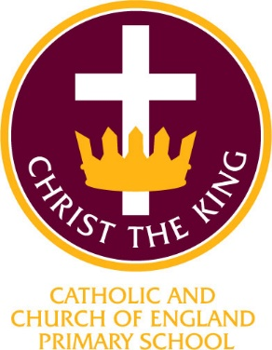
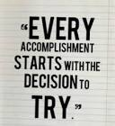

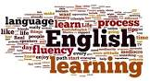

Christ the King Catholic and Church of England Curriculum Policy

English

I have come that they may have life and have it to the full (John10:10)

CURRICULUM AIMS
At Christ the King, we shape our curriculum so that all pupils are provided with high quality teaching and learning, with Jesus Christ at the centre of all we do. We aim to inspire our learners to feel empowered and able to become responsible citizens in the community and the wider world, whilst motivating them to aspire and achieve the highest standard.
We aim to
- provide a Christian education based on the life and teaching of Jesus Christ, in which the Gospel values underpin all aspects of school life
- embed our core Christian values at the heart of our curriculum
- provide a nurturing environment in which the dignity of each person as a child of God is recognised and developed; and to promote the full potential of each child through a curriculum which develops spiritual, academic, creative, social and emotional growth
- provide a curriculum which is enriching and challenging, where pupils experience the opportunity to learn in a wide range of contexts.
Creativity
Hope

Respect and Reverence

Wisdom
Forgiveness
Perseverance
INTENT

At Christ the King, our aims are to fulfil the requirements of the National Curriculum for English; providing a broad, balanced and differentiated curriculum; ensuring the progressive development of knowledge, skills and vocabulary and for our children to develop a love of Reading and Writing.
At Christ the King we believe that a quality English curriculum should develop children’s love of reading, writing and discussion. One of our priorities is helping children read and develop their all-important comprehension skills. We recognise the importance of nurturing a culture where children take pride in their writing, can write clearly and accurately and adapt their language and style for a range of contexts. We want to inspire children to be confident in the art of speaking and listening and who can use discussion to communicate and further their learning. We know that children need to develop a secure knowledge-base in English, which follows a clear pathway of progression as they advance through the primary curriculum. English skills are crucial to a high quality education and will give our children the tools they need to participate fully as a member of society.

This includes the lessons they complete in their classrooms, outdoor learning experiences and an integrated plan of enrichment experiences they are offered such as educational and residential visits, visitors and theme days.

The aims of teaching English at Christ the King are:

To develop pupils’ spoken language, reading, writing and vocabulary as integral aspects of the teaching of every subject. English is both a subject in its own right and the medium for teaching; for pupils, understanding the language provides access to the whole curriculum. Fluency in the English language is an essential foundation for success in all subjects.
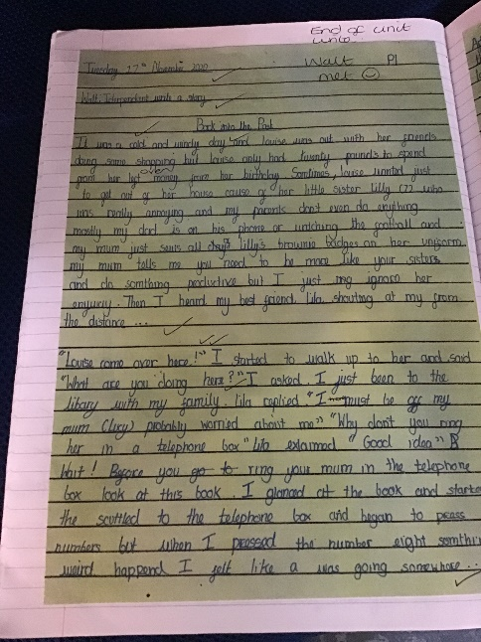
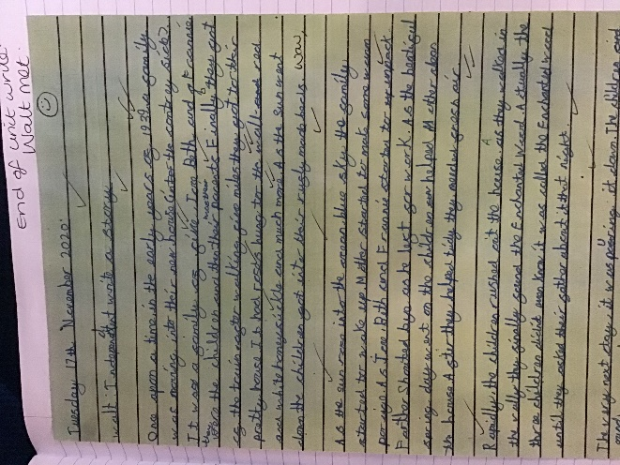

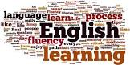

IMPLEMENTATION

At CTK Primary School, the Catholic faith underpins every aspect of the curriculum and is at the centre of our learning. Children are actively encouraged to ‘Live life to the full’.
It is our intent at CTK Primary school to provide pupils with a high-quality education in English that teaches pupils to speak and write fluently so that they can communicate their ideas and emotions to others, and through their reading and listening, others can communicate with them. Through reading in particular, pupils have a chance to develop culturally, emotionally, intellectually, socially and spiritually.
At CTK, English is a crucial part of our curriculum. All children from Foundation Stage to Year 6 are provided with many opportunities to develop and apply their English skills right across the curriculum.
The overarching aim for English in the national curriculum is to promote high standards of language and literacy by equipping pupils with a strong command of the spoken and written language, and to develop their love of literature through widespread reading for enjoyment.
Writing at CTK
We plan our English writing curriculum through Pathways to Write, which uses a text-based learning approach- all texts are current and up to date. Through this, various genres of writing are taught whilst taking into account all ability levels, learning styles, disadvantaged pupils and those with EAL. Pupils are expected to write clearly, accurately and coherently, adapting their language and style in and for a range of contexts, purposes and audiences. The process of the writing journey is clear to see- this consists of children collecting ideas, composing, drafting, and rereading to check their meaning is clear.
Grammar and punctuation skills are taught through writing and the exploration of texts read. Key vocabulary along with common exception words are displayed and children are encouraged to use a high level and rich variety of language within their writing. Pathways to Write ensures coverage and progression of skills providing opportunities to link to other subject areas.
Skills are assessed at the end of each unit against the feature and mastery keys. Feedback is provided using the keys as success criteria,
which the children respond to in turn.
Poetry is also taught using Pathways to Write during which children read, enjoy, analyse, write and perform poetry.

Reading at CTK – Pathways to read
Our aim at CTK is that every child should read for pleasure and enjoyment. It is a core life skill allowing children to access all areas of learning. Books are at the heart of our learning challenge curriculum. Every class has a library and we have a new school library, which is part of an ongoing project supported by our PTA-the library is available for whole class or group sessions.
We support the children on their reading journey through Guided Reading (KS1) and whole class (KS2), individual reading and phonics teaching (see phonics Intent and subject lead for more information.)
In Key Stage 1 during Guided Reading, the children are taught in small groups. Teaching is closely matched to the needs of the children and high quality texts are carefully selected from different genres of fiction and non-fiction. The weekly sessions are carefully planned and recorded whilst also giving the opportunity to read for pleasure.
From Years 2 – 6, we follow a Mastery approach to Reading through the programme Pathways to Read. Units of work are delivered using high quality texts and children in all year groups are given varied opportunities for reading. Skills are built up through repetition within the units, and children apply these skills in the reading activities provided. We deliver three whole class shared reading lesson per week and there is a clear teaching focus with the opportunity to master key reading skills in each session. There are follow on reading tasks to enable pupils to evidence the skills they have mastered independently.
Many opportunities for widening children’s vocabulary are given through the Pathways to Read approach and this builds on the extensive work we do in school to provide our children with a rich and varied vocabulary.
Skills are assessed using SSRT to find a child’s reading age, reading journal tasks using Mastery focus and termly Pira tests.

As the children become more confident readers, they move off the scheme books and onto free readers, these books are still banded.

We also encourage reading every night at home and evidence of this is recorded in Homework Diaries. Volunteer readers are allocated to classes who feel they would benefit from extra reading support where possible.

At CTK Primary English is a crucial part of our curriculum. All children from Foundation Stage to Year 6 are provided with many opportunities to develop and apply their English skills right across the curriculum.

We also use Pathways to Write to drive our writing curriculum. This aligns with Pathways to Read ensuring meaningful links for our pupils with texts and topics that are used across Literacy and other foundation subjects.
You will find the end of year expectations for reading for each of our year groups in the attached documents. For further detail on the skills that your children are learning on a termly basis, please contact your class teacher.

ASSESSMENT

English assessment is based on teacher’s assessment and test. This is then reported on the school assessment grid held on the school server.
These are collated half-termly by the subject leader. The percentage of children working above, at and below age-related standards are identified.
These assessments are shared with the next class teacher as a record of a pupil’s progress throughout the year. Where appropriate, they are used to identify starting points for new units.

At Christ the King, we are committed to engaging with parents and carers and believe that they should be actively involved in their child’s learning.
We encourage children and parents to discuss their topics at the start of a unit and send enquiry questions into school that can be researched or investigated. These are displayed on the ‘Tree of Enquiry’ in each class.
Parents are also encouraged to support their children with home learning tasks nightly with reading and weekly with spellings, short writing tasks and Grammar tasks.
There is book week in school every year, where families are invited to actively participate in visiting the school to read, participate in quizzes and competitions and dress up day.
NB This will need to be reviewed this year in the light of the global pandemic to ensure it is covid safe.

EARLY YEARS
High quality Early Years teaching is key to building the foundations needed for school life and beyond. Developing secure phonic knowledge and skills is fundamental to successful reading. Prior to being taught these, children will be provided with many opportunities in the Foundation Stage to
rhyme and enjoy hearing and making sounds. Teachers use a variety of games to allow children to become familiar with the teaching strategies they will encounter when they are ready for formal phonics.

INCLUSION 
All children receive Quality First Teaching. Any children identified with SEND or in receipt of pupil premium funding may have work additional to and different from their peers in order to access the curriculum dependent upon their needs. In addition, our school offers a vibrant, interesting and varied curriculum, providing all our pupils with a range of opportunities in order for them to reach their full potential, enjoy and achieve regardless of their starting points.

IMPACT


At Christ the King we have chosen to participate in Language and Literacy development days so that our teaching of English is fresh and up to date. . Since this, we have grown and developed our use of the Language and Literacy Programme and ensured our approach is tailored to match the needs of our pupils. This demonstrates our commitment to high standards of English teaching. Within English, we strive to create a supportive and collaborative ethos for learning by providing opportunities for pupils to learn from their mistakes and each other.

We measure the impact of our curriculum in the following ways:
- Marking of English work in books
- Using dialogic learning tasks to assess children’s understanding
- Summative assessment
- Images of the children’s practical learning
- Displays and working walls
- Interviewing the pupils about their learning (pupil voice)
- Staff professional development meetings where pupil’s books are scrutinised and there is the opportunity for a dialogue between teachers to consider quality, content and consistency
- Formal reporting of standards at the end of each Key Stage
- Annual reporting of standards to parents

The English subject leader will continually monitor the impact of English teaching is having on the pupil’s learning through scrutinised books, to ensure the progress of knowledge and skills is being taught. They will also ensure the knowledge taught is retained by the pupils, continually revisited and that the learners are able to apply the skills they have been taught to a variety of different contexts, demonstrating independence with their learning.

Continuing Professional Development
CPD for staff is always ongoing through staff meetings or Team meetings delivered by the Engish subject lead. All staff are regularly updated with any changes.
There is a vibrant professional dialogue about the teaching and learning of English and all staff are keen to develop and enhance their teaching. This might be through formally planned Professional Development Meetings, professional conversations, shared planning sessions or email exchanges along with sharing our ideas, models of writing and moderation.

