
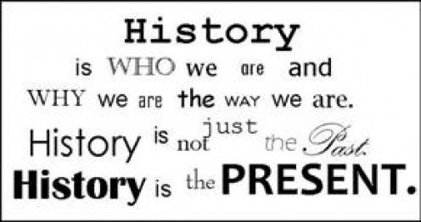

Christ the King Catholic and Church of England Curriculum Policy

History

I have come that they may have life and have it to the full (John10:10)

Approved by: | IEB | Date | Autumn 2024
Next review due by: | Autumn 2025

CURRICULUM AIMS
At Christ the King, we shape our curriculum so that all pupils are provided with high quality teaching and learning, with Jesus Christ at the centre of all we do. We aim to inspire our learners to feel empowered and able to become responsible citizens in the community and the wider world, whilst motivating them to aspire and achieve the highest standard.
We aim to
- provide a Christian education based on the life and teaching of Jesus Christ, in which the Gospel values underpin all aspects of school life
- embed our core Christian values at the heart of our curriculum
- provide a nurturing environment in which the dignity of each person as a child of God is recognised and developed; and to promote the full potential of each child through a curriculum which develops spiritual, academic, creative, social and emotional growth
- provide a curriculum which is enriching and challenging, where pupils experience the opportunity to learn in a wide range of contexts.
Creativity
Hope

Respect and Reverence

Wisdom
Forgiveness
Perseverance

INTENT

HISTORY INTENT
At Christ the King Catholic and C of E Primary School our Intent is to give children a History curriculum which enables them to establish a sense of identity, community and family. Our aim is to provide exciting, practical experiences that build resilience and well-being and extend their historical knowledge. History is led through enquiry-based learning to encourage questions and interpretation of the past.

At Christ the King, our aims are to fulfil the requirements of the National Curriculum for History providing a broad, balanced and differentiated curriculum; ensuring the progressive development of knowledge, skills and vocabulary and for our children to develop a love of History. We aim

- To immerse the children in an interest in the past to develop an understanding that enables them to enjoy all that history has to offer;
- To enable children to learn about significant events in British history, the wider world and to appreciate how things have changed over time;
- To develop a sense of chronology;
- To know and understand how the British system of democratic government has developed and, in so doing, to contribute to a child’s citizenship education;
- To understand how Britain is part of a wider European culture, and to study some aspects of European history;
- To develop in children the skills of enquiry, investigation, analysis, evaluation and presentation.
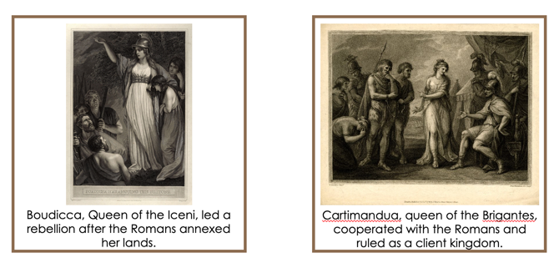
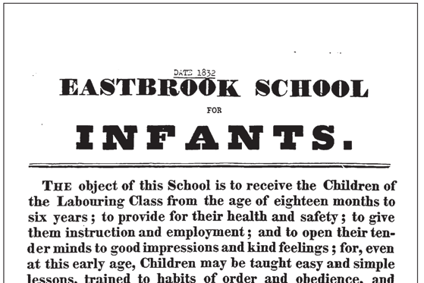
We place an emphasis on examining historical artefacts and primary sources. In order to provide a rich curriculum, we ensure that ALL children are provided with opportunities to enrich their learning experiences and develop their cultural capital. This is through an integrated, planned calendar of activities which enhance the classroom learning experience such as themed days, educational visits, and visitors. In each key stage we aim to give children the opportunity to visit sites of historical significance. History is also promoted through home learning activities to enthuse, inspire and encourage parents as partners in learning.

We recognise and value the importance of stories in history teaching, and we regard this as an important way of stimulating interest in the past. We accomplish this by using experiences which emerges the children in their learning about their topic. We focus on helping children understand that historical events can be interpreted in different ways, and that they should always ask searching questions, such as ‘how do we know?’, about information they are given.

IMPLEMENTATION

History teaching at Christ the King focuses on enabling children to think as historians and is led through enquiry-based learning to encourage questions and interpretation of the past.

We ensure that there are opportunities for children of all abilities to develop their skills and knowledge in each unit, and we plan progression into the scheme of work, so that the children are increasingly challenged as they move through the school. The History Scheme of Work has been designed by the Curriculum Lead bespoke to the needs of our children and in line with The National Curriculum expectations regarding coverage and progression. All teachers have a curriculum folder with Yearly Overviews and a Skills Grid to assist with planning objectives. These objectives are planned for each half-term. Curriculum Folders contain vocabulary expectations for each topic and are progressive as the children move through school. Where appropriate, staff draw on a rich bank of secondary internet resources.
To ensure high standards of teaching and learning in History, we implement a curriculum that is progressive throughout the whole school. History is taught in discrete lessons for a minimum of one hour each week. Work is recorded in orange exercise books consistently throughout the school. At Christ the King, we expect all History to be recorded with the same high expectations and at the same pitch as are expected in English books. Presentation and feedback on learning are in line with whole school policy and monitored in the same way by the subject leader.

History provides excellent opportunities to enhance the learning of more able pupils through planning lines of enquiry, asking open ended questions and using these to enable them to interpret the past. We encourage children to be able to make links across different time periods in History.

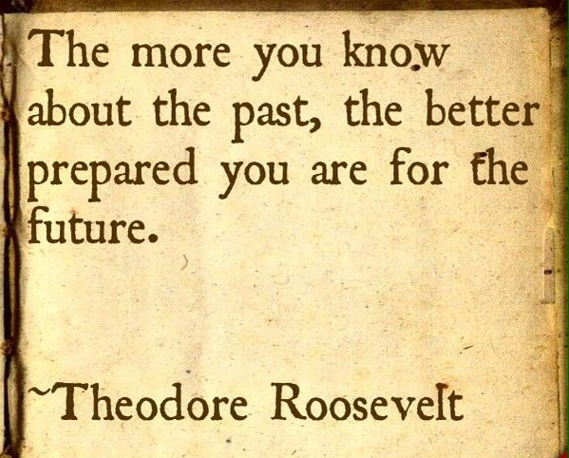
History contributes significantly to the teaching of personal, social education and citizenship. At Christ the King, we encourage our children to develop self-confidence by having opportunities to deepen their Christian understanding and explain their views on a number of social questions, such as how society should respond to poverty and homelessness. Through our Christian ethos, children discover how to be active citizens in a democratic society by learning how laws are made and changed, and they learn how to recognise and challenge stereotypes, and to appreciate that racism is a harmful aspect of society. They learn how society is made up of people from different cultures, and they start to develop tolerance and respect for others. Through this they are able to compare and contrast what life is like now and what it was like throughout the past.

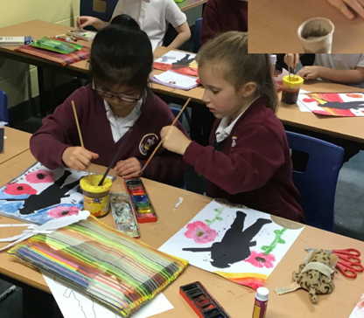
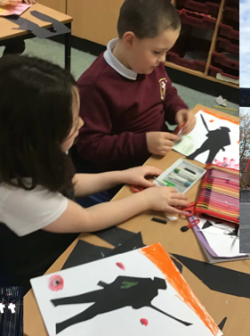
In our teaching of History, we continue to embed the children’s spiritual development, as in the annual school wide focus on remembrance, ‘What are we remembering on Remembrance Day?’ History provides many opportunities for us to reinforce our core values of Respect and Reverence, Forgiveness, Hope, Creativity, Perseverance and Wisdom. We also provide children with the opportunity to discuss moral questions, or what is right and wrong. We encourage children to make links between History, historical questions and the teachings of the Christian faith. Children learn about the role of the church in Tudor times, and they find out how British society has changed over time. The history programme of study enables children to understand that Britain’s rich cultural heritage can be further enriched by the multi-cultural British society of today.

ASSESSMENT

History assessment is based on teacher’s assessment. Children demonstrate their ability in history in a variety of different ways. Younger children might, for example, act out a famous historical event, whilst older pupils may produce a presentation based on their investigation, for example, the Greeks. Teachers will assess children’s work by making judgements during lessons. On completion of a piece of work, the teacher assesses the work and uses this information to plan for future learning. Next steps written feedback is given to the child in line with whole school policy. Older children are encouraged to make judgements about how they can improve their own work.

At the end of a whole unit of work, the teacher makes a summary judgement about the learning of each pupil in relation to the learning enquiry question that is shared at the start of the unit. Children are assessed as Working below, at Age Related Expectations or Greater Depth. This is then reported on the school assessment in DCPRO.
These are collated termly by the subject leader. The percentage of children working above, at and below age-related standards are calculated and this is used to monitor progress, evaluate impact and inform future actions.

These assessments are shared with the next class teacher as a record of a pupil’s progress throughout the year.

At Christ the King, we are committed to engaging with parents and carers and believe that they should be actively involved in their child’s learning.

EARLY YEARS
In the area of learning, Knowledge and Understanding of the World, children are developing the crucial knowledge, skills and understanding to enable them to make sense of the world around them. At Christ the King, we strive to stimulate children’s interest and curiosity through learning opportunities that are based on first-hand experience in both the indoor and outdoor learning environments. We aim to provide a balance in experiences from all aspects of this area of learning including opportunities to explore other cultures and religions.
Throughout the Foundation Stage there is a strong emphasis on the use of language to develop a Sense of Time. Words such as “before”, “after”, “next”, “then”, “this morning”, “this afternoon”, “last night”, “yesterday”, etc are used on a regular daily basis as part of all ongoing activities.

INCLUSION
All children receive Quality First Teaching. Any children identified with SEND or in receipt of pupil premium funding may have work additional to and different from their peers in order to access the curriculum dependent upon their needs. In addition, our school offers a vibrant, interesting and varied curriculum, providing all our pupils with a range of opportunities in order for them to reach their full potential, enjoy and achieve regardless of their starting points.

IMPACT

Monitoring of the standards of children’s work and of the quality of teaching in history is the responsibility of the history subject leader. This is done in a variety of ways and informs future actions. School membership of the Historical Association ensures that Christ the King always aspires to high standards of history teaching. Within history, we strive to create a supportive and collaborative ethos for learning.
We measure the impact of our curriculum in the following ways:
- Marking of history learning in books
- Using dialogic learning tasks to assess children’s understanding
- Summative assessment
- Observations of the children’s practical learning
- Displays and working walls
- Interviewing the pupils about their learning (pupil voice)
- Staff professional development meetings where pupil’s books are scrutinised and there is the opportunity for a dialogue between teachers to consider quality, content and consistency
- Assessing learning from enquiry question at the end of each unit
- Annual reporting to parents

The history subject leader will continually monitor the impact history teaching is having on the pupil’s learning through scrutinised books, to ensure the progress of knowledge and skills is being taught. They will also ensure the knowledge taught is retained by the pupils, continually revisited and pupils demonstrate developing independence with their learning.

Continuing Professional Development
CPD for staff is always ongoing through staff meetings or Team meetings delivered by the history subject lead. All staff are regularly updated with any changes.

Membership of the Historical Association ensures the subject leader is regularly updated with current thinking and good practice in history education. This information is shared regularly with staff.
There is a vibrant professional dialogue about the teaching and learning of history. Staff are committed to providing the highest quality of teaching and learning and they demonstrate a strong desire to continually develop their own knowledge and skills in the teaching of history. This might be through formally planned Professional Development Meetings, professional conversations, shared planning sessions or email exchanges.

The work of the subject leader also involves supporting colleagues in their teaching, being informed about current developments in the subject, and providing a strategic lead and direction for the subject in the school.

