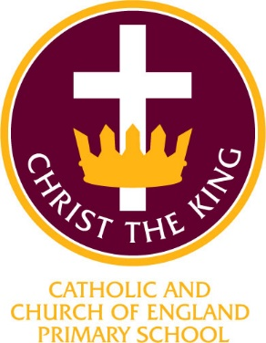

Christ the King Catholic and Church of England Curriculum Policy

Physical Education

I have come that they may have life and have it to the full (John10:10)

Approved by: | SLT | Date | November 2024
Last reviewed on: | November 2024
Next review due by: | Autumn 2026

CURRICULUM AIMS
At Christ the King, we shape our curriculum so that all pupils are provided with high quality teaching and learning, with Jesus Christ at the centre of all we do. We aim to inspire our learners to feel empowered and able to become responsible citizens in the community and the wider world, whilst motivating them to aspire and achieve the highest standard.

We aim to
- provide a Christian education based on the life and teaching of Jesus Christ, in which the Gospel values underpin all aspects of school life
- embed our core Christian values at the heart of our curriculum
- provide a nurturing environment in which the dignity of each person as a child of God is recognised and developed; and to promote the full potential of each child through a curriculum which develops spiritual, academic, creative, social and emotional growth
- provide a curriculum which is enriching and challenging, where pupils experience the opportunity to learn in a wide range of contexts.

Creativity
Hope

Respect and Reverence
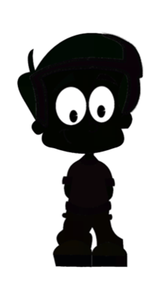
Wisdom
Forgiveness
Perseverance
INTENT

At Christ the King, our aims are to fulfil the requirements of the National Curriculum for Physical Education; providing a broad, balanced and differentiated curriculum; ensuring the progressive development of knowledge, skills and vocabulary and for our children to develop a love of Physical Education in a way that supports their health and fitness.

Physical Education at Christ the King includes the lessons they complete in their classrooms, outdoor learning experiences and an integrated plan of enrichment experiences they are offered such as national skipping day, sports days, educational and residential visits, visitors and theme days.

The aims of teaching Physical Education at Christ the King are to create a culture which aims to inspire an active generation who enjoy Physical Education, encourage each other and achieve personal success. We provide a safe and supportive environment for children to flourish in a wide range of different physical activities, which is essential in supporting all children’s physical, emotional, spiritual, social and moral development.

The aim of Physical Education is to promote physical activity and healthy lifestyles. Children are taught to observe and produce the conventions of fair play, honest competition, teamwork and good sporting behaviour as individual participants, team members and spectators. Thus embedding life-long values such as co-operation, collaboration and equity of play.

IMPLEMENTATION

At Christ the King, our teaching of Physical Education is based on the hand (doing), heart (feeling) and head (emotional) curriculum planning model from our PE partners, School of Play who provide support and expert guidance to our staff in the delivery and planning of our Physical Education curriculum. Our curriculum is designed to develop children’s ability to participate in Physical Education from a holistic perspective whilst achieving the aims of the 2014 National Curriculum for Physical Education.

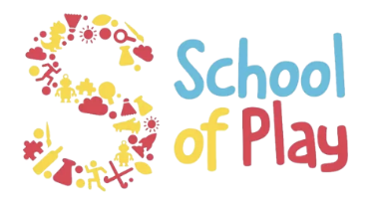

To ensure high standards of teaching and learning in Physical Education, we implement a curriculum that is progressive throughout the whole school. Physical Education is taught in discrete lessons for at least 1 hour per week in EYFS and 2 hours per week in both KS1 and KS2.

The Physical Education curriculum is based upon the 2014 Primary National Curriculum in England, which provides a broad framework and outlines the knowledge and skills taught in each Key Stage. Teachers plan lessons for their class based on the Physical Education Curriculum Overview, which ensures that knowledge and skills are taught progressively across the school. Teachers plan their Physical Education lessons, taking into account what their pupils need to learn.

Physical Education provides excellent opportunities to enhance the learning of more able pupils through challenging them physically in a safe yet rewarding manner. At Christ the King, we provide a variety of opportunities for Physical Education learning inside and outside the classroom. Our school is well equipped with a hall for indoor Physical Education lessons, which includes wall-mounted gymnastic apparatus. Outdoor PE lessons take place either on one of our two playground courts or on our school playing field. To support the development of physical education during playtimes, we also have our jungle gym and pupils are encouraged to partake in sporting activities during their lunchtime play, for example, football, skipping, tennis, throwing and catching.

At Christ the King, we make sporting connections with our local community, including Macclesfield Town Football Club and All Hallows Community College Being part of a community network and interschool competition helps develop friendly competition, engender a sense of pride and mutual respect and helping our pupils live their lives to the full. We also are pleased to be able to utilise sporting facilities in our local community, including the Swimming Pool at Macclesfield Leisure Centre.

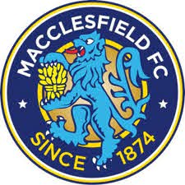


PE KIT
All pupils should wear PE kit to participate safely in Physical Education lessons. PE kit should be kept at school all week. Our school PE kit requirements are:-
- White t-shirt
- Black shorts
- Black pumps
- track suit and training shoes for outdoor games
Watches and any simple jewellery worn at school should be removed for Physical Education lessons. If pupils are unable to remove any small stud earrings that they are wearing, these can be covered with masking tape for safety. Please note, in line with our Uniform Policy, it is important for the safety of our pupils that all larger earrings and other jewellery are not worn to school. Our teachers are unable to accept responsibility for any jewellery or watches removed for Physical Education lessons. As stated in our Uniform Policy, longer hair should be tied back. For the purpose of Physical Education lessons, hair should be tied back in a simple hair band and all clips or larger hair decorations should be removed.

ASSESSMENT

Physical Education assessment is based on teacher’s/sports coaches assessment. For each PE unit, teachers begin with a pre-assessment and then complete the unit with team or individual assessment. This is then reported on the school assessment grid held on the school server. These are collated half-termly by the subject leader. The percentage of children working above, at and below age-related standards are identified.

At Christ the King, we are committed to engaging with parents and carers and believe that they should be actively involved in their child’s learning.
This includes activities for children to participate in for homework. Parents are also invited to attend sports day events.

EARLY YEARS

Physical Development is an essential part of the Early Learning Goals enabling children to develop fine and gross motor skills. Pupils in EYFS have a dedicated well-equipped indoor and outdoor space where they are able to learn through play and their interests, developing their core strength, stability, balance, spatial awareness, co-ordination and agility. In EYFS at Christ the King, we recognise that gross motor skills provide the foundation for developing healthy bodies and social and emotional well-being.

INCLUSION
All children receive Quality First Teaching. Any children identified with SEND or in receipt of pupil premium funding may have work additional to and different from their peers in order to access the curriculum dependent upon their needs. in addition, our school offers a vibrant, interesting and varied curriculum, providing all our pupils with a range of opportunities in order for them to reach their full potential, enjoy and achieve regardless of their starting points.

IMPACT

We measure the impact of our curriculum through the following methods:
- Assessing children’s understanding of topic linked vocabulary before and after the unit is taught
- Summative assessment of pupil’s learning.
- Images and videos of the children’s practical learning.
- Displays
- Interviewing the pupils about their learning (pupil voice)

The Physical Education subject leader will continually monitor the impact Physical Education teaching is having on the pupil’s learning through the above measures, to ensure the progress of knowledge and skills is being taught. They will also ensure the knowledge taught is retained by the pupils, continually revisited and that the learners are able to apply the skills they have been taught to a variety of different contexts, demonstrating independence with their learning.
Continuing Professional development CPD for staff is always ongoing through staff meetings or Team meetings delivered by the Physical Education Lead or Senior Leadership Team. All staff are regularly updated with any changes or upcoming whole school events to celebrate learning in Physical Education.

