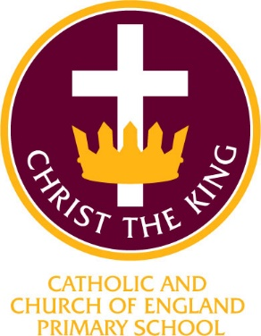

Christ the King Catholic and Church of England Curriculum Policy

Mathematics

I have come that they may have life and have it to the full (John10:10)

Approved by: | SLT | Date | November 2024
Last reviewed on: | November 2024
Next review due by: | Autumn 2026
Signed on behalf of governors:

CURRICULUM AIMS
At Christ the King, we shape our curriculum so that all pupils are provided with high quality teaching and learning, with Jesus Christ at the centre of all we do. We aim to inspire our learners to feel empowered and able to become responsible citizens in the community and the wider world, whilst motivating them to aspire and achieve the highest standard.
We aim to
- provide a Christian education based on the life and teaching of Jesus Christ, in which the Gospel values underpin all aspects of school life
- embed our core Christian values at the heart of our curriculum
- provide a nurturing environment in which the dignity of each person as a child of God is recognised and developed; and to promote the full potential of each child through a curriculum which develops spiritual, academic, creative, social and emotional growth
- provide a curriculum which is enriching and challenging, where pupils experience the opportunity to learn in a wide range of contexts.
Creativity
Hope

Respect and Reverence

Wisdom
Forgiveness
Perseverance

INTENT

At Christ the King, our aims are to fulfil the requirements of the National Curriculum for maths; providing a broad, balanced and differentiated curriculum; ensuring the progressive development of knowledge, skills and vocabulary and for our children to develop a love of maths.

CHRIST THE KING MATHEMATICS INTENT
At Christ the King, children of all ages will have enjoyment and curiosity through the use of a mastery approach to help learners meet their needs. Our ambitious maths curriculum provides Quality First Teaching at the heart of every lesson. Children will be fluent with the fundamentals of maths, reason mathematically, have the ability to solve problems and apply this knowledge across the curriculum, in real life contexts and as they progress to their next stage of learning in school and the wider world.

This includes the lessons they complete in their classrooms, cross curricular teaching and themed maths days to promote investigative and problem solving skills.

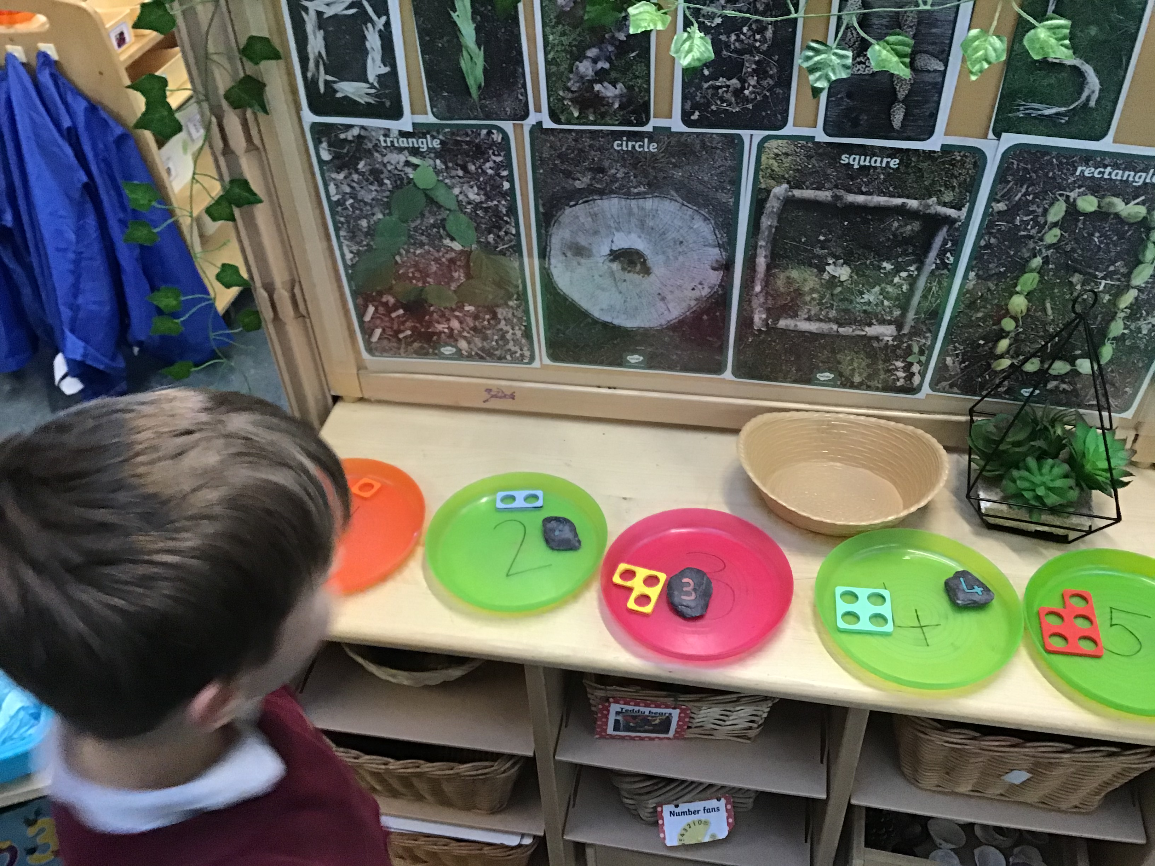The aims of teaching maths at Christ the King are
- to develop a deeper understanding of maths
- to have confidence in our own ability
- and become competent mathematicians

IMPLEMENTATION

At Christ the King, our teaching of maths is based on the White Rose Hub from Early Years Foundation Stage through to Year 6.

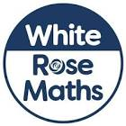

At Christ the King, we believe
‘Everyone Can do Maths!’

We believe that we can have happy, independent and confident mathematicians who can carry out a challenge in maths and reflect on their thinking.
Teachers use the White Rose Small Steps of progression document to create an ambitious curriculum for their learners. Using the White Rose Hub premium resources allows teachers to tailor their lessons and ensure the content is correct, age appropriate and challenging for each year group. Each lesson starts with ‘Flashback 4’. This is an important part of the lesson as it revisits previous learning, therefore allowing the children to consolidate previous learning. The teaching input will allow pupils to take ownership of their learning to help build on their understanding of the lesson learning intention. Through this process the teacher shapes the learning by responding to misconceptions as they occur, intervenes appropriately and takes the opportunity to support children to reflect on their learning. Pupils carry out a variety of independent tasks that challenge them and enable them to develop fluency, reasoning and problem solving. We aim to ensure that opportunities are provided to offer enrichment to motivate learners and enable them to aspire to be the best they can be.

To ensure high standards of teaching and learning in maths, we implement a curriculum that is progressive throughout the whole school. Maths is taught in discrete lessons from in Early years, Y1/2, Y3/4 and Y5/6.
We ensure that teachers have the consistent expectations for the presentation of maths learning. It is vital that any mathematical or language barriers should not impede a pupil’s maths learning. At Christ the King, the interaction between the teacher and the pupil is vital to effective learning and the design of future learning experiences.

The maths curriculum is based upon the 2014 Primary National Curriculum in England, which provides a broad framework and outlines the knowledge and skills taught in each Key Stage. Teachers plan lessons for their class based on the Whole School Maths Curriculum Overview (based on the White Rose Hub mixed aged Schemes of Learning Small Steps of Progression), which ensures that knowledge and skills are taught progressively across the school. Teachers plan their maths lessons, taking into account their prior learning and building on this to create next steps. .

Teaching subject specific vocabulary is also a key part of our maths curriculum. The vocabulary the children will need is identified in the scheme of learning under ‘Mathematical Talk’ and this builds on vocabulary they have learned in previous years. Sentence stems are also used allowing children to generate answers using mathematical vocabulary.

Maths provides excellent opportunities to enhance, stimulate and challenge the learning of more able pupils through
- solving problems with greater complexity
- independent exploration and investigation of mathematical contexts and structures
- communicating their results clearly
- systematically explaining and generalising their mathematics

At Christ the King, we provide a variety of opportunities for learning in creative ways through practical approaches and making use of indoor and outdoor environments where appropriate.

Our Gospel values underpin all we do and we aim to support children to develop their understanding of the wider world through our teaching of maths. In particular, we aim to embed our core values of Reverence and Respect, Hope, Creativity, Wisdom, Perseverance and Forgiveness in our maths teaching. Maths is essential to everyday life and to show an appreciation of the beauty and power of maths in God’s creation and to create a sense of enjoyment and curiosity about the wonders of our world.

ASSESSMENT

.Teachers will continually assess their pupils’ learning and knowledge in the daily maths lesson, address any misconceptions and intervene in any areas that need support. Misconceptions are addressed by the children using green pen.
From Year 2 to Year 6, pupils undertake a PUMA maths test in Autumn, Spring and Summer. Year 1 undertake this in Summer. For Year 1 pupils in Autumn and Spring, teachers will assess their knowledge from observations and White Rose Hub End of Block Assessments.
Knowledge and understanding is assessed against a Performance Indicator Score of 100. These assessments are recorded on an excel grid to allow diagnostic use of the information. Assessments are also entered by teachers onto the school tracking system DCPro to facilitate constructive discussion at Pupil Progress Meetings and for the Maths subject leader to analyse data.

Self-assessment and peer assessment are vital elements of our maths teaching and provide regular opportunities to continue to develop the confidence in all learners to believe that ‘Everyone can do Maths’. In celebrating achievements in this way, we continue to develop children’s resilience and promote our core value of Perseverance.

The outcomes of these assessments help to identify starting points for new units and support transition into the next phase of learning.
MASTERING NUMBER

Christ the King approached the Cheshire and Wirral Maths Hub in 2024. The school have implemented the Mastering Number programme in Reception and Y1/2 classes. This project aims to secure firm foundations in the development of good number sense for all children from Reception through to Year 1 and Year 2. The aim over time is that children will leave KS1 with fluency in calculation and a confidence and flexibility with number. Attention will be given to key knowledge and understanding needed in Reception classes, and progression through KS1 to support success in the future

ENGAGEMENT WITH PARENTS

At Christ the King, we are committed to engaging with parents and carers with their child’s learning. We believe that they should be actively involved in their child’s learning and strive to provide opportunities where they too feel confident to participate.
Parents attend parents evening twice a year where there child’s progression in maths can be discussed. Annual reports are also written for parents/carers showing their child’s progress in maths/

EARLY YEARS

‘The goal of early childhood education is to activate the child’s own natural desire to learn.’
Maria Montessori

Our Early Years environment is crucial for igniting children’s curiosity building on their capacity to learn and thriving in mathematics. In EYFS children are given the opportunity to develop their understanding of number, measurement, pattern shape and space through a combination of short, formal teaching as well as a range of planned structured play situations where there is plenty of scope for exploration.

INCLUSION
All children receive Quality First Teaching. Any children identified with SEND or in receipt of pupil premium funding may have work adapted from their peers in order to access the curriculum dependent upon their needs. In addition, our school offers a vibrant, interesting and varied curriculum, providing all our pupils with a range of opportunities in order for them to reach their full potential, enjoy and achieve regardless of their starting points.

IMPACT

Within maths, we strive to create a supportive and collaborative ethos for learning by providing opportunities for pupils to learn from their mistakes and each other.

We measure the impact of our curriculum in the following ways:
- Marking of maths work in books
- Using dialogic learning tasks to assess children’s understanding
- Summative assessment
- Images of the children’s practical learning
- Displays and working walls
- Interviewing the pupils about their learning (pupil voice)
- Staff professional development meetings where pupil’s books are scrutinised and there is the opportunity for a dialogue between teachers to consider quality, content and consistency
- Formal reporting of standards at the end of each Key Stage
- Annual reporting of standards to parents

“I like counting to ten. I am good at numbers.” Early Years pupil
“I like adding and subtracting using column method.” Key stage one pupil
“Maths is my favourite. I am good at solving problems.” Key stage two

The maths subject leader will monitor the impact maths teaching is having on the pupil’s learning through scrutinised books, to ensure the progress of knowledge and skills is being taught. They will also ensure the knowledge taught is retained by the pupils, continually revisited and that the learners are able to apply the skills they have been taught to a variety of different contexts, demonstrating independence with their learning.

Continuing Professional Development

CPD for staff is always ongoing through staff meetings or Team meetings delivered by the Maths subject lead. All staff are regularly updated with any changes.
There is a vibrant professional dialogue about the teaching and learning of maths and all staff are keen to develop and enhance their teaching. This might be through formally planned Professional Development Meetings, professional conversations, shared planning sessions or email exchanges.

