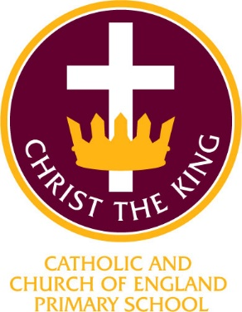

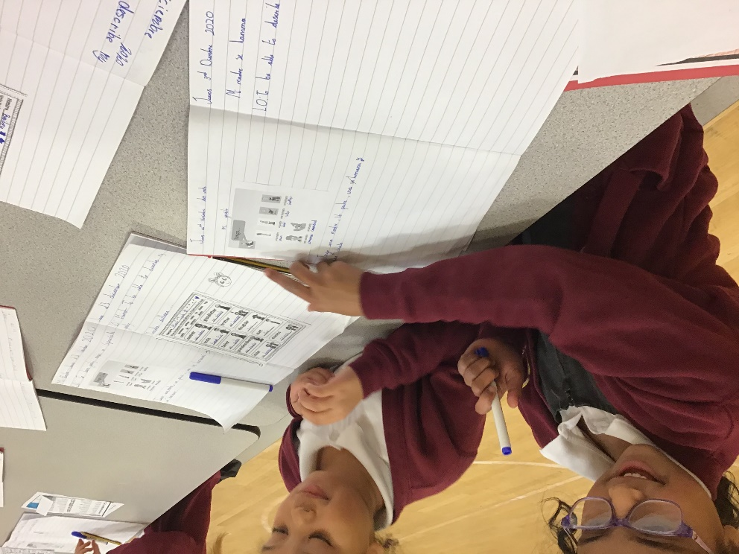

Christ the King Catholic and Church of England Curriculum Policy

Modern Foreign Languages

I have come that they may have life and have it to the full (John10:10)

CURRICULUM AIMS
At Christ the King, we shape our curriculum so that all pupils are provided with high quality teaching and learning, with Jesus Christ at the centre of all we do. We aim to inspire our learners to feel empowered and able to become responsible citizens in the community and the wider world, whilst motivating them to aspire and achieve the highest standard.
We aim to
- provide a Christian education based on the life and teaching of Jesus Christ, in which the Gospel values underpin all aspects of school life
- embed our core Christian values at the heart of our curriculum
- provide a nurturing environment in which the dignity of each person as a child of God is recognised and developed; and to promote the full potential of each child through a curriculum which develops spiritual, academic, creative, social and emotional growth
- provide a curriculum which is enriching and challenging, where pupils experience the opportunity to learn in a wide range of contexts.
Creativity
Hope

Respect and Reverence

Wisdom
Forgiveness
Perseverance

INTENT


INTENT
Christ the King Catholic and Church of England Primary Schools aim is that all pupils will develop a genuine interest and positive curiosity about foreign languages, predominantly Spanish. learning a second language will offer pupils the opportunities to explore relationship between language and identify, develop a deeper understanding of cultures and the world around them with a better awareness of self, key individuals and cultural differences, Our intention is that pupils will feel able and encouraged to continue studying languages beyond the primary phase and ultimately be working towards becoming lifelong language learners.

At Christ the King, we are delighted to provide a specialist curriculum for Modern Foreign Languages across the whole of Key Stage 2. We employ a teacher from our cluster high school, All Hallows Catholic College to deliver specialist teaching and deliver the requirements of the National Curriculum for Modern Foreign Languages. This provides a broad, balanced and differentiated curriculum; ensuring the progressive development of knowledge, skills and vocabulary and for our children to develop a love of the Spanish language and an interest in Spanish culture.

Where appropriate, we make connections with the wider curriculum. For example, we enable our children to make links between Christ the King’s Christian ethos, Catholic and Anglican traditions through celebrating as a school, the Feast of the Three Kings ‘Dia de los Reyes Magos’, or The Epiphany as we know it.
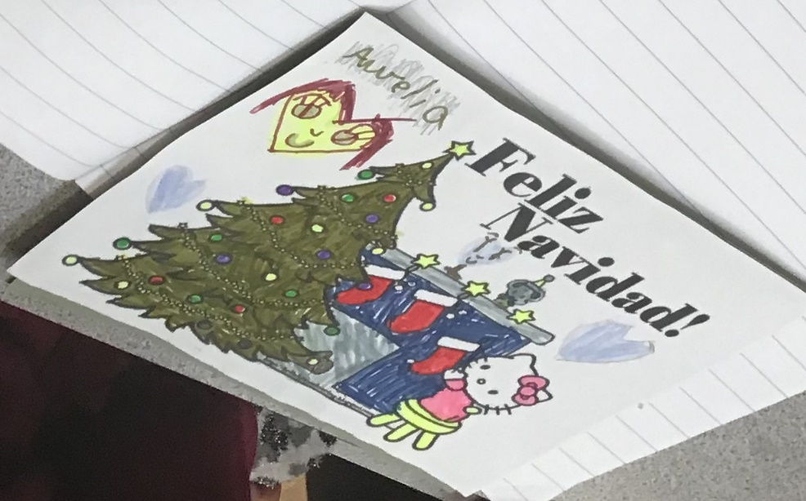
Designing Christmas Cards in Spanish for a National foreign language
Christmas Card competition by Routes Into Language

Learning a foreign language provides an opening to other cultures. At Christ the King, our high-quality languages education aims to foster pupils’ curiosity and deepen their understanding of the world. We ensure pupils have opportunities for speaking, listening, reading and writing.
In choosing Spanish, we recognise it as one of the most spoken languages around the world. As such the opportunities for our children to communicate for practical purposes in their learning and experiences beyond the classroom, such as foreign holidays, are many. At Christ the King, we believe excellent language teaching provides the foundation for learning further languages as the children move onto their next stage of learning. We are delighted that the employment of a high school teacher additionally supports the transition of our children into high school life.

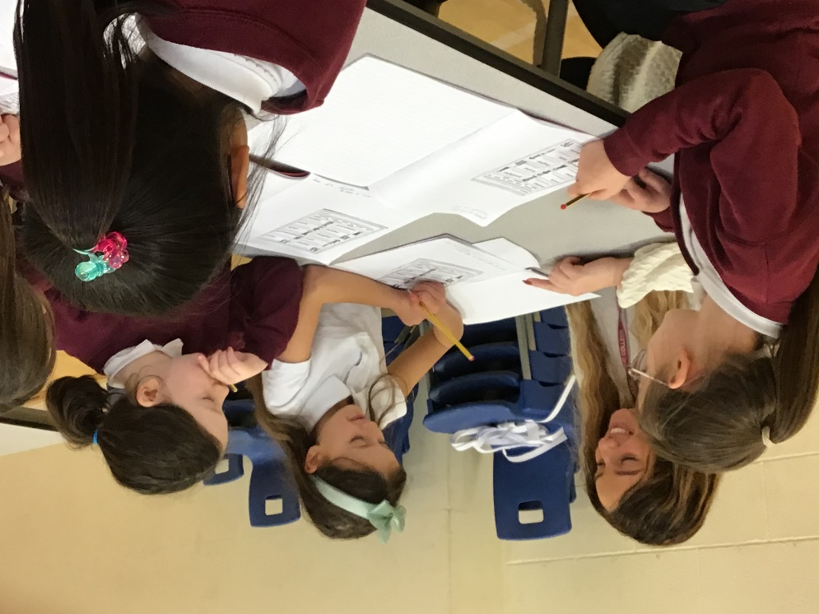

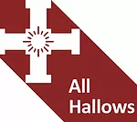

At Christ the King, we aim for the children to
- understand and respond to spoken and written language
- speak with increasing confidence, fluency and spontaneity, finding ways of communicating what they want to say, including through discussion and asking questions, and continually improving the accuracy of their pronunciation and intonation
- write at varying length, for different purposes and audiences, using the variety of grammatical structures that they have learnt
- discover and develop an appreciation of a range of writing in the language studied.

IMPLEMENTATION

At Christ the King, our teaching of MfL is based on the National Curriculum 2014 and ensuring high expectations and working towards the next stage of earning at high school.
The curriculum has been designed to cover a range of key topics e.g. Pets and Families whilst incorporating a progressive development of skills in the key language teaching areas of speaking, listening, reading, writing and grammar.

To ensure high standards of teaching and learning in MfL we implement a curriculum that is progressive throughout Key Stage 2. Spanish is taught in discrete lessons for a minimum of 45 minutes per week. Teachers take planned opportunities, additional to specialist sessions, to revisit and embed key words and phrases and foster an understanding of Spanish culture.

We ensure that teachers have the same expectations during MfL that they would have when teaching other subjects and that tasks are pitched at an age appropriate level to ensure sufficient challenge. At Christ the King, the interaction between the teacher and the pupil is vital to effective learning and the design of future learning experiences.

The MfL curriculum is based upon the 2014 Primary National Curriculum in England, which provides a broad framework and outlines the knowledge and skills taught in each Key Stage. Specialist teachers work closely with the MfL lead to ensure provision follows the Whole School MfL Curriculum Overview, which ensures that knowledge and skills are taught progressively across the school. Lessons are planned, taking into account what children need to learn. Opportunities to investigate the children’s interests and generate independent tasks are planned for using relevant questions from the ‘Curriculum Jigsaw’ which are sent home for parent(s)/carer(s) to complete at the start of each half-term.

Teaching vocabulary is also a key part of our language curriculum. The vocabulary the children will need is related to the topics on the MfL school overview and displayed in classrooms when children are learning that topic. This builds on vocabulary they have learned in previous years.

MfL provides excellent opportunities to enhance the learning of more able pupils through
- varying sentence starters
- extending conversations
- learning a greater variety of vocabulary
- setting open ended tasks
At Christ the King, we provide a variety of opportunities for language learning beyond formal teaching sessions such as ‘Three Kings Day’ and Spanish Greeting Day.

ASSESSMENT

MfL assessment is based on teacher’s assessment, with students being assessed on the 4 aspects of language (reading, writing, speaking and listening) through assessment tasks each half-term. These are collated half-termly by the subject leader. The percentage of children working above, at and below age-related standards are identified. These assessments are shared with the next class teacher as a record of a pupil’s progress throughout the year. Where appropriate, they are used to identify starting points for new units.

At Christ the King, we are committed to engaging with parents and carers and believe that they should be actively involved in their child’s learning. We encourage children and parents to discuss their MfL topics at the start of a unit and send enquiry questions into school that can be researched or investigated. These are displayed on the ‘Tree of Enquiry’ in each class and shared with our specialist Spanish teacher.

INCLUSION
All children receive Quality First Teaching. Any children identified with SEND or in receipt of pupil premium funding may have work additional to and different from their peers in order to access the curriculum dependent upon their needs. in addition, our school offers a vibrant, interesting and varied curriculum, providing all our pupils with a range of opportunities in order for them to reach their full potential, enjoy and achieve regardless of their starting points.

IMPACT

We measure the impact of our curriculum through the following methods:
- Assessing children’s understanding of topic linked vocabulary before and after the unit is taught
- Using dialogic learning tasks to assess children’s understanding
- Summative assessment of pupil discussions about their learning.
- Images and videos of the children’s practical learning.
- Displays
- Interviewing the pupils about their learning (pupil voice)
- Marking of MfL work in books
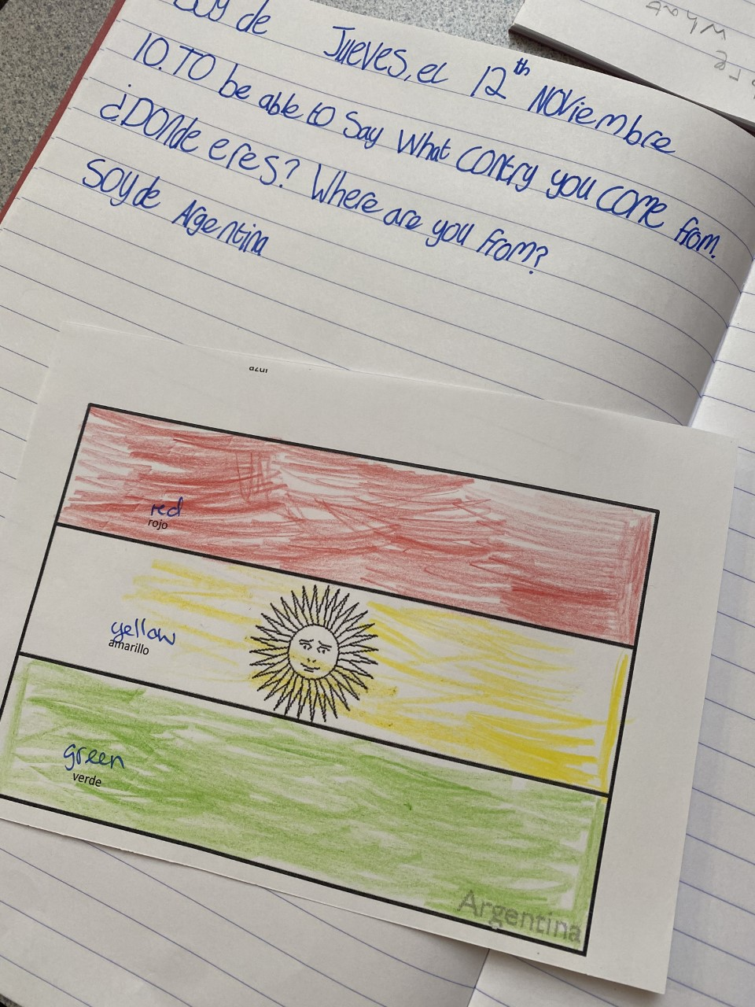
Making explicit the different way that questions are punctuated in Spanish and English as an opportunity to review English SpaG.
Preparing for a display of flags of countries where Spanish is spoken as mother tongue.
Spanish sentence formation is practised first as spoken language and then as written language.
Using opportunities to revisit review and apply previously taught vocabulary in new contexts
Year 3 work about countries where people come from. Including working on the 1st (soy) and 3rd (eres) person form of the verb to be (ser)
The MfL subject leader will continually monitor the impact modern foreign language teaching is having on the pupil’s learning through the above measures, to ensure the progress of knowledge and skills is being taught. They will also ensure the knowledge taught is retained by the pupils, continually revisited and that the learners are able to apply the skills they have been taught to a variety of different contexts, demonstrating independence with their learning. Additionally the MfL continually liases with our specialist Spanish teacher and the Head of MfL Department from All

Hallows Catholic College.
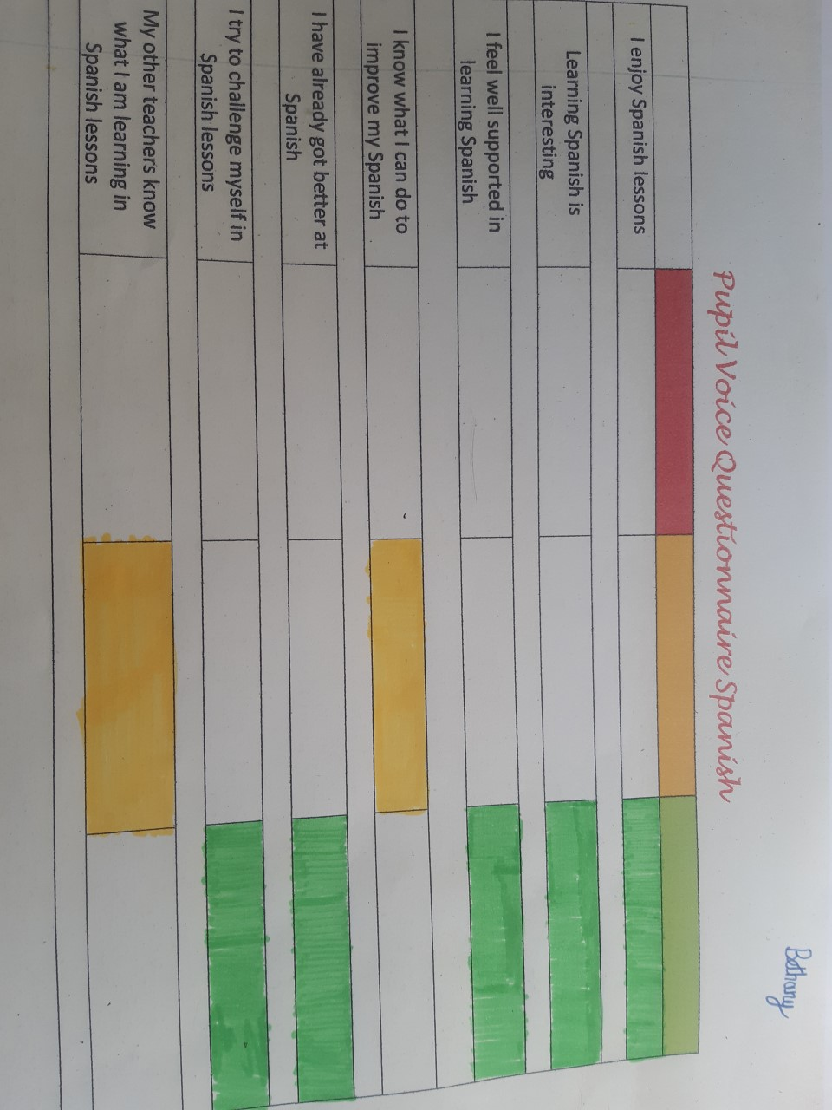
I like learning Spanish, it is fun!
Anna Klos Year 4
To improve my Spanish I listen well and try my best.
Maisy Peacock Year 6
Learning Spanish is really interesting. I like learning how to speak a new language.
Justin Zhang Year 4
A Pupil Voice Questionnaire from a Year 5 pupil, 3 months after starting learning Spanish.
Continuing Professional development CPD for staff is always ongoing through staff meetings or Team meetings delivered by the MfL Lead or Senior Leadership Team. All staff are regularly updated with any changes or upcoming whole school events to celebrate MfL learning.
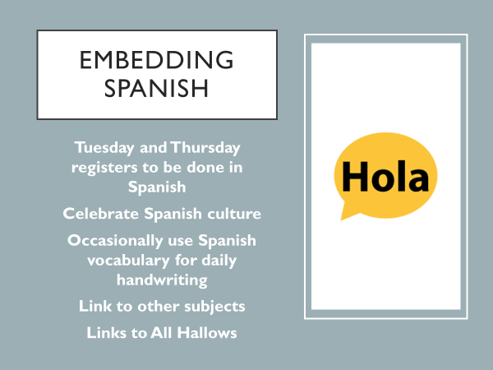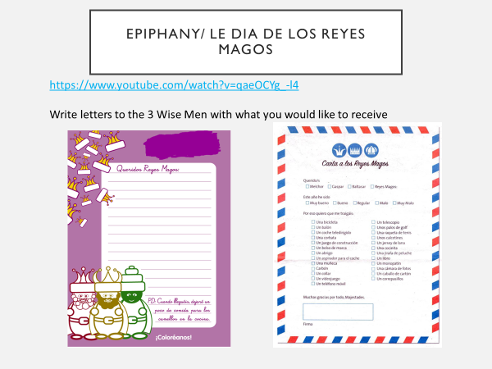
MfL staff meeting PPT slides
Staff Meeting preparing for whole school Epiphany (Dia de los Reyes Magos) celebrations

