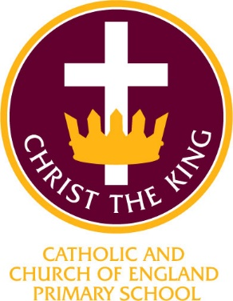
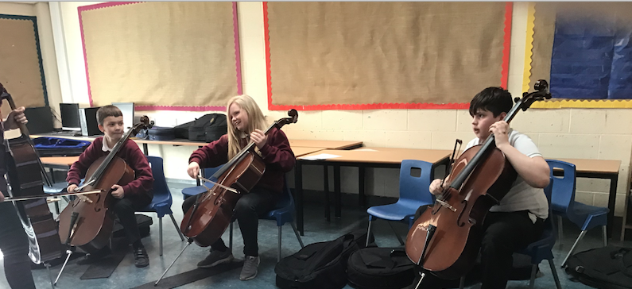

Christ the King Catholic and Church of England Curriculum Policy

Music

I have come that they may have life and have it to the full (John10:10)

CURRICULUM AIMS
At Christ the King, we shape our curriculum so that all pupils are provided with high quality teaching and learning, with Jesus Christ at the centre of all we do. We aim to inspire our learners to feel empowered and able to become responsible citizens in the community and the wider world, whilst motivating them to aspire and achieve the highest standard.
We aim to
- provide a Christian education based on the life and teaching of Jesus Christ, in which the Gospel values underpin all aspects of school life
- embed our core Christian values at the heart of our curriculum
- provide a nurturing environment in which the dignity of each person as a child of God is recognised and developed; and to promote the full potential of each child through a curriculum which develops spiritual, academic, creative, social and emotional growth
- provide a curriculum which is enriching and challenging, where pupils experience the opportunity to learn in a wide range of contexts.
Creativity
Hope

Respect and Reverence

Wisdom
Forgiveness
Perseverance

INTENT

At Christ the King, our aims are to fulfil the requirements of the National Curriculum for Music; providing a broad, balanced and differentiated curriculum.
We want to develop a secure knowledge-base in Music which follows a clear pathway of progression as they advance through the primary curriculum. In school, we will, through the effective teaching and learning of the knowledge, skills and understanding in music, maintain and stimulate pupil curiosity, interest and enjoyment. We will teach towards the National Curriculum requirements for music. We will, wherever possible, make meaningful links with the other subjects of the curriculum through our creative curriculum approach. We will work alongside the specialist music teachers to develop our own skills and knowledge to ensure music teaching at Christ the King is as effective and creative as possible.

This includes the lessons they complete in their classrooms, outdoor learning experiences and an integrated plan of enrichment experiences they are offered such as performing to our local community family, our own families and entering competitions such as Sing Fest.

The aims of teaching Music at Christ the King are:
To build a musical curriculum which develops learning and result in the acquisition of knowledge and improved wellbeing, continue to promote a love of music and singing across a broadened curriculum. Perform, listen to, review and evaluate music across a range of historical periods, genres, styles and traditions, including the works of the great composers and musicians; • Learn to sing and to use their voices, to create and compose music on their own and with others, have the opportunity to learn a musical instrument, use technology appropriately and have the opportunity to progress to the next level of musical excellence. To understand and explore how music is created, produced and communicated, including through the interrelated dimensions: pitch, duration, dynamics, tempo, timbre, texture, structure and appropriate musical notations. (As outlined in the 2014 National Curriculum)

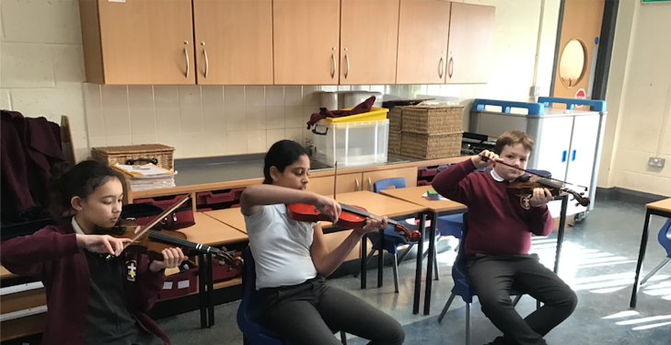
IMPLEMENTATION

At Christ the King, we enable our children to meet the intentions of the Music Curriculum, it is delivered through the Love Music Trust Scheme. This scheme provides teachers with week-by-week lesson support for each year group in the school. It is ideal for specialist and non-specialist teachers and provides lesson plans, assessment, clear progression and engaging and exciting whiteboard resources to support every lesson. The Scheme supports all the requirements of the national curriculum. In line with the curriculum for music and guidance from Ofsted, this scheme moves away from the previous levels and learning objective/outcome concepts to an integrated, practical, exploratory and child-led approach to musical learning. Ofsted have stated that ‘We will not always know the learning outcomes’ so segregated learning objectives at the start of each lesson are not appropriate. Instead the interrelated dimensions of music weave through the units to encourage the development of musical skills as the learning progresses through listening and appraising, differing musical activities (including creating and exploring) and performing. Music can be incorporated within all other curriculum areas to enhance and develop skills further. Peripatetic music teachers are actively encouraged to come into school and work with children wishing to learn and develop their skills playing particular instruments. The extra-curricular choir club allows the children attending to sing to a range of differing audiences and build upon songs that they have learnt through their music lessons, as well as widening their song repertoire though other songs and experiences such as Young Voices.

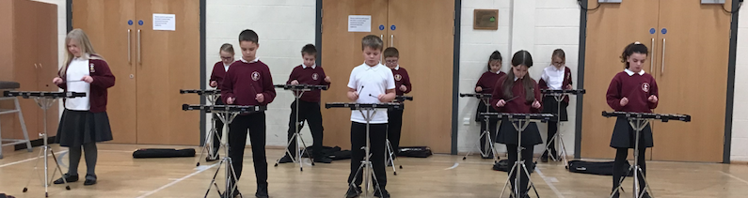

ASSESSMENT

Music assessment is based on the specialised teacher’s assessment. The interaction between the teacher and the pupil is vital to effective learning and the design of future learning experiences.
This is then reported on the school assessment grid held on the school server.
These are collated half-termly by the subject leader. The percentage of children working above, at and below age-related standards are identified.
These assessments are shared with the next class teacher as a record of a pupil’s progress throughout the year. Where appropriate, they are used to identify starting points for new units.

At Christ the King, we are committed to engaging with parents and carers and believe that they should be actively involved in their child’s learning.
We encourage children and parents to discuss their topics at the start of a unit and send enquiry questions into school that can be researched or investigated. These are displayed on the ‘Tree of Enquiry’ in each class.


INCLUSION
All children receive Quality First Teaching. Any children identified with SEND or in receipt of pupil premium funding may have work additional to and different from their peers in order to access the curriculum dependent upon their needs. In addition, our school offers a vibrant, interesting and varied curriculum, providing all our pupils with a range of opportunities in order for them to reach their full potential, enjoy and achieve regardless of their starting points.

IMPACT

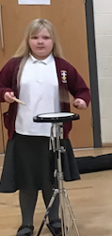
Spiritual, Moral, Social and Cultural

The spiritual development of pupils is shown by their:
• Sense of enjoyment and fascination in learning about themselves, others and the world around them;
• Use of imagination and creativity in their learning;
• Willingness to reflect on their experiences.
The social development of pupils is show by their:
• Willingness to participate in a variety of communities and social settings, including by volunteering, cooperating well with others and being able to resolve conflicts effectively.
The cultural development of pupils is shown by their:
• Understanding and appreciation of the wide range of cultural influences that have shaped their own heritage and that of others;
• Willingness to participate in and respond positively to artistic, sporting and cultural opportunities; • Interest in exploring, improving understanding of and showing respect for different faiths and cultural diversity, and the extent to which they understand, accept, respect and celebrate diversity, as shown by their tolerance and attitudes towards different religious, ethnic, and socio-economic groups in the local, national and global communities.

“I like to play the Glocks because I really enjoy it.”

“I want to be in an orchestra when I am older” “Music is fun.”

The Music subject leader will continually monitor the impact of Music teaching is having on the pupil’s learning through Pupil voice to ensure the progress of knowledge and skills is being taught.

Continuing Professional Development
CPD for staff is always ongoing through staff meetings or Team meetings delivered by the Music subject lead. All staff are regularly updated with any changes.
There is a vibrant professional dialogue about the teaching and learning of Music and all staff are keen to develop and enhance their teaching. This might be through formally planned Professional Development Meetings, professional conversations, shared planning sessions or email exchanges along with sharing our ideas.

