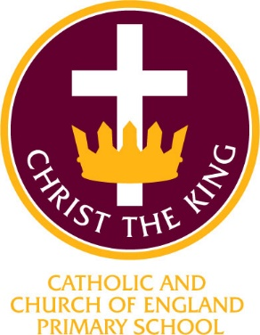
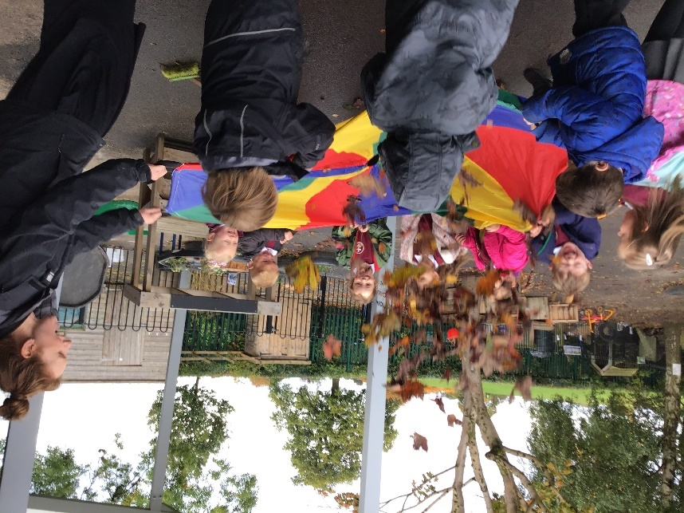
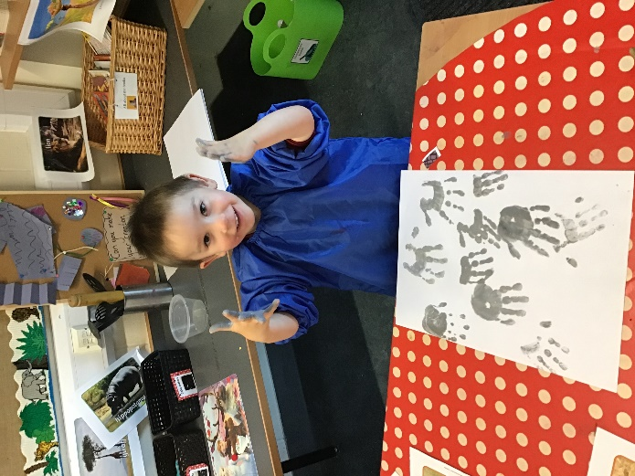

Christ the King Catholic and Church of England Curriculum Policy

Early Years Foundation Stage

I have come that they may have life and have it to the full (John10:10)

Approved by: | Governing Body | Date | September 2022
Last reviewed on: | September 2022
Next review due by: | Summer 2023
Signed on behalf of governors:

CURRICULUM AIMS
At Christ the King, we shape our curriculum so that all pupils are provided with high quality teaching and learning, with Jesus Christ at the centre of all we do. We aim to inspire our learners to feel empowered and able to become responsible citizens in the community and the wider world, whilst motivating them to aspire and achieve the highest standard.
We aim to
- provide a Christian education based on the life and teaching of Jesus Christ, in which the Gospel values underpin all aspects of school life
- embed our core Christian values at the heart of our curriculum
- provide a nurturing environment in which the dignity of each person as a child of God is recognised and developed; and to promote the full potential of each child through a curriculum which develops spiritual, academic, creative, social and emotional growth
- provide a curriculum which is enriching and challenging, where pupils experience the opportunity to learn in a wide range of contexts.
Creativity
Hope

Respect and Reverence

Wisdom
Forgiveness
Perseverance

INTENT

At Christ the King, our aims are to fulfil the requirements of the Statutory Framework for Early Years Foundation Stage Curriculum and shape our practice around the four main principles:
- Every child is a unique child
- Children learn through strong and positive relationships
- Learn and develop in an enabling environment with teaching and support from adults
- Understand the importance of learning and development.

CHRIST THE KING EARLY YEARS FOUNDATION STAGE INTENT
In our Early Years Foundation Stage, we believe that every child is unique. In collaboration with parents, we enable our pupils to be resilient, confident and self-assured learners by sparking their curiosity. We provide a nurturing, creative and inclusive Early Years learning environment which enables our pupils to flourish spiritually, emotionally, academically and socially.

At Christ the King, we provide quality and consistency in our Early Years setting so that every child makes good progress. By building a secure foundation through planning and development of each individual child, we ensure that we assess and review their learning regularly. Working in partnership with practitioners and parents we ensure that children learn and develop well and are kept healthy and safe. We ensure that every child is supported and included through an equality of opportunity.
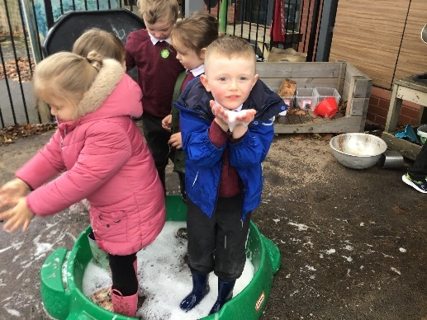

The aim of our Early Years Foundation stage at Christ the King is to:
Activate their own natural desire to learn and build strong foundations for good future progress through school and later life.

IMPLEMENTATION

At Christ the King, we were an Early Adopter school from 2020-2021 which allowed us to implement the new revised Early Years Foundation Framework a year earlier. This gave us a great opportunity to create, review and revise our own Early Years curriculum ready for the statutory framework start date of September 2021.

There are 7 areas of learning and development which we focus on the Early Years Foundation Stage curriculum. These seven areas are:
- Communication and language
- Physical development
- Personal, social and emotional development
- Literacy
- Mathematics
- Understanding the world
- Expressive arts
Communication and Language, physical development and personal, social and emotional development are the three prime areas. These are crucial in our Early Years environment for igniting children’s curiosity, building their capacity to learn and form relationships and thrive. All the seven areas will be interconnected and will involve activities and experiences that are differentiated for every pupil.
At Christ the King, our Early Years Curriculum is tailored to individual needs and builds on the children’s interests in order to achieve their learning outcomes. Our on going assessment allows us to plan a curriculum which will inspire and provide engagement for all our learners. Through carefully selected stories which are based on the children’s interests, we provide the characteristics of effective learning which are engagement, motivation and creating and thinking critically. These characteristics underpin learning and development across our curriculum and support our children to be an effective and motivated learner. Our curriculum is carefully planned through a chosen story which incorporates the half term theme. Activities are planned on a weekly basis by the class teacher and teaching assistants for both Nursery and Reception children which include activities focussing on the seven strands of learning in a cross curricular way.
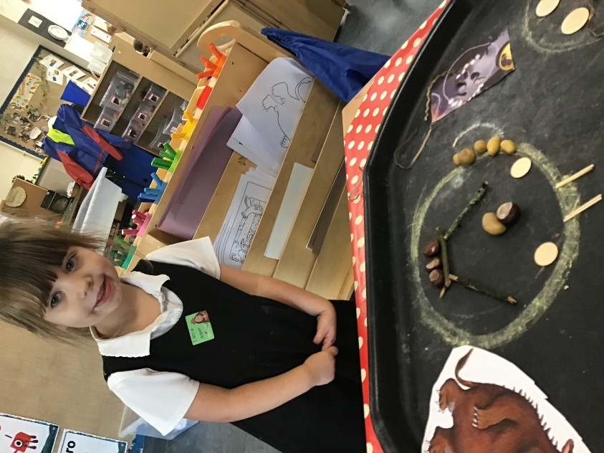
Our indoor and outdoor learning environment is designed to encourage children to extend, challenge and deepen their understanding of the Early Years Curriculum. These environments allow for independence, curiosity and hands on play-based learning. Through carefully selected resources and enhancements, we allow children to explore recent learning, practise their skills and follow their own interests. Challenges are provided in each area to extend their learning. Adult engagement in these areas allow us to enhance our provision through knowing when to stand back and observe, question the children to extend and develop their learning, model and intervene to support teaching and learning.
In our Early Years, we provide a mixture of child led and adult led experiences, activities and exploration through play.
Systematic Phonics is taught daily in a structured way using Read Write Inc to the Reception children with 1:1 interventions taking place in an afternoon. Our aim in Reception is that every child becomes a fluent and confident reader who has a love of reading. Phase one phonics from Letters and Sounds begins with our Nursery children to pave the way for children to make a good start to reading and writing. The teaching of reading starts from the moment our pupils join us in Nursery. We provide many opportunities for all our pupils to develop a ‘love of reading’ from an early age. Daily story time takes place at the end of the day from a basket of carefully chosen topic themed books linked to our half term topic. Each half term, five stories are selected by the class teacher called ‘Mrs Bradley’s favourite five.’ One of these stories will be read every day to allow the children to develop their confidence, comprehension, vocabulary and understanding. Rereading the same story will also help them strengthen their phonics ability and pronunciation. Each of the areas in our continuous provision have baskets of books available for the children to read. A dedicated reading tent is positioned in the room to provide a quiet place for the children to sit and read a story on their own, with a friend or with their teacher. Library books are also sent home every week to all Early Years children which are selected by the pupils themselves and encourages interaction and parental engagement in their child’s learning. Once the Reception children are beginning to blend, carefully matched reading books with be sent home which highlight the grapheme-phoneme correspondences they know, both at school and at home.
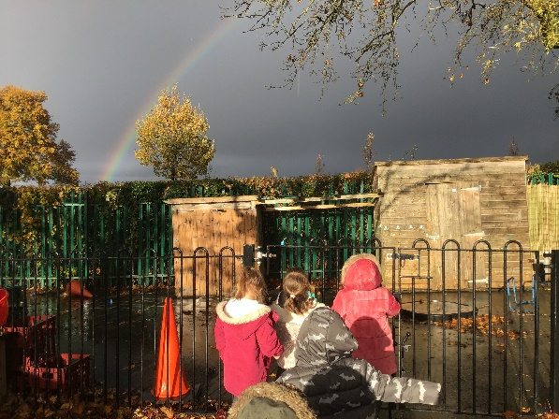
For Mathematics, we use a Mastery approach in White Rose Hub schemes of learning and set the foundations of ‘Everyone can in Maths.’ We want our pupils to develop a deep understanding of and acquisition of mathematical language that they use independently during their learning through play approach.
At Christ the King, we know that children’s spoken language underpins all seven areas of language and development. Our language rich environment and interaction is crucial for laying the foundations for language and cognitive development. Wellcomm interventions are carried out daily with the targeted pupils who need support. Toddler talk and Children’s chatter are also communication interventions that we use with our Nursery children.

Our Gospel values underpin all we do and we aim to support children to develop their understanding of the wider world. In particular, we aim to embed our core values of Reverence and Respect, Hope, Creativity, Wisdom, Perseverance and Forgiveness in our teaching in Early Years. is essential to everyday life and to show an appreciation of the beauty and power of maths in God’s creation and to create a sense of enjoyment and curiosity about the wonders of our world.

ASSESSMENT
Assessment is also especially important in Early Years and is an integral part of the learning and development process. We will observe each child in Early Years to understand their level of achievement, interests and learning styles. We will ensure that we shape learning experiences for each child reflecting these observations. All the observations gathered throughout the year will allow us to track the child’s progress and ensure they are on their way to meeting their end of year Early Learning Goal.
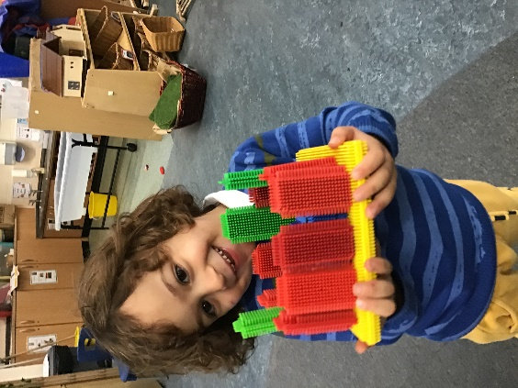
For every child starting in Reception, we undertake the Statutory Reception Baseline Assessment within the first six weeks covering Mathematics, Literacy and Communication and Language. This data will be uploaded to the Baseline E portal and narrative reports will be read and discussed as an EYFS team. An independent baseline will also be carried out by the class teacher during the first six weeks, focussing on all seven of the prime areas. This will be a mix of observations and ‘pre arranged’ learning activities which allow us to have clear understanding of their on entry stating points in all seven of the areas of the curriculum. Development Matters 2020 is used to help assist us in understanding if the child is working at 0-3 years, 3- 4 years of Reception. We track their progress using the statements ‘emerging’ and secure.’ Dedicated assessment weeks occur in December, March and June. Long observations will be completed on each child during these assessment weeks by practitioners, as well as daily observations that occur in the continuous provision, to assess their progress. At the end of Reception we use the Early Learning Goals to support the teachers knowledge to make a holistic and best fit judgement about a child’s development.
Throughout the year, weekly next steps will be set for each child in Reception to enable them to make progress and challenge them. These next steps will be reviewed each week by the class teacher.
Observations are ongoing in the early years and key assessment opportunities will be uploaded to the online learning journey Tapestry. Wow moments will all be collected and shared with parents through a collaborative partnership both at home and at school. These observations will help to make a holistic judgment towards to the long observations that are carried out in December, March and June (Early Learning goals for EYFSP)
In the final term in Reception, an Early Learning Profile will be completed on each child. This will give a well rounded picture and holistic judgment of each child’s knowledge, understanding and abilities and their attainment against expected levels and readiness for Year 1.

Each Nursery child in our Early Years in assigned to a key worker. This key worker will set next steps for their targeted children to help them fulfil their full potential and provide opportunities for them to make good progress of development. A next steps board is located in the Early Years room and is used as a working wall to help track the progress and achievements of our learners.
All Nursery children will have a baseline assessment completed in the form of a long observation within the first term of attending the setting. At the end of July, a long observation will be carried out by the key workers and the Early Years Lead and an assessment meeting will take place to discuss each child and their progress. These long observations will be shared with parents at parents meetings throughout the year.
Each Nursery child will also have their own Tapestry account to enable key workers to upload observations and wow moments to their online learning journey which can be shared with parents. Parents will also be encouraged to upload their own observations and wow moments too to ensure a collaborative learning approach takes place.

Two Year Check
When a child enters the setting between the ages of two and three, a two year check will be carried out. This will also form the baseline assessment and will be shared with both parents and the health visitor.

ENGAGEMENT WITH PARENTS

At Christ the King, we are committed to engaging with parents and carers with their child’s learning. We believe that they should be actively involved in their child’s learning and strive to provide opportunities where they too feel confident to participate.
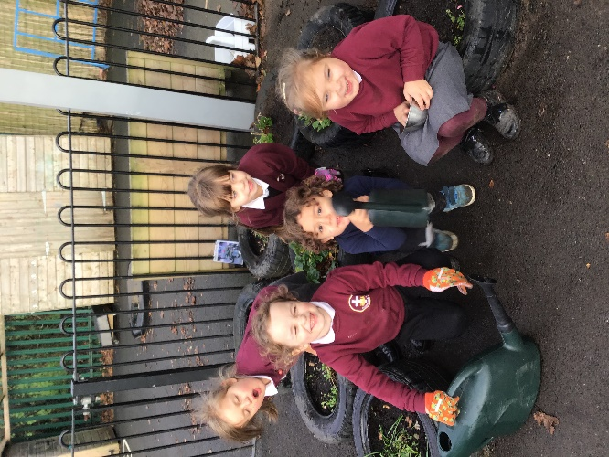
At Christ the King, we use Tapestry to record our ‘Wow’ moments of each pupil in their own online ‘Learning Journey’. This allows parents and carers a secure and quick way of accessing their own child’s learning at school. This online platform allows us to share photos, videos and comments about the learning completed in school. Parents and carers can also add photos and comments about any experiences, activities or learning that has been completed at home.

Weekly homework is sent home to both Nursery and Reception and provides an opportunity for parents to help support and encourage their child’s love of learning. We know that parents are the first educators of their child and have a wealth of knowledge and we believe that it is very important that this is a shared learning journey in Early Years.

Parents are invited to ‘stay and play’ sessions in our Early Years throughout the year to see how their children flourish in our Early Years setting.
NB The format of this may need to be revised in the light of any covid guidelines or restrictions.

INCLUSION
All children receive Quality First Teaching. Any children identified with SEND or in receipt of pupil premium funding may have work additional to and different from their peers in order to access the curriculum dependent upon their needs. In addition, our school offers a vibrant, interesting and varied curriculum, providing all our pupils with a range of opportunities in order for them to reach their full potential, enjoy and achieve regardless of their starting points.

Our Inclusive approach allows all children to learn together. We use additional interventions and support to enhance and scaffold children who may need help to achieve their full potential. We use Wellcomm intervention to support communication and language, 1:1 Rwi interventions, ‘pinny time’ to deliver on the spot intervention with reading words, sounds and blending. Daily dough disco occurs to help strengthen their muscles to prepare them for writing. Maths interventions for pupils who need extra support using the maths recovery based approach.
IMPACT

Our curriculum meets the needs of our children. We ensure that this happens by observing and evaluating how our children learn. We engage with the children, celebrate their achievements, observe their learning in the environment and analyse their progress using the Development Matters 2020 and Early Learning goals at the end of the Reception year.

We measure the impact of our Early Years Curriculum in the following ways:
- Daily observations
- Interaction and feedback from practitioners on the progress of their key children
- Next steps board
- Baseline assessment
- Three assessment windows throughout the year to assess the impact of the teaching and learning
- Tracking their progress on DCPRO
- Evidence of their ‘wow’ moments in their online learning journey on Tapestry
At Christ the King we take part in ‘Cheshire Chatters’ which is a collaborative initiative led by Speech and Language Therapists to our Nursery children. Our Early Years practitioners are trained to identify and support children’s early language development and any difficulties they may have. This allows our children to develop their communication and language skills which are the foundations for children’s learning in school and beyond.
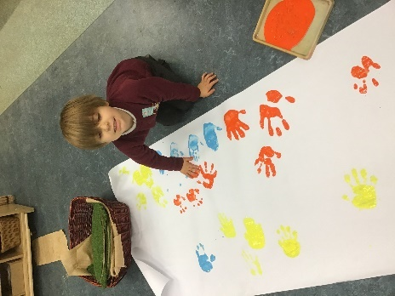
Our Early Years Lead also takes part in two Network reform groups with other Early Years practitioners in Cheshire East to help imbed and explore the Early Adopter reforms in both Reception and Nursery

The Early Years Leader will continually monitor the impact the teaching and learning in EYFS through termly pupil progress meetings with Senior Leadership team.

Continuing Professional Development
CPD for staff is always ongoing through staff meetings, online courses and Team meetings delivered by a variety of outside agencies which include speech and language, Early Excellence, Early Network Reform group etc. All staff are regularly updated with any changes.
There is a vibrant professional dialogue about the teaching and learning in Early Years and all staff are keen to develop and enhance their knowledge and teaching. This might be through formally planned Professional Development Meetings, professional conversations, shared planning sessions or email exchanges.

